Guide de l’apprenant
  - L’examen clinique de l’état mental de l’aîné dans le contexte des troubles neurocognitifs majeurs
Tous droits réservés - www.philippevoyer.org

Formation destinée :

au personnel infirmier;

aux travailleurs sociaux;

au membre de l’équipe d’encadrement clinique;

aux autres professionnels de la santé.

Nom : _________________________________________________________
1
Préparation à la formation

Bienvenue à la formation sur l’examen clinique de l’état mental dans le contexte des troubles neurocognitifs majeurs !
- Avant de débuter la formation, assurez-vous que vous avez lu récemment un livre de physiopathologie du corps humain, vous permettant d’être en mesure de bien comprendre la formation qui suit.
- Nous vous invitons fortement à suivre la formation dans l’ordre suggéré par le guide de l’apprenant.

2
Vidéo 1

1. Visionnez la première vidéo.
Durée : 24 min 35 sec.
Date de visionnement de la vidéo : _________________
Notes
______________________________________________________________________________________________________________________________________________________________________________________________________________________________________________________________________________________________________________________________________________________________________________________________________________________________________________________________________________________________________________________________________________________________________________________________________________________________________________________________________________________________________________________________________________________________________________________________________________________________________________________________________________________________________________________________________________________________________________________________________________________________________________________________________________________________________________________________________________________________________________________________________________________________________
3
Vidéo 2

1. Visionnez la deuxième vidéo.
Durée : 15 min 50 sec.
Date de visionnement de la vidéo : _________________
Notes
______________________________________________________________________________________________________________________________________________________________________________________________________________________________________________________________________________________________________________________________________________________________________________________________________________________________________________________________________________________________________________________________________________________________________________________________________________________________________________________________________________________________________________________________________________________________________________________________________________________________________________________________________________________________________________________________________________________________________________________________________________________________________________________________________________________________________________________________________________________________________________________________________________________________________
4
Vidéo 3

1. Visionnez la troisième vidéo.
Durée : 14 min 26 sec.
Date de visionnement de la vidéo : _________________
Notes
_________________________________________________________________________________________________________________________________________________________________________________________________________________________________________________________________________________________________________________________________________________________________________________________________________________________________________________________________________________________________________________________________________________________________________________________________________________________________________________________________________________________________________________________________________________________________________________________________________________________________________________________________________________________________________________________________________________________________________________________________________________________________________________________________________________________________________________________________________________

5
Vidéo 4

1. Visionnez la quatrième vidéo.
Durée : 5 min 24 sec.
Date de visionnement de la vidéo : _________________
Notes
______________________________________________________________________________________________________________________________________________________________________________________________________________________________________________________________________________________________________________________________________________________________________________________________________________________________________________________________________________________________________________________________________________________________________________________________________________________________________________________________________________________________________________________________________________________________________________________________________________________________________________________________________________________________________________________________________________________________________________________________________________________________________________________________________________________________________________________________________________________________________________________________________________________________________
6
Vidéo 5

1. Visionnez la cinquième vidéo.
Durée : 20 min 42 sec.
Date de visionnement de la vidéo : _________________
Notes
______________________________________________________________________________________________________________________________________________________________________________________________________________________________________________________________________________________________________________________________________________________________________________________________________________________________________________________________________________________________________________________________________________________________________________________________________________________________________________________________________________________________________________________________________________________________________________________________________________________________________________________________________________________________________________________________________________________________________________________________________________________________________________________________________________________________________________________________________________________________________________________________________________________________________
7
Vidéo 6

1. Visionnez la sixième vidéo.
Durée : 31 min 52 sec.
Date de visionnement de la vidéo : _________________
Notes
______________________________________________________________________________________________________________________________________________________________________________________________________________________________________________________________________________________________________________________________________________________________________________________________________________________________________________________________________________________________________________________________________________________________________________________________________________________________________________________________________________________________________________________________________________________________________________________________________________________________________________________________________________________________________________________________________________________________________________________________________________________________________________________________________________________________________________________________________________________________________________________________________________________________________
8
Vidéo 7

1. Visionnez la septième vidéo.
Durée : 16 min 27 sec.
Date de visionnement de la vidéo : _________________
Notes
______________________________________________________________________________________________________________________________________________________________________________________________________________________________________________________________________________________________________________________________________________________________________________________________________________________________________________________________________________________________________________________________________________________________________________________________________________________________________________________________________________________________________________________________________________________________________________________________________________________________________________________________________________________________________________________________________________________________________________________________________________________________________________________________________________________________________________________________________________________________________________________________________________________________________
9
Vidéo 8

1. Visionnez la huitième vidéo.
Durée : 21 min 25 sec.
Date de visionnement de la vidéo : _________________
Notes
______________________________________________________________________________________________________________________________________________________________________________________________________________________________________________________________________________________________________________________________________________________________________________________________________________________________________________________________________________________________________________________________________________________________________________________________________________________________________________________________________________________________________________________________________________________________________________________________________________________________________________________________________________________________________________________________________________________________________________________________________________________________________________________________________________________________________________________________________________________________________________________________________________________________________
10
Vidéo 9

1. Visionnez la neuvième vidéo.
Durée : 17 min 53 sec.
Date de visionnement de la vidéo : _________________
Notes
______________________________________________________________________________________________________________________________________________________________________________________________________________________________________________________________________________________________________________________________________________________________________________________________________________________________________________________________________________________________________________________________________________________________________________________________________________________________________________________________________________________________________________________________________________________________________________________________________________________________________________________________________________________________________________________________________________________________________________________________________________________________________________________________________________________________________________________________________________________________________________________________________________________________________
11
Vidéo 10

1. Visionnez la dixième vidéo.
Durée : 9 min 09 sec.
Date de visionnement de la vidéo : _________________
Notes
______________________________________________________________________________________________________________________________________________________________________________________________________________________________________________________________________________________________________________________________________________________________________________________________________________________________________________________________________________________________________________________________________________________________________________________________________________________________________________________________________________________________________________________________________________________________________________________________________________________________________________________________________________________________________________________________________________________________________________________________________________________________________________________________________________________________________________________________________________________________________________________________________________________________________
12
Après la formation

Vous avez terminé de visionner les vidéos de la formation.
1. (Facultatif) Selon les directives de votre organisation, veuillez faire le questionnaire de validation des apprentissages en cliquant sur la rubrique encadrée en rouge.
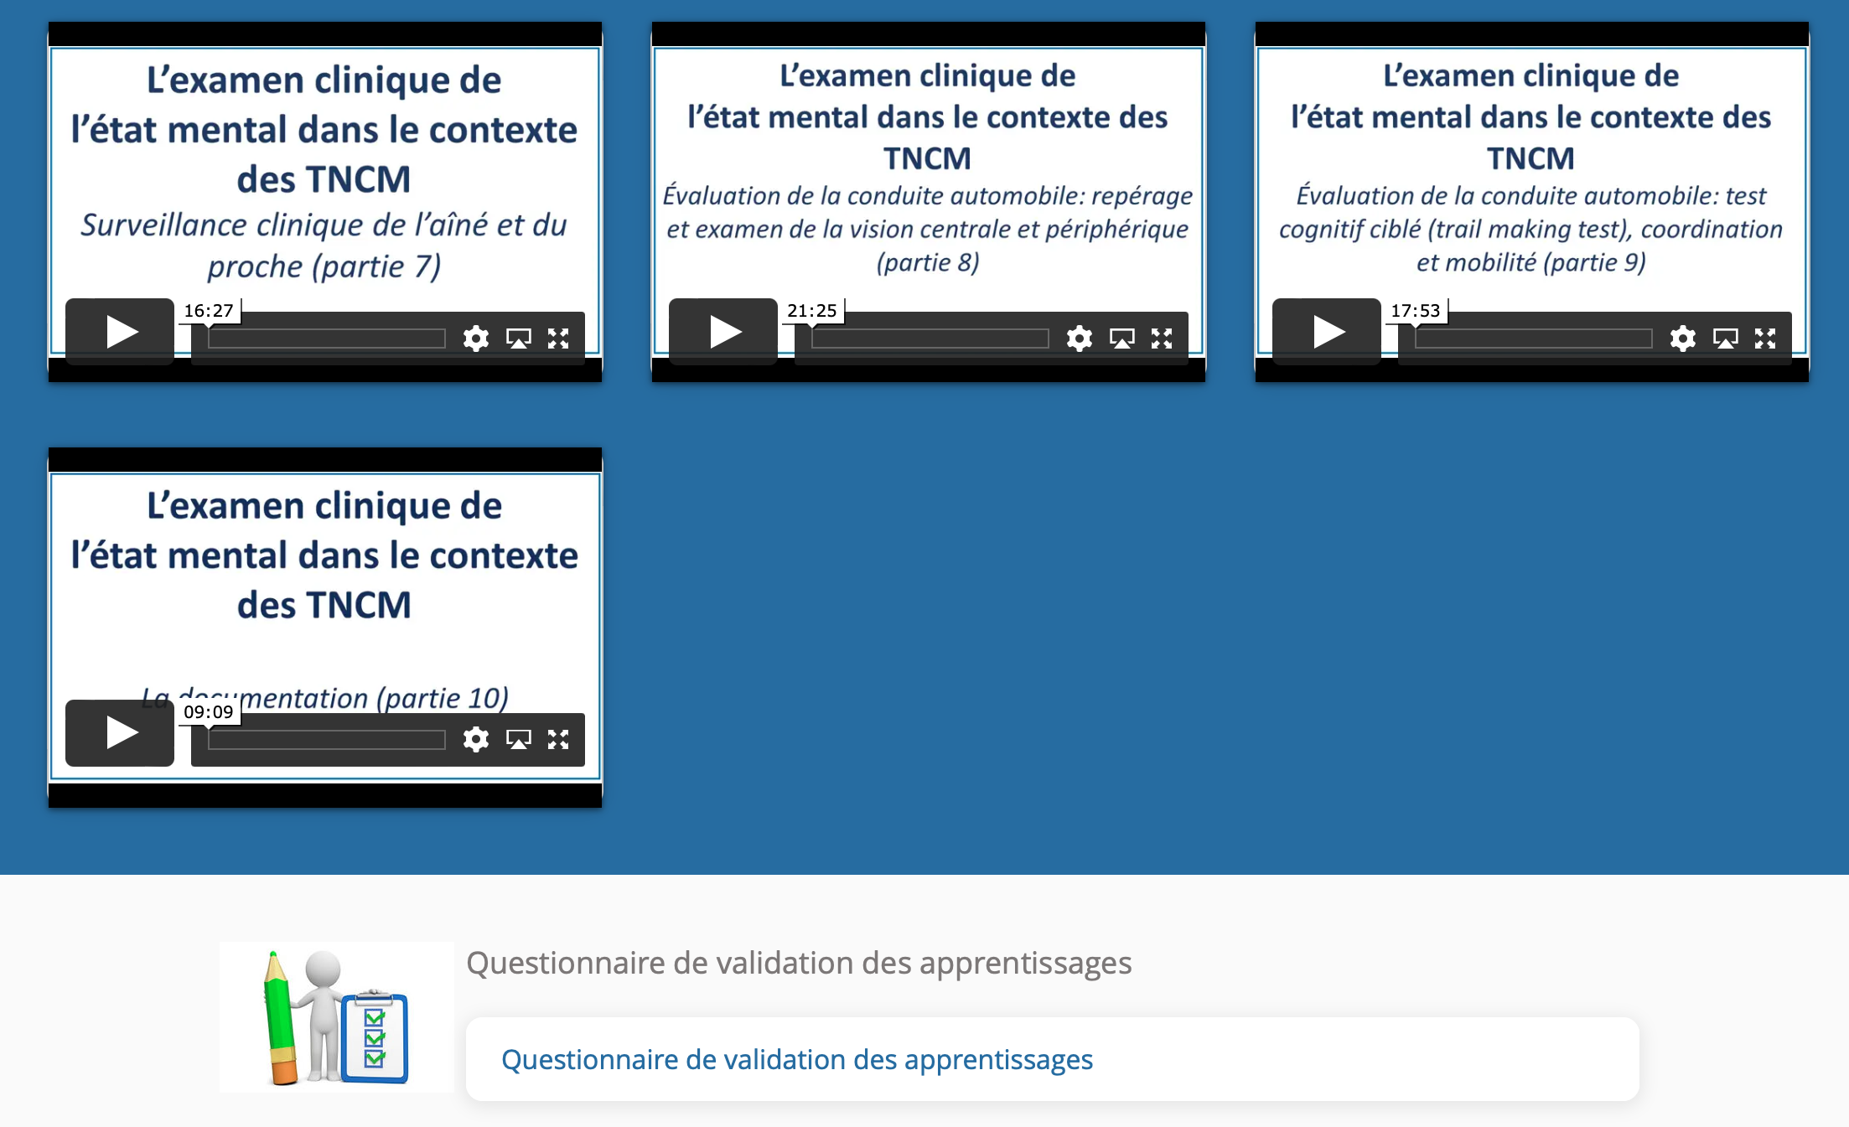

Durée approximative du questionnaire : 25 min.
Date de la réalisation du questionnaire : _________________
Résultat : _________
Signature approbative : ____________________________________________

