Guide de l’apprenant
  - Maladie d’Alzheimer et troubles neurocognitifs majeurs : dépistage, surveillance clinique et interventions à domicile et en GMF (Formation cible- Plan Alzheimer et soins à domicile et GMF)
Tous droits réservés - www.philippevoyer.org

Formation destinée :

au personnel infirmier;

aux travailleurs sociaux;

au membre de l’équipe d’encadrement clinique;

aux autres professionnels de la santé.

Nom : _________________________________________________________
1
Préparation à la formation

Bienvenue à la formation sur le Plan Alzheimer – soins à domicile et GMF !
- Avant de débuter la formation, assurez-vous que vous avez lu récemment un livre de physiopathologie du corps humain, vous permettant d’être en mesure de bien comprendre la formation qui suit.
- Nous vous invitons fortement à suivre la formation dans l’ordre suggéré par le guide de l’apprenant.

2
Vidéo 1

1. Visionnez la première vidéo.
Durée : 24 min 35 sec.
Date de visionnement de la vidéo : _________________
Notes
______________________________________________________________________________________________________________________________________________________________________________________________________________________________________________________________________________________________________________________________________________________________________________________________________________________________________________________________________________________________________________________________________________________________________________________________________________________________________________________________________________________________________________________________________________________________________________________________________________________________________________________________________________________________________________________________________________________________________________________________________________________________________________________________________________________________________________________________________________________________________________________________________________________________________
3
Vidéo 2

1. Visionnez la deuxième vidéo.
Durée : 17 min 53 sec.
Date de visionnement de la vidéo : _________________
Notes
____________________________________________________________________________________________________________________________________________________________________________________________________________________________________________________________________________________________________________________________________________________________________________________________________________________________________________________________________________________________________________________________________________________________________________________________________________________________________________________________________________________________________________________________________________________________________________________________________________________________________________________________________________________________________________________________________________________________________________________________________________________________________________________________

4
Vidéo 3

1. Visionnez la troisième vidéo.
Durée : 21 min 06 sec.
Date de visionnement de la vidéo : _________________
Notes
______________________________________________________________________________________________________________________________________________________________________________________________________________________________________________________________________________________________________________________________________________________________________________________________________________________________________________________________________________________________________________________________________________________________________________________________________________________________________________________________________________________________________________________________________________________________________________________________________________________________________________________________________________________________________________________________________________________________________________________________________________________________________________________________________________________________________________________________________________________________________________________________________________________________________
5
Vidéo 4

1. Visionnez la quatrième vidéo.
Durée : 15 min 49 sec.
Date de visionnement de la vidéo : _________________
Notes
______________________________________________________________________________________________________________________________________________________________________________________________________________________________________________________________________________________________________________________________________________________________________________________________________________________________________________________________________________________________________________________________________________________________________________________________________________________________________________________________________________________________________________________________________________________________________________________________________________________________________________________________________________________________________________________________________________________________________________________________________________________________________________________________________________________________________________________________________________________________________________________________________________________________________
6
Vidéo 5

1. Visionnez la cinquième vidéo.
Durée : 14 min 25 sec.
Date de visionnement de la vidéo : _________________
Notes
______________________________________________________________________________________________________________________________________________________________________________________________________________________________________________________________________________________________________________________________________________________________________________________________________________________________________________________________________________________________________________________________________________________________________________________________________________________________________________________________________________________________________________________________________________________________________________________________________________________________________________________________________________________________________________________________________________________________________________________________________________________________________________________________________________________________________________________________________________________________________________________________________________________________________
7
Vidéo 6

1. Visionnez la sixième vidéo.
Durée : 5 min 23 sec.
Date de visionnement de la vidéo : _________________
Notes
______________________________________________________________________________________________________________________________________________________________________________________________________________________________________________________________________________________________________________________________________________________________________________________________________________________________________________________________________________________________________________________________________________________________________________________________________________________________________________________________________________________________________________________________________________________________________________________________________________________________________________________________________________________________________________________________________________________________________________________________________________________________________________________________________________________________________________________________________________________________________________________________________________________________________
8
Vidéo 7

1. Visionnez la septième vidéo.
Durée : 20 min 40 sec.
Date de visionnement de la vidéo : _________________
Notes
______________________________________________________________________________________________________________________________________________________________________________________________________________________________________________________________________________________________________________________________________________________________________________________________________________________________________________________________________________________________________________________________________________________________________________________________________________________________________________________________________________________________________________________________________________________________________________________________________________________________________________________________________________________________________________________________________________________________________________________________________________________________________________________________________________________________________________________________________________________________________________________________________________________________________
9
Vidéo 8

1. Visionnez la huitième vidéo.
Durée : 31 min 50 sec.
Date de visionnement de la vidéo : _________________
Notes
______________________________________________________________________________________________________________________________________________________________________________________________________________________________________________________________________________________________________________________________________________________________________________________________________________________________________________________________________________________________________________________________________________________________________________________________________________________________________________________________________________________________________________________________________________________________________________________________________________________________________________________________________________________________________________________________________________________________________________________________________________________________________________________________________________________________________________________________________________________________________________________________________________________________________
10
Vidéo 9

1. Visionnez la neuvième vidéo.
Durée : 16 min 22 sec.
Date de visionnement de la vidéo : _________________
Notes
______________________________________________________________________________________________________________________________________________________________________________________________________________________________________________________________________________________________________________________________________________________________________________________________________________________________________________________________________________________________________________________________________________________________________________________________________________________________________________________________________________________________________________________________________________________________________________________________________________________________________________________________________________________________________________________________________________________________________________________________________________________________________________________________________________________________________________________________________________________________________________________________________________________________________
11
Vidéo 10

1. Visionnez la dixième vidéo.
Durée : 20 min 14 sec.
Date de visionnement de la vidéo : _________________
Notes
______________________________________________________________________________________________________________________________________________________________________________________________________________________________________________________________________________________________________________________________________________________________________________________________________________________________________________________________________________________________________________________________________________________________________________________________________________________________________________________________________________________________________________________________________________________________________________________________________________________________________________________________________________________________________________________________________________________________________________________________________________________________________________________________________________________________________________________________________________________________________________________________________________________________________
12
Vidéo 11

1. Visionnez la onzième vidéo.
Durée : 20 min 48 sec.
Date de visionnement de la vidéo : _________________
Notes
______________________________________________________________________________________________________________________________________________________________________________________________________________________________________________________________________________________________________________________________________________________________________________________________________________________________________________________________________________________________________________________________________________________________________________________________________________________________________________________________________________________________________________________________________________________________________________________________________________________________________________________________________________________________________________________________________________________________________________________________________________________________________________________________________________________________________________________________________________________________________________________________________________________________________
13
Vidéo 12

1. Visionnez la douzième vidéo.
Durée : 17 min 51 sec.
Date de visionnement de la vidéo : _________________
Notes
______________________________________________________________________________________________________________________________________________________________________________________________________________________________________________________________________________________________________________________________________________________________________________________________________________________________________________________________________________________________________________________________________________________________________________________________________________________________________________________________________________________________________________________________________________________________________________________________________________________________________________________________________________________________________________________________________________________________________________________________________________________________________________________________________________________________________________________________________________________________________________________________________________________________________
14
Vidéo 13

1. Visionnez la treizième vidéo.
Durée : 18 min 44 sec.
Date de visionnement de la vidéo : _________________
Notes
______________________________________________________________________________________________________________________________________________________________________________________________________________________________________________________________________________________________________________________________________________________________________________________________________________________________________________________________________________________________________________________________________________________________________________________________________________________________________________________________________________________________________________________________________________________________________________________________________________________________________________________________________________________________________________________________________________________________________________________________________________________________________________________________________________________________________________________________________________________________________________________________________________________________________
15
Vidéo 14

1. Visionnez la quatorzième vidéo.
Durée : 15 min 05 sec.
Date de visionnement de la vidéo : _________________
Notes
_________________________________________________________________________________________________________________________________________________________________________________________________________________________________________________________________________________________________________________________________________________________________________________________________________________________________________________________________________________________________________________________________________________________________________________________________________________________________________________________________________________________________________________________________________________________________________________________________________________________________________________________________________________________________________________________________________________________________________________________________________________________________________________________________________________________________________________________________________________
_____________________________________________________________________________________
16
Vidéo 15

1. Visionnez la quinzième vidéo.
Durée : 16 min 34 sec.
Date de visionnement de la vidéo : _________________
Notes
______________________________________________________________________________________________________________________________________________________________________________________________________________________________________________________________________________________________________________________________________________________________________________________________________________________________________________________________________________________________________________________________________________________________________________________________________________________________________________________________________________________________________________________________________________________________________________________________________________________________________________________________________________________________________________________________________________________________________________________________________________________________________________________________________________________________________________________________________________________________________________________________________________________________________
17
Vidéo 16

1. Visionnez la seizième vidéo.
Durée : 21 min 56 sec.
Date de visionnement de la vidéo : _________________
Notes
______________________________________________________________________________________________________________________________________________________________________________________________________________________________________________________________________________________________________________________________________________________________________________________________________________________________________________________________________________________________________________________________________________________________________________________________________________________________________________________________________________________________________________________________________________________________________________________________________________________________________________________________________________________________________________________________________________________________________________________________________________________________________________________________________________________________________________________________________________________________________________________________________________________________________
18
Vidéo 17

1. Visionnez la dix-septième vidéo.
Durée : 23 min 38 sec.
Date de visionnement de la vidéo : _________________
Notes
______________________________________________________________________________________________________________________________________________________________________________________________________________________________________________________________________________________________________________________________________________________________________________________________________________________________________________________________________________________________________________________________________________________________________________________________________________________________________________________________________________________________________________________________________________________________________________________________________________________________________________________________________________________________________________________________________________________________________________________________________________________________________________________________________________________________________________________________________________________________________________________________________________________________________
19
Vidéo 18

1. Visionnez la dix-huitième vidéo.
Durée : 41 min 27 sec.
Date de visionnement de la vidéo : _________________
Notes
______________________________________________________________________________________________________________________________________________________________________________________________________________________________________________________________________________________________________________________________________________________________________________________________________________________________________________________________________________________________________________________________________________________________________________________________________________________________________________________________________________________________________________________________________________________________________________________________________________________________________________________________________________________________________________________________________________________________________________________________________________________________________________________________________________________________________________________________________________________________________________________________________________________________________
20
Vidéo 19

1. Visionnez la dix-neuvième vidéo.
Durée : 24 min 45 sec.
Date de visionnement de la vidéo : _________________
Notes
______________________________________________________________________________________________________________________________________________________________________________________________________________________________________________________________________________________________________________________________________________________________________________________________________________________________________________________________________________________________________________________________________________________________________________________________________________________________________________________________________________________________________________________________________________________________________________________________________________________________________________________________________________________________________________________________________________________________________________________________________________________________________________________________________________________________________________________________________________________________________________________________________________________________________
21
Après la formation

Vous avez terminé de visionner les vidéos de la formation.
1. (Facultatif) Selon les directives de l’organisation, veuillez faire le questionnaire de validation des apprentissages en cliquant sur la rubrique encadrée en rouge.
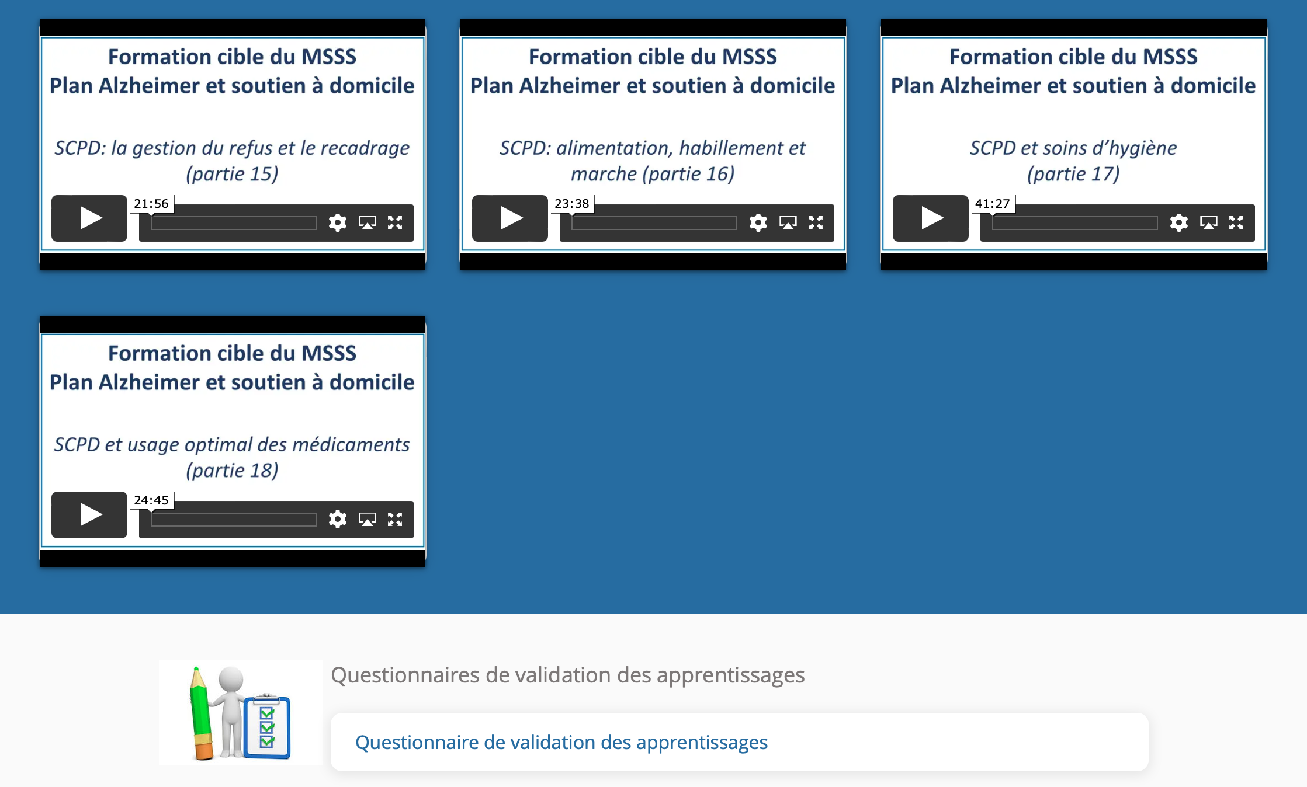

Durée approximative du questionnaire : 25 min.
Date de la réalisation du questionnaire : _________________
Résultat : _________
Signature approbative : ____________________________________________

