Guide de l’apprenant
  - Cheminement d’apprentissage – Personnel infirmier et milieux d’hébergement
Tous droits réservés - www.philippevoyer.org

Année 5

Formation destinée au personnel infirmier des milieux d’hébergement (CHSLD, MDA, RI et RPA)

Nom : _________________________________________________________
Plan de développement des compétences

Au terme de cette cinquième année de formation, vous devrez avoir effectué les formations suivantes :
- Évaluation, intervention et surveillance clinique des signes AINÉES version pour le personnel infirmier et autres professionnels de la santé ;
- Détecter la dépression chez les aînés (administrer l’échelle de dépression gériatrique et l’échelle PHQ-9) ;
- Détecter la dépression chez les aînés atteints de problèmes cognitifs. Administrer l’échelle de dépression en cours d’un trouble neurocognitif majeur (échelle Cornell) ;
- Les besoins sexuels et affectifs : l’enjeu des problèmes cognitifs ;
- L’examen clinique de l’oreille et lavage de l’oreille ;
- Le webinaire-interactif : Maladie d’Alzheimer et les problèmes comportementaux : comprendre pour mieux prévenir ;
- Le webinaire-interactif : L’évaluation et la surveillance clinique de l’aîné ;
- Le mentorat clinique à distance : Les problèmes de comportements et psychologiques liés aux troubles neurocognitifs majeurs.

Préparation aux formations

Bienvenue à ce plan de développement de compétences, destiné au personnel infirmier des milieux d’hébergement (CHSLD, RI, MA, RPA). Ce plan de cheminement contient toutes les formations à réaliser durant la cinquième année d’embauche !
- Avant de débuter les formations, assurez-vous d’avoir lu récemment un livre de physiopathologie du corps humain, vous permettant d’être en mesure de bien comprendre les formations qui suivent.
- Nous vous invitons fortement à suivre les formations dans l’ordre suggéré par le guide de l’apprenant.

Formation #1
Évaluation, intervention et surveillance clinique des signes AINÉES version pour le personnel infirmier et autres professionnels de la santé

Format : Vidéos asynchrones
Durée de la formation : 3 heures 4 minutes

1.1
Vidéo 1

1. Visionnez la première vidéo.
Durée : 25 min 49 sec.
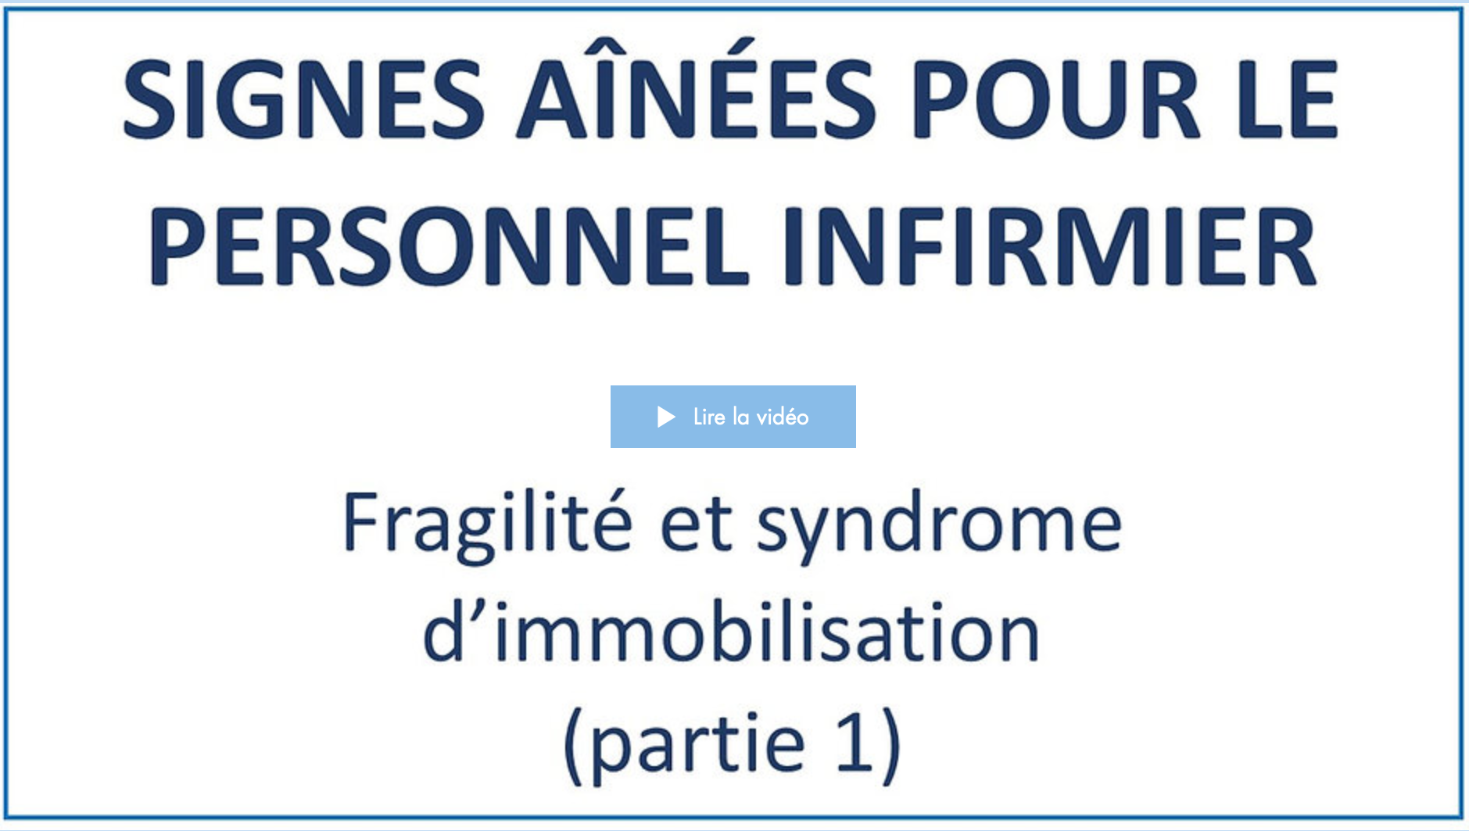
Date de visionnement de la vidéo : _________________
Notes
______________________________________________________________________________________________________________________________________________________________________________________________________________________________________________________________________________________________________________________________________________________________________________________________________________________________________________________________________________________________________________________________________________________________________________________________________________________________________________________________________________________________________________________________________________________________________________________________________________________________________________________________________________________________________________________________________________________________________________________________________________________________________________________________________________________________________________________________________________________________________________________________________________________________________
1.2
Vidéo 2

1. Visionnez la deuxième vidéo.
Durée : 33 min 52 sec.
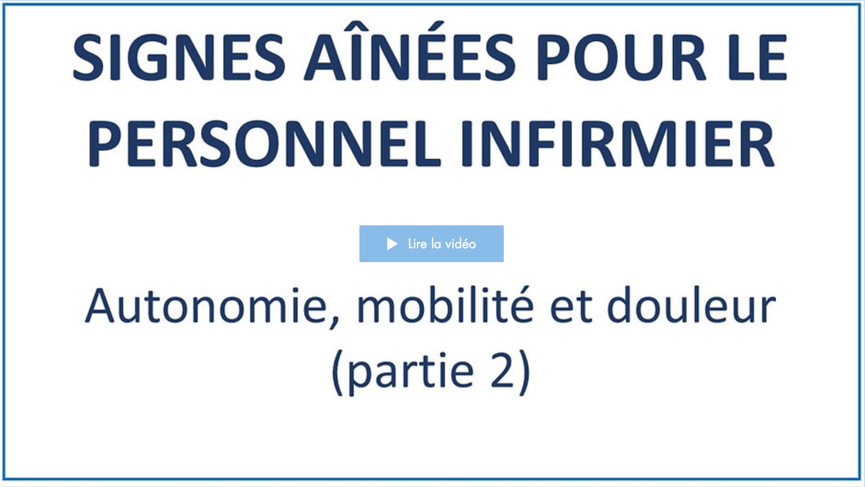
Date de visionnement de la vidéo : _________________
Notes
______________________________________________________________________________________________________________________________________________________________________________________________________________________________________________________________________________________________________________________________________________________________________________________________________________________________________________________________________________________________________________________________________________________________________________________________________________________________________________________________________________________________________________________________________________________________________________________________________________________________________________________________________________________________________________________________________________________________________________________________________________________________________________________________________________________________________________________________________________________________________________________________________________________________________
1.3
Vidéo 3

1. Visionnez la troisième vidéo.
Durée : 27 min 41 sec.
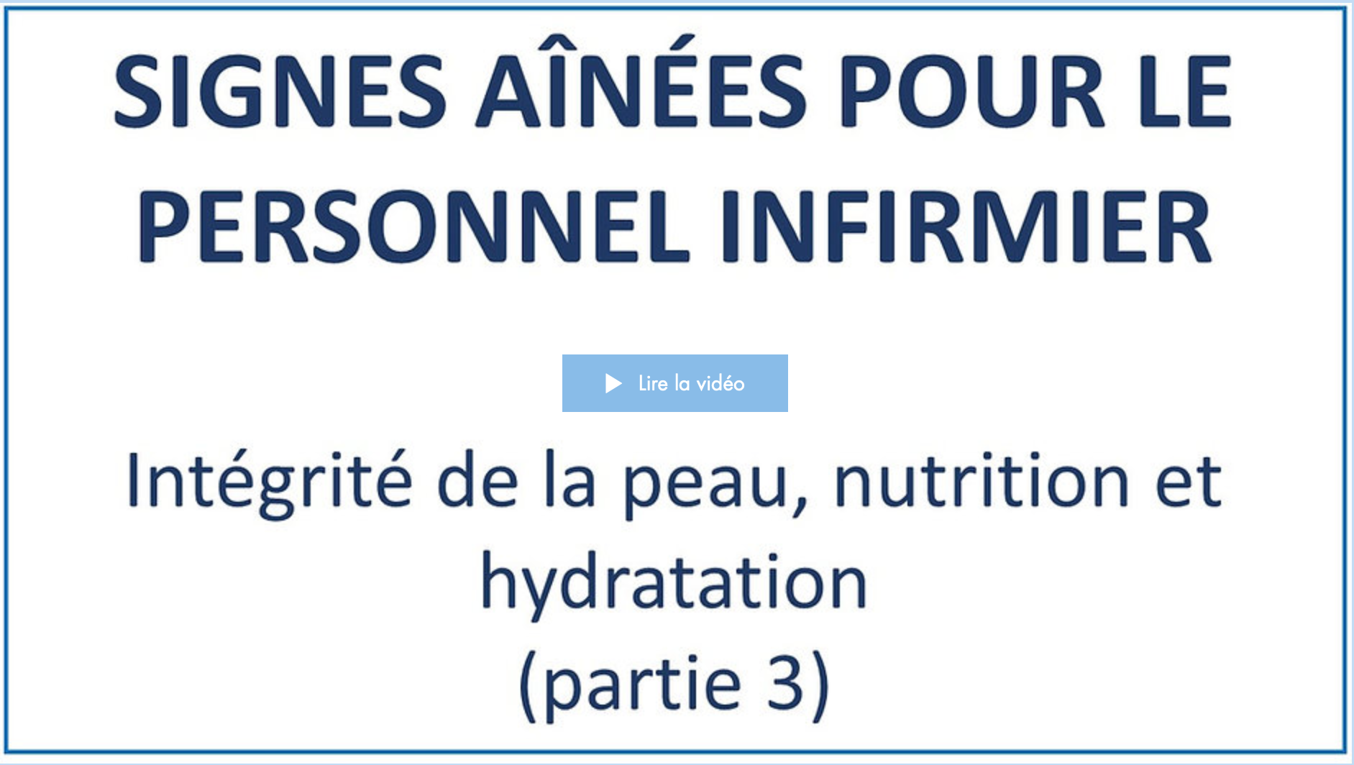
Date de visionnement de la vidéo : _________________
Notes
______________________________________________________________________________________________________________________________________________________________________________________________________________________________________________________________________________________________________________________________________________________________________________________________________________________________________________________________________________________________________________________________________________________________________________________________________________________________________________________________________________________________________________________________________________________________________________________________________________________________________________________________________________________________________________________________________________________________________________________________________________________________________________________________________________________________________________________________________________________________________________________________________________________________________
1.4
Vidéo 4

1. Visionnez la quatrième vidéo.
Durée : 30 min 11 sec.
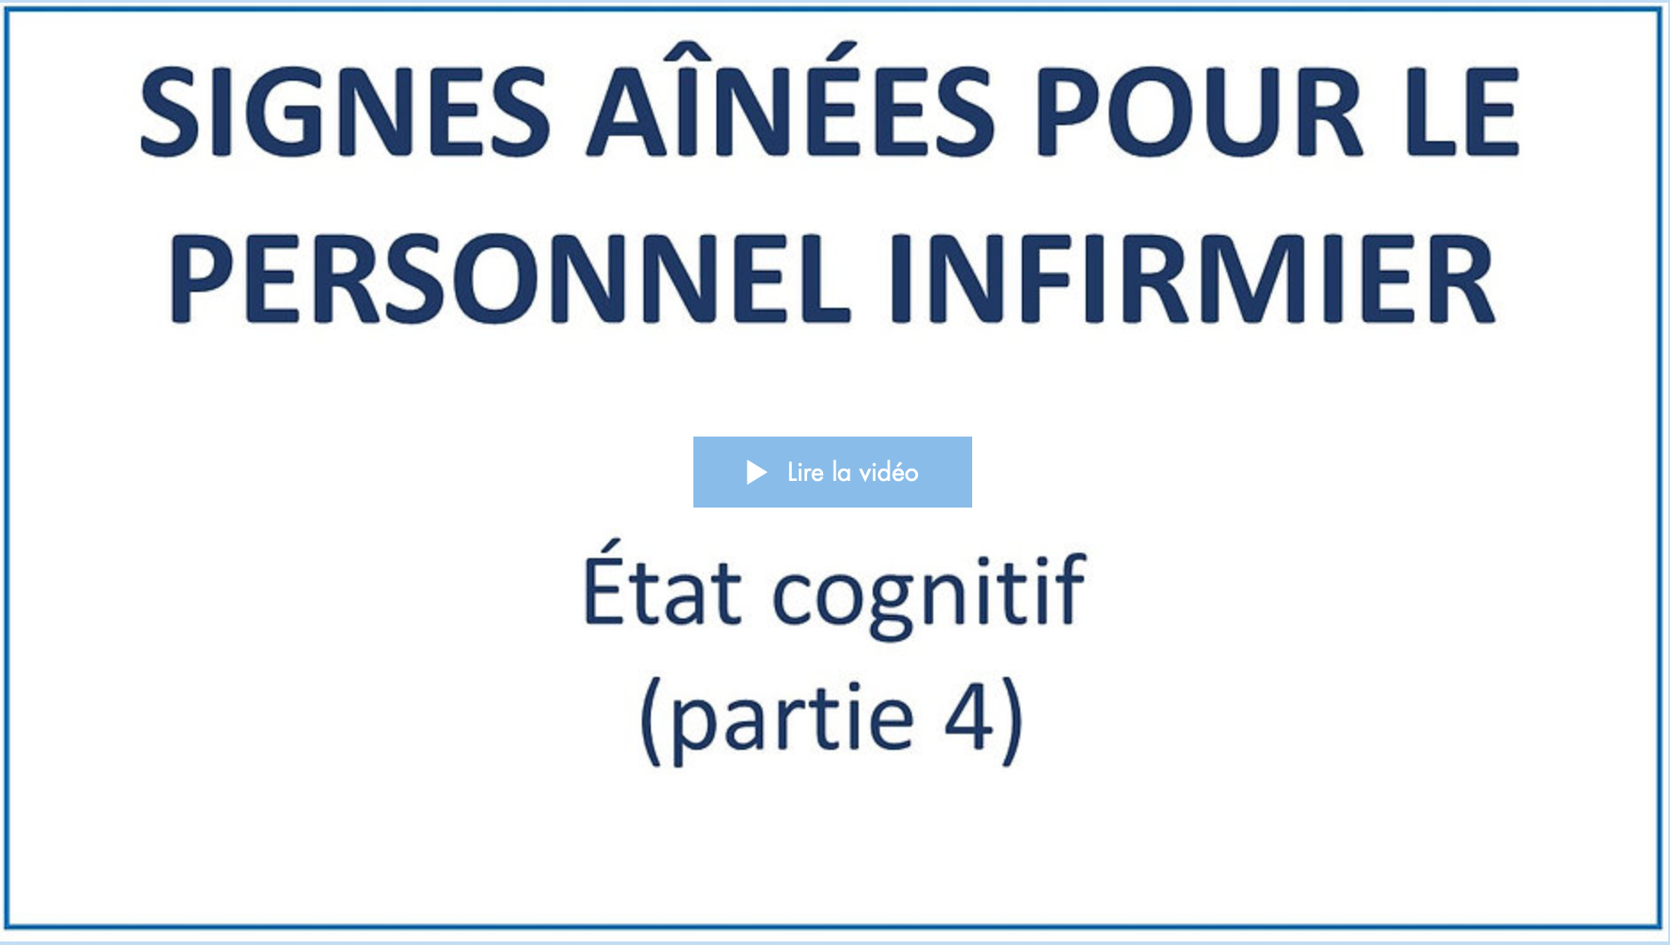
Date de visionnement de la vidéo : _________________
Notes
______________________________________________________________________________________________________________________________________________________________________________________________________________________________________________________________________________________________________________________________________________________________________________________________________________________________________________________________________________________________________________________________________________________________________________________________________________________________________________________________________________________________________________________________________________________________________________________________________________________________________________________________________________________________________________________________________________________________________________________________________________________________________________________________________________________________________________________________________________________________________________________________________________________________________
1.5
Vidéo 5

1. Visionnez la cinquième vidéo.
Durée : 37 min 35 sec.
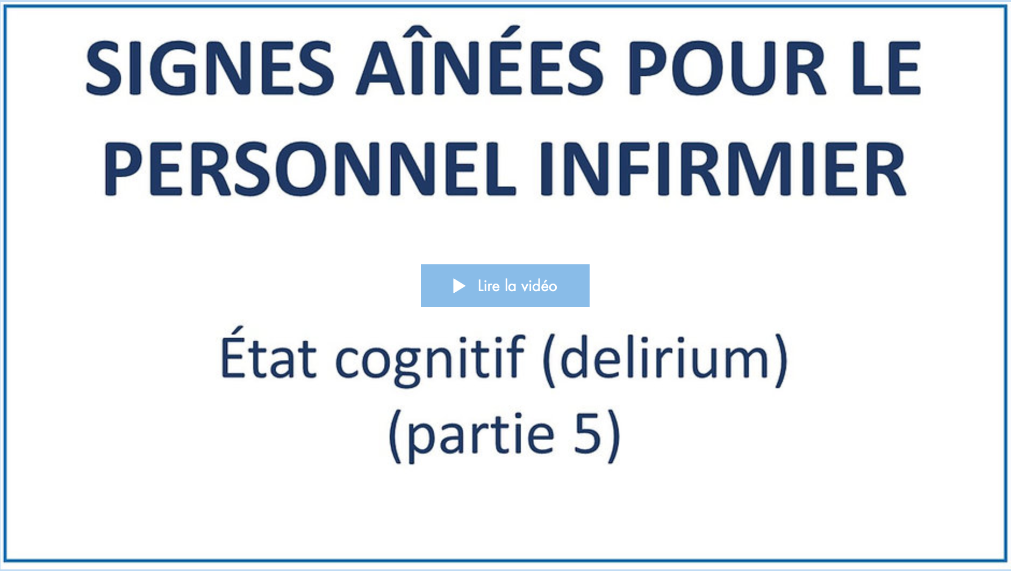
Date de visionnement de la vidéo : _________________
Notes
______________________________________________________________________________________________________________________________________________________________________________________________________________________________________________________________________________________________________________________________________________________________________________________________________________________________________________________________________________________________________________________________________________________________________________________________________________________________________________________________________________________________________________________________________________________________________________________________________________________________________________________________________________________________________________________________________________________________________________________________________________________________________________________________________________________________________________________________________________________________________________________________________________________________________
1.6
Vidéo 6

1. Visionnez la sixième vidéo.
Durée : 28 min 11 sec.
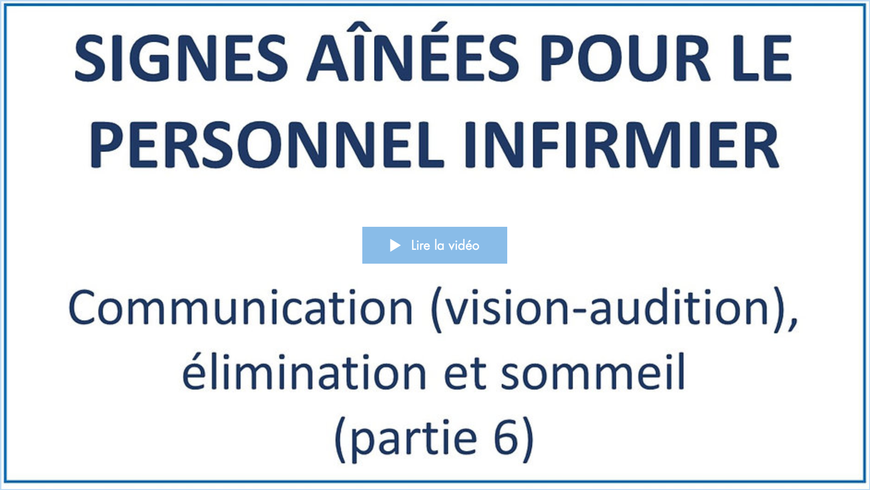
Date de visionnement de la vidéo : _________________
Notes
______________________________________________________________________________________________________________________________________________________________________________________________________________________________________________________________________________________________________________________________________________________________________________________________________________________________________________________________________________________________________________________________________________________________________________________________________________________________________________________________________________________________________________________________________________________________________________________________________________________________________________________________________________________________________________________________________________________________________________________________________________________________________________________________________________________________________________________________________________________________________________________________________________________________________
Validation des apprentissages

Vous avez terminé de visionner les vidéos de la formation.
1. (Facultatif) Selon les directives de votre organisation, veuillez faire le questionnaire de validation des apprentissages en cliquant sur la rubrique encadrée en rouge.
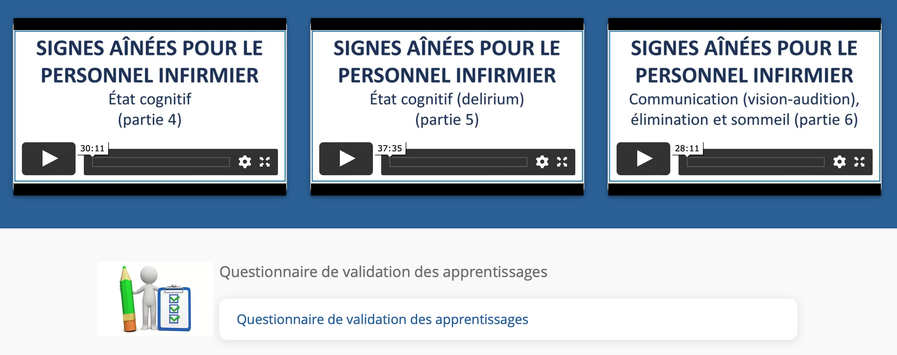
Durée approximative du questionnaire : 25 min.
Date de la réalisation du questionnaire : _________________
Résultat : _________
Signature approbative : ____________________________________________

Formation #2
Détecter la dépression chez les aînés (administrer l’échelle de dépression gériatrique et l’échelle PHQ-9)

Format : Vidéos asynchrones
Durée de la formation : 33 minutes

2.1
Vidéo 1

1. Visionnez la première vidéo.
Durée : 32 min 33 sec.
Date de visionnement de la vidéo : _________________
Notes
______________________________________________________________________________________________________________________________________________________________________________________________________________________________________________________________________________________________________________________________________________________________________________________________________________________________________________________________________________________________________________________________________________________________________________________________________________________________________________________________________________________________________________________________________________________________________________________________________________________________________________________________________________________________________________________________________________________________________________________________________________________________________________________________________________________________________________________________________________________________________________________________________________________________________
Formation #3
Détecter la dépression chez les aînés atteints de problèmes cognitifs. Administrer l’échelle de dépression en cours d’un trouble neurocognitif majeur (échelle Cornell)

Format : Vidéos asynchrones
Durée de la formation : 25 minutes

3.1
Vidéo 1

1. Visionnez la première vidéo.
Durée : 24 min 30 sec.
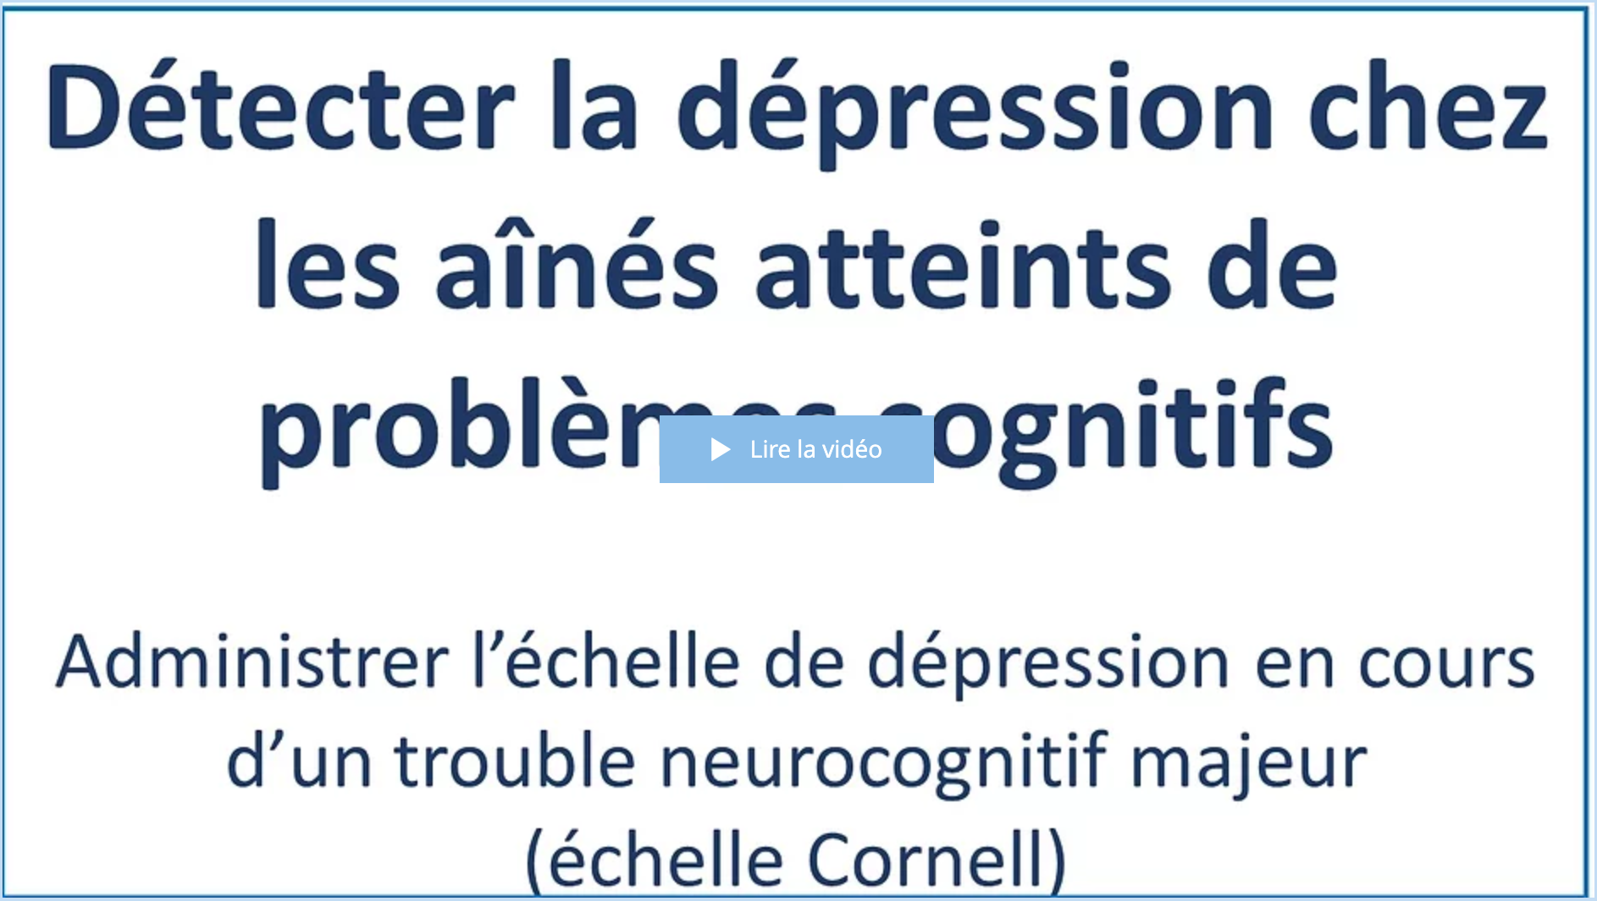
Date de visionnement de la vidéo : _________________
Notes
______________________________________________________________________________________________________________________________________________________________________________________________________________________________________________________________________________________________________________________________________________________________________________________________________________________________________________________________________________________________________________________________________________________________________________________________________________________________________________________________________________________________________________________________________________________________________________________________________________________________________________________________________________________________________________________________________________________________________________________________________________________________________________________________________________________________________________________________________________________________________________________________________________________________________
Formation #4
Les besoins sexuels et affectifs : l’enjeu des problèmes cognitifs

Format : Vidéos asynchrones
Durée de la formation : 40 minutes

4.1
Vidéo 1

1. Visionnez la première vidéo.
Durée : 18 min 06 sec.
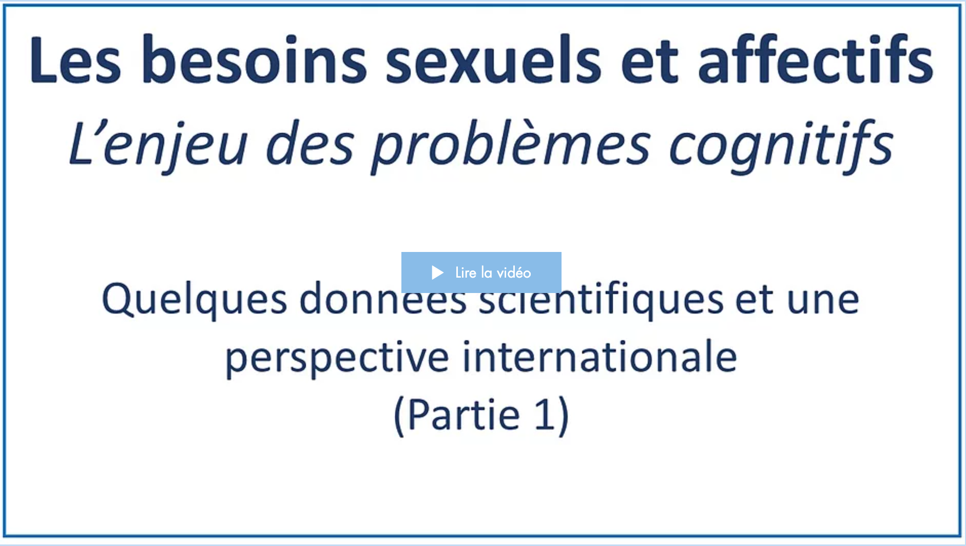
Date de visionnement de la vidéo : _________________
Notes
______________________________________________________________________________________________________________________________________________________________________________________________________________________________________________________________________________________________________________________________________________________________________________________________________________________________________________________________________________________________________________________________________________________________________________________________________________________________________________________________________________________________________________________________________________________________________________________________________________________________________________________________________________________________________________________________________________________________________________________________________________________________________________________________________________________________________________________________________________________________________________________________________________________________________
4.2
Vidéo 2

1. Visionnez la deuxième vidéo.
Durée : 22 min 23 sec.
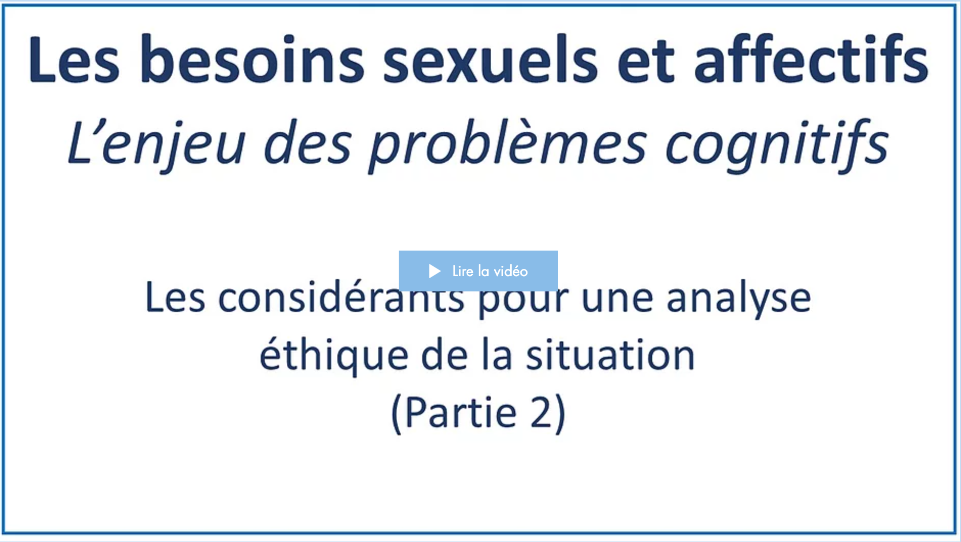
Date de visionnement de la vidéo : _________________
Notes
______________________________________________________________________________________________________________________________________________________________________________________________________________________________________________________________________________________________________________________________________________________________________________________________________________________________________________________________________________________________________________________________________________________________________________________________________________________________________________________________________________________________________________________________________________________________________________________________________________________________________________________________________________________________________________________________________________________________________________________________________________________________________________________________________________________________________________________________________________________________________________________________________________________________________
Formation #5
L’examen clinique de l’oreille et lavage de l’oreille

Format : Vidéos asynchrones
Durée de la formation : 21 minutes

5.1
Vidéo 1

1. Visionnez la première vidéo.
Durée : 21 min 24 sec.
Date de visionnement de la vidéo : _________________
Notes
______________________________________________________________________________________________________________________________________________________________________________________________________________________________________________________________________________________________________________________________________________________________________________________________________________________________________________________________________________________________________________________________________________________________________________________________________________________________________________________________________________________________________________________________________________________________________________________________________________________________________________________________________________________________________________________________________________________________________________________________________________________________________________________________________________________________________________________________________________________________________________________________________________________________________
Formation #6
Maladie d’Alzheimer et les problèmes comportementaux : comprendre pour mieux prévenir

Format : Webinaires-interactifs - Virtuelles synchrones
Durée de la formation : 60 minutes

Webinaire-interactif

1. Le moment venu, participez au webinaire-interactif.
Date de participation du webinaire-interactif : _____________________

Notes
__________________________________________________________________________________________________________________________________________________________________________________________________________________________________________________________________________________________________________________________________________________________________________________________________________________________________________________________________________________________________________________________________________________________________________________________________________________________________________________________________________________________________________________________________________________________________________________________________________________________________________________________________________________________________________________________________________________________________________________________________________________________________________________________________________________________________________________________________________________________________________________________________________________________________________________________________________________________________________________________________________________________________________________________________________________________________________________________________________________________________________________________________________________________________________________________________________________________________________________________________________________________________________________________________________________________________________________________________________________________________________________________________________________________________________________________________________________________________________________________________________________________________________________________________________________________________________________________________________________________________________________________________________________________________________________________________________________________________
Formation #7
L’évaluation et la surveillance clinique de l’aîné

Format : Webinaires-interactifs - Virtuelles synchrones
Durée de la formation : 60 minutes

Webinaire-interactif

1. Le moment venu, participez au webinaire-interactif.
Date de participation au webinaire-interactif : _____________________

Notes
__________________________________________________________________________________________________________________________________________________________________________________________________________________________________________________________________________________________________________________________________________________________________________________________________________________________________________________________________________________________________________________________________________________________________________________________________________________________________________________________________________________________________________________________________________________________________________________________________________________________________________________________________________________________________________________________________________________________________________________________________________________________________________________________________________________________________________________________________________________________________________________________________________________________________________________________________________________________________________________________________________________________________________________________________________________________________________________________________________________________________________________________________________________________________________________________________________________________________________________________________________________________________________________________________________________________________________________________________________________________________________________________________________________________________________________________________________________________________________________________________________________________________________________________________________________________________________________________________________________________________________________________________________________________________________________________________________________________________
Formation #8
Le mentorat clinique à distance : Les problèmes de comportements et psychologiques liés aux troubles neurocognitifs majeurs

Format : Webinaires-interactifs - Virtuelles synchrones
Durée de la formation : 60 minutes

Mentorat clinique

1. Le moment venu, participez au mentorat clinique.
Date de participation au mentorat clinique : _____________________

Notes
__________________________________________________________________________________________________________________________________________________________________________________________________________________________________________________________________________________________________________________________________________________________________________________________________________________________________________________________________________________________________________________________________________________________________________________________________________________________________________________________________________________________________________________________________________________________________________________________________________________________________________________________________________________________________________________________________________________________________________________________________________________________________________________________________________________________________________________________________________________________________________________________________________________________________________________________________________________________________________________________________________________________________________________________________________________________________________________________________________________________________________________________________________________________________________________________________________________________________________________________________________________________________________________________________________________________________________________________________________________________________________________________________________________________________________________________________________________________________________________________________________________________________________________________________________________________________________________________________________________________________________________________________________________________________________________________________________________________________
Cheminement d’apprentissage – Personnel infirmier et milieux d’hébergement

Félicitations ! Vous avez complété le plan de développement des compétences prévu à la cinquième année d’embauche.
Maintenant, il ne vous reste plus qu’à mettre en application vos apprentissages auprès des résidents !

