Guide de l’apprenant
  - Cheminement d’apprentissage – Personnel infirmier et milieux d’hébergement
Tous droits réservés - www.philippevoyer.org

Année 4

Formation destinée au personnel infirmier des milieux d’hébergement (CHSLD, MDA, RI et RPA)

Nom : _________________________________________________________
Plan de développement des compétences

Au terme de cette quatrième année de formation, vous devrez avoir effectué les formations suivantes :
- Le delirium : le prévenir, le détecter et le traiter ;
- La relation entre le poids, le vieillissement normal et les troubles neurocognitifs majeurs ;
- L’impact d’une transition sur l’aîné atteint de problèmes cognitifs : mieux comprendre pour en atténuer les effets potentiellement négatifs ;
- Détection et surveillance clinique de la douleur chez les aînés atteints de TNCM ;
- Le webinaire-interactif : Maladie d’Alzheimer et les problèmes comportementaux : comprendre pour mieux prévenir ;
- Le webinaire-interactif : L’évaluation et la surveillance clinique de l’aîné ;
- Le mentorat clinique à distance : Les problèmes comportementaux et psychologiques liés aux troubles neurocognitifs majeurs.

Préparation aux formations

Bienvenue à ce plan de développement de compétences, destiné au personnel infirmier des milieux d’hébergement (CHSLD, RI, MA, RPA). Ce plan de cheminement contient toutes les formations à réaliser durant la quatrième année d’embauche !
- Avant de débuter les formations, assurez-vous d’avoir lu récemment un livre de physiopathologie du corps humain, vous permettant d’être en mesure de bien comprendre les formations qui suivent.
- Nous vous invitons fortement à suivre les formations dans l’ordre suggéré par le guide de l’apprenant.

Formation #1
Le delirium : le prévenir, le détecter et le traiter

Format : Vidéos asynchrones
Durée de la formation : 2 heures 47 minutes

1.1
Vidéo 1

1. Visionnez la première vidéo.
Durée : 24 min 54 sec.
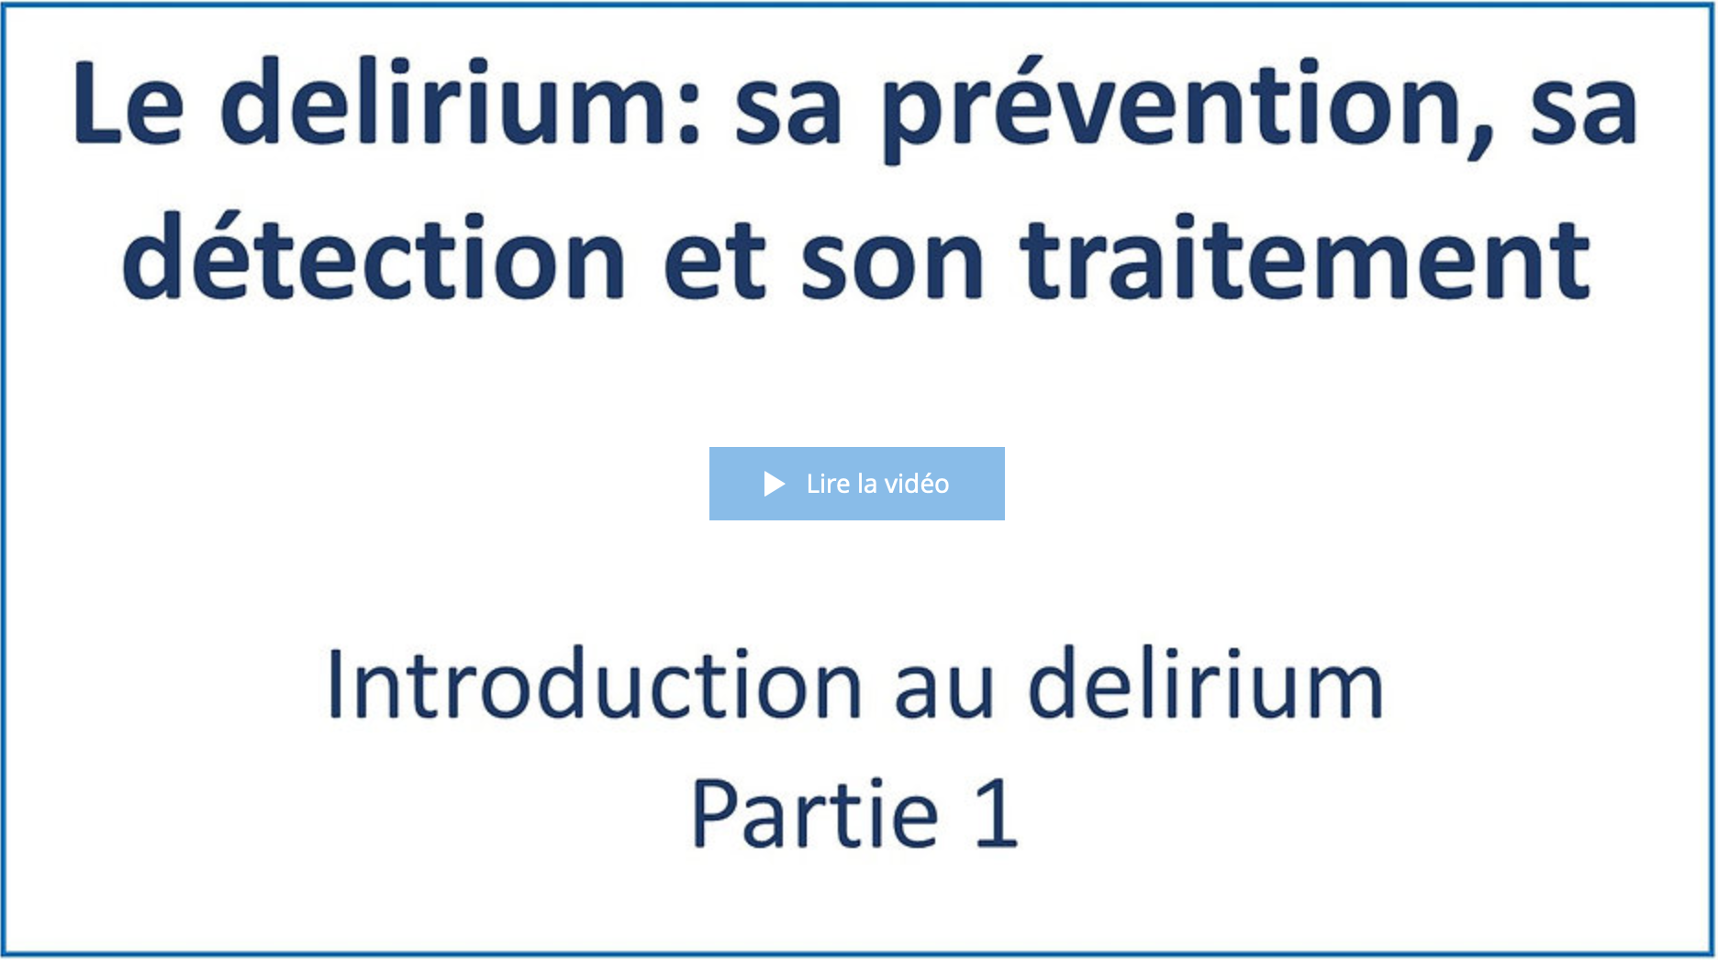
Date de visionnement de la vidéo : _________________
Notes
______________________________________________________________________________________________________________________________________________________________________________________________________________________________________________________________________________________________________________________________________________________________________________________________________________________________________________________________________________________________________________________________________________________________________________________________________________________________________________________________________________________________________________________________________________________________________________________________________________________________________________________________________________________________________________________________________________________________________________________________________________________________________________________________________________________________________________________________________________________________________________________________________________________________________

1.2
Vidéo 2

1. Visionnez la deuxième vidéo.
Durée : 15 min 59 sec.
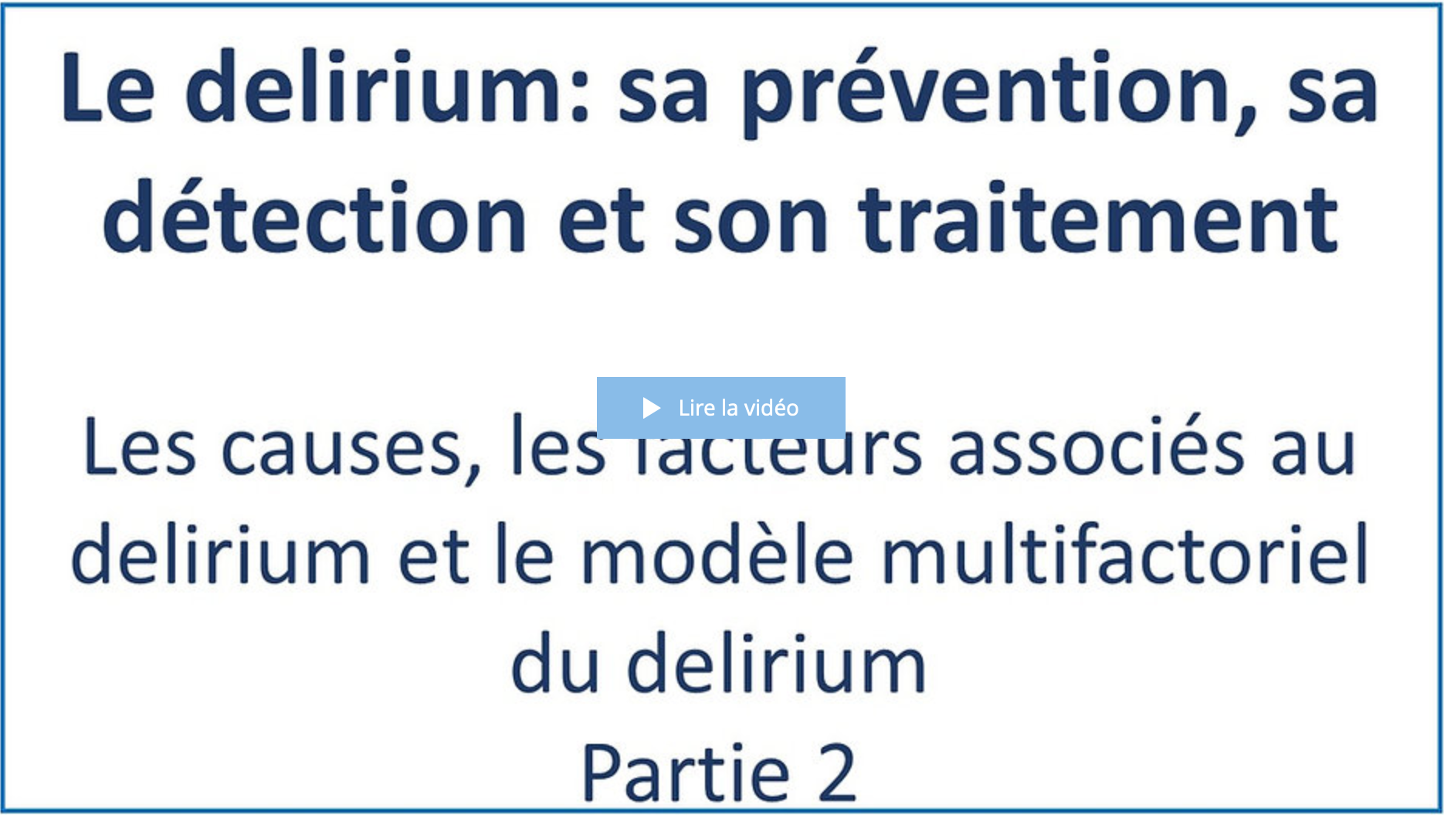
Date de visionnement de la vidéo : _________________
Notes
______________________________________________________________________________________________________________________________________________________________________________________________________________________________________________________________________________________________________________________________________________________________________________________________________________________________________________________________________________________________________________________________________________________________________________________________________________________________________________________________________________________________________________________________________________________________________________________________________________________________________________________________________________________________________________________________________________________________________________________________________________________________________________________________________________________________________________________________________________________________________________________________________________________________________
1.3
Vidéo 3

1. Visionnez la troisième vidéo.
Durée : 14 min 10 sec.
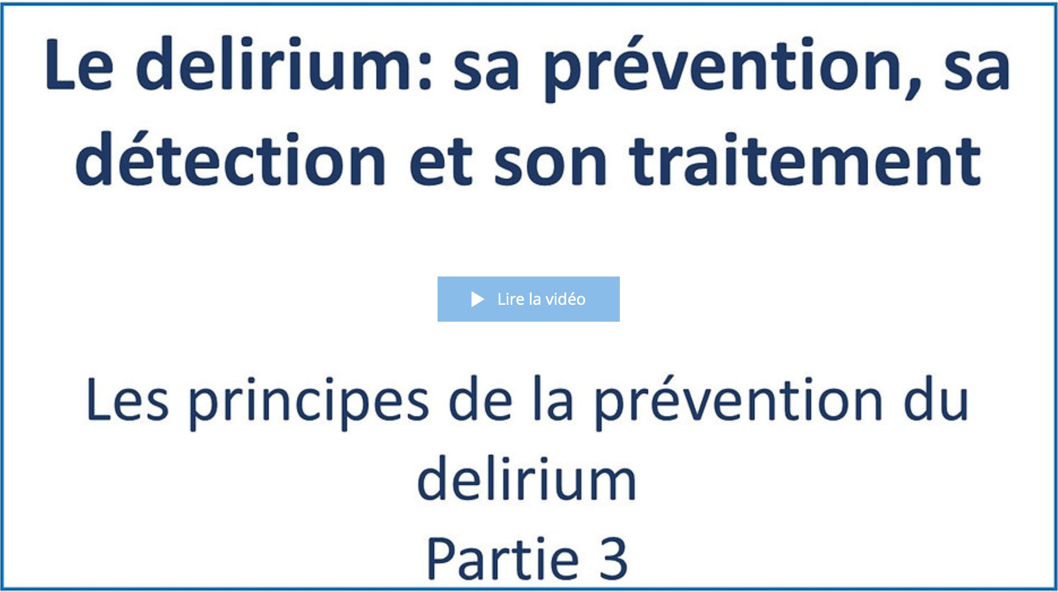
Date de visionnement de la vidéo : _________________
Notes
______________________________________________________________________________________________________________________________________________________________________________________________________________________________________________________________________________________________________________________________________________________________________________________________________________________________________________________________________________________________________________________________________________________________________________________________________________________________________________________________________________________________________________________________________________________________________________________________________________________________________________________________________________________________________________________________________________________________________________________________________________________________________________________________________________________________________________________________________________________________________________________________________________________________________

1.4
Vidéo 4

1. Visionnez la quatrième vidéo.
Durée : 13 min 55 sec.
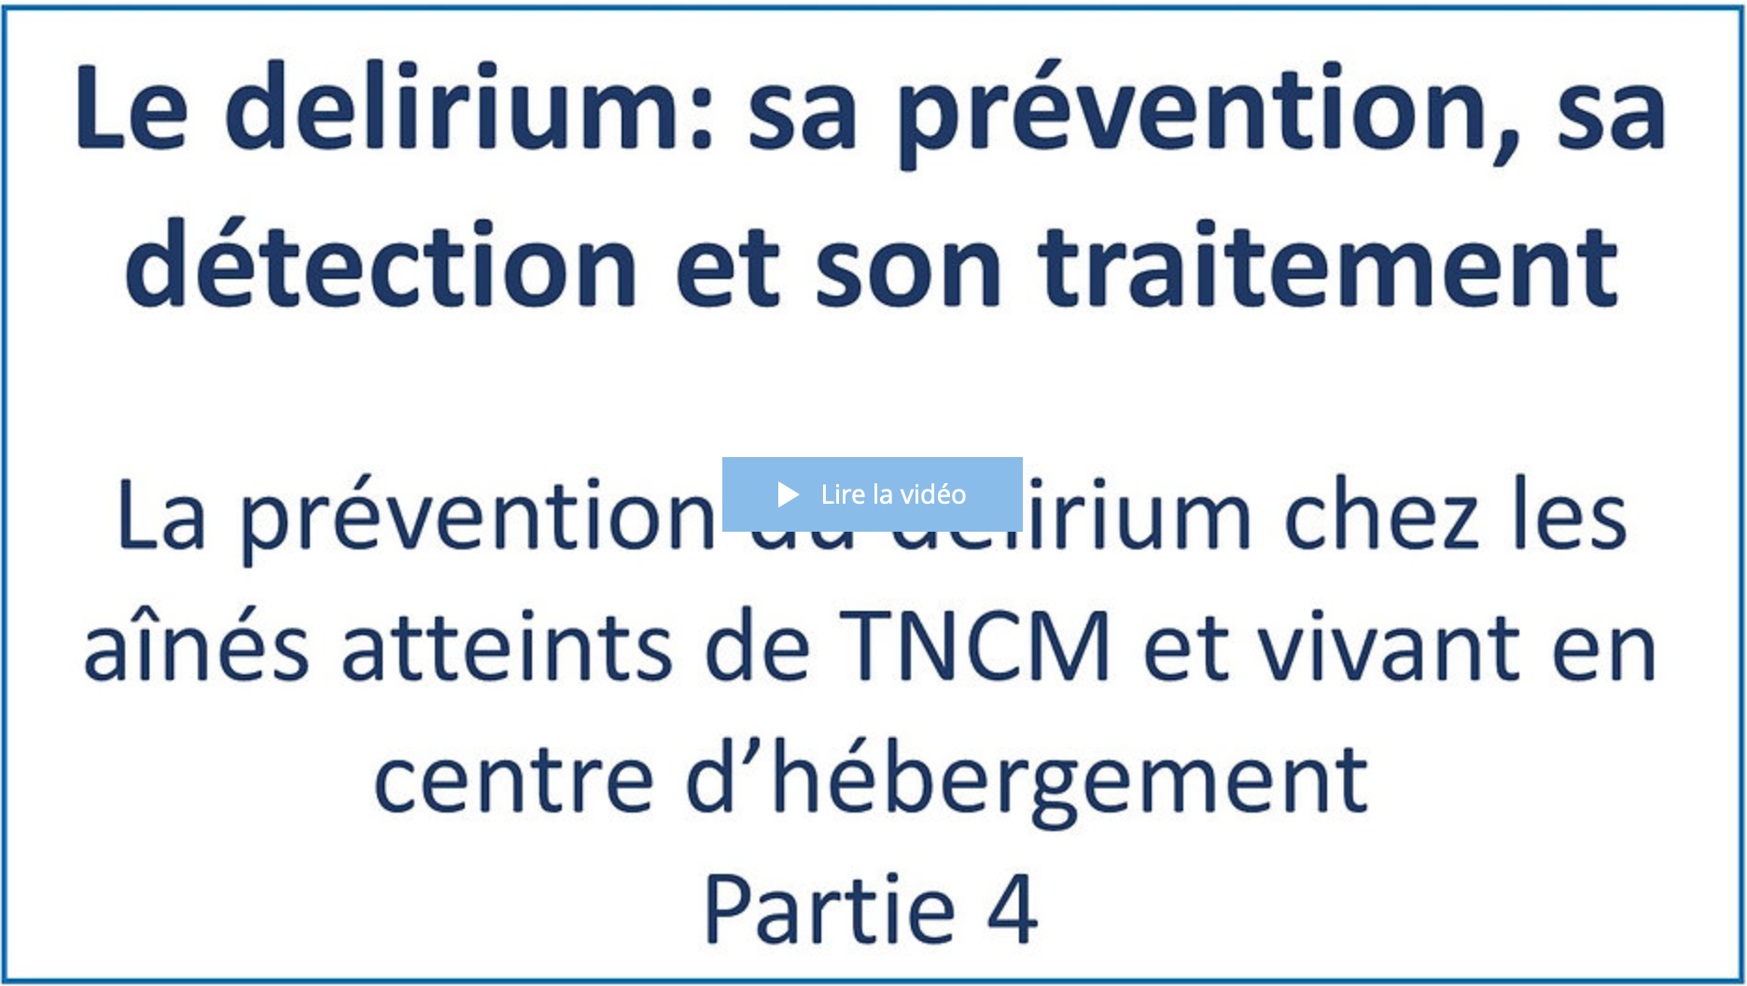
Date de visionnement de la vidéo : _________________
Notes
______________________________________________________________________________________________________________________________________________________________________________________________________________________________________________________________________________________________________________________________________________________________________________________________________________________________________________________________________________________________________________________________________________________________________________________________________________________________________________________________________________________________________________________________________________________________________________________________________________________________________________________________________________________________________________________________________________________________________________________________________________________________________________________________________________________________________________________________________________________________________________________________________________________________________
1.5
Vidéo 5

1. Visionnez la cinquième vidéo.
Durée : 18 min 20 sec.
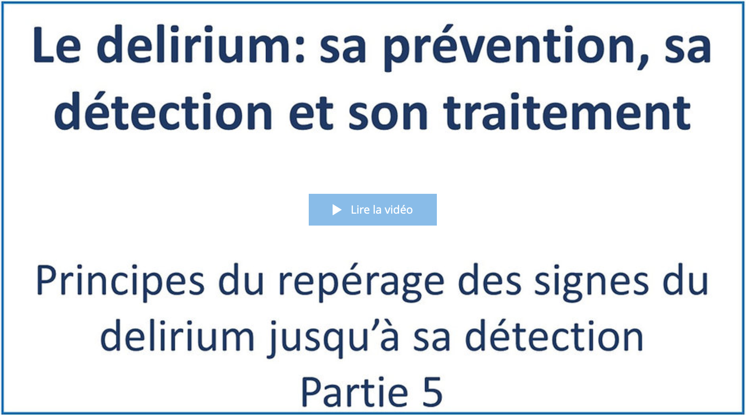
Date de visionnement de la vidéo : _________________
Notes
_________________________________________________________________________________________________________________________________________________________________________________________________________________________________________________________________________________________________________________________________________________________________________________________________________________________________________________________________________________________________________________________________________________________________________________________________________________________________________________________________________________________________________________________________________________________________________________________________________________________________________________________________________________________________________________________________________________________________________________________________________________________________________________________________________________________________________________________________________________
_____________________________________________________________________________________
1.6
Vidéo 6

1. Visionnez la sixième vidéo.
Durée : 27 min 07 sec.
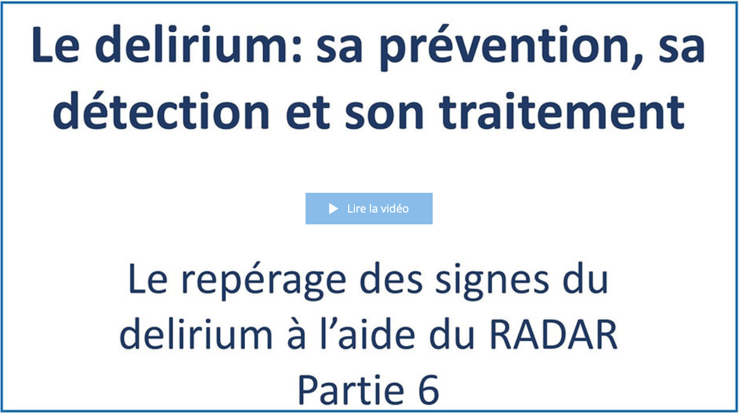
Date de visionnement de la vidéo : _________________
Notes
______________________________________________________________________________________________________________________________________________________________________________________________________________________________________________________________________________________________________________________________________________________________________________________________________________________________________________________________________________________________________________________________________________________________________________________________________________________________________________________________________________________________________________________________________________________________________________________________________________________________________________________________________________________________________________________________________________________________________________________________________________________________________________________________________________________________________________________________________________________________________________________________________________________________________

1.7
Vidéo 7

1. Visionnez la septième vidéo.
Durée : 8 min 52 sec.
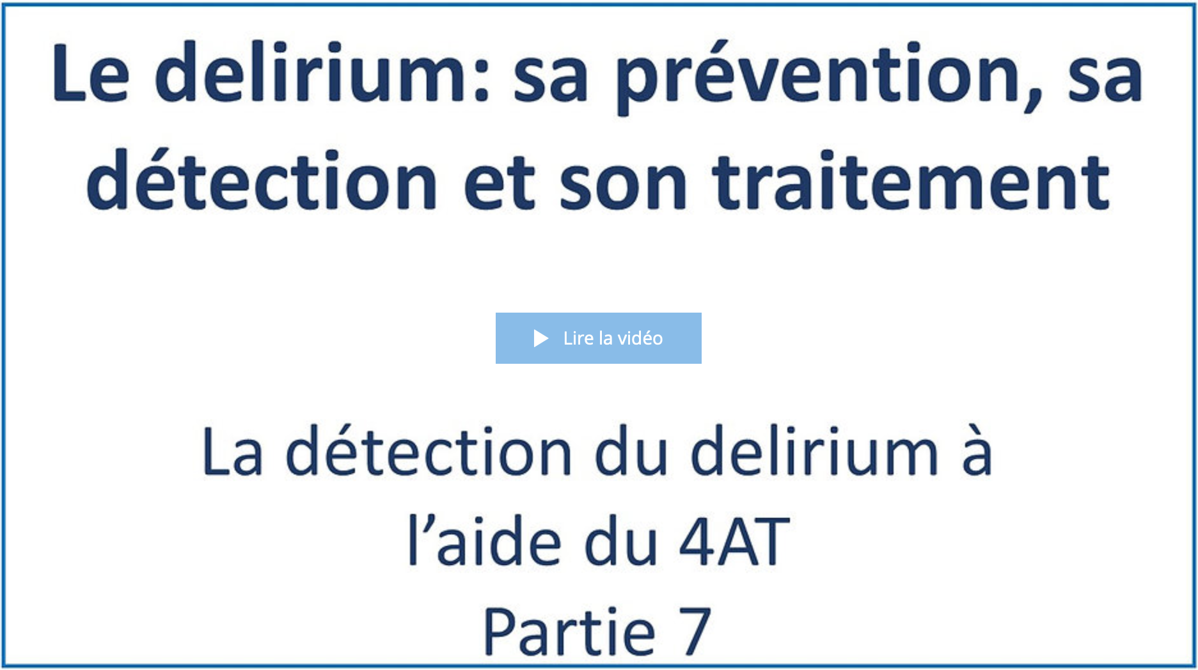
Date de visionnement de la vidéo : _________________
Notes
______________________________________________________________________________________________________________________________________________________________________________________________________________________________________________________________________________________________________________________________________________________________________________________________________________________________________________________________________________________________________________________________________________________________________________________________________________________________________________________________________________________________________________________________________________________________________________________________________________________________________________________________________________________________________________________________________________________________________________________________________________________________________________________________________________________________________________________________________________________________________________________________________________________________________

1.8
Vidéo 8

1. Visionnez la huitième vidéo.
Durée : 28 min 58 sec.
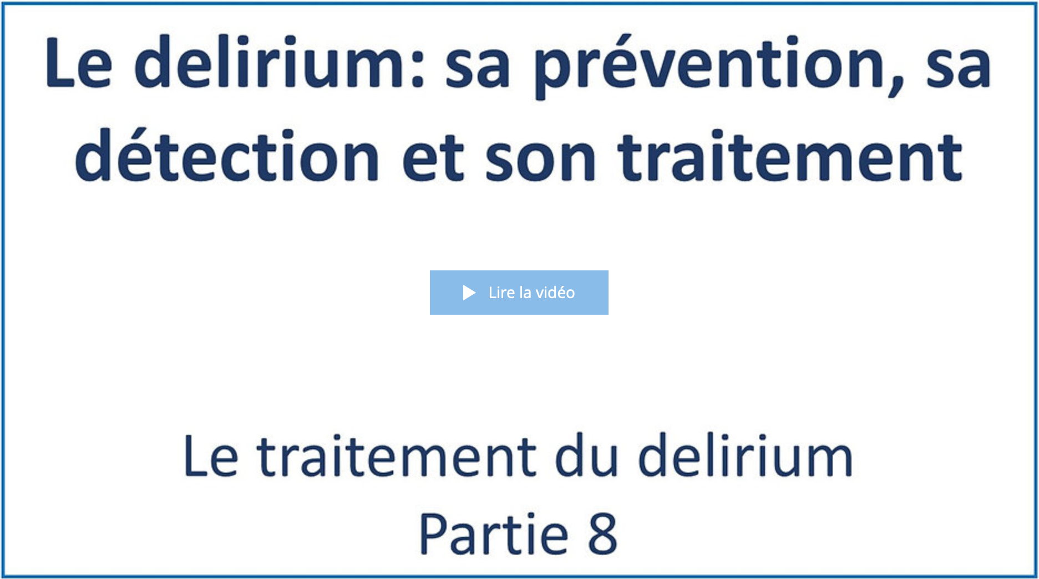
Date de visionnement de la vidéo : _________________
Notes
______________________________________________________________________________________________________________________________________________________________________________________________________________________________________________________________________________________________________________________________________________________________________________________________________________________________________________________________________________________________________________________________________________________________________________________________________________________________________________________________________________________________________________________________________________________________________________________________________________________________________________________________________________________________________________________________________________________________________________________________________________________________________________________________________________________________________________________________________________________________________________________________________________________________________
_____________________________________________________________________________________
1.9
Vidéo 9

1. Visionnez la neuvième vidéo.
Durée : 14 min 32 sec.
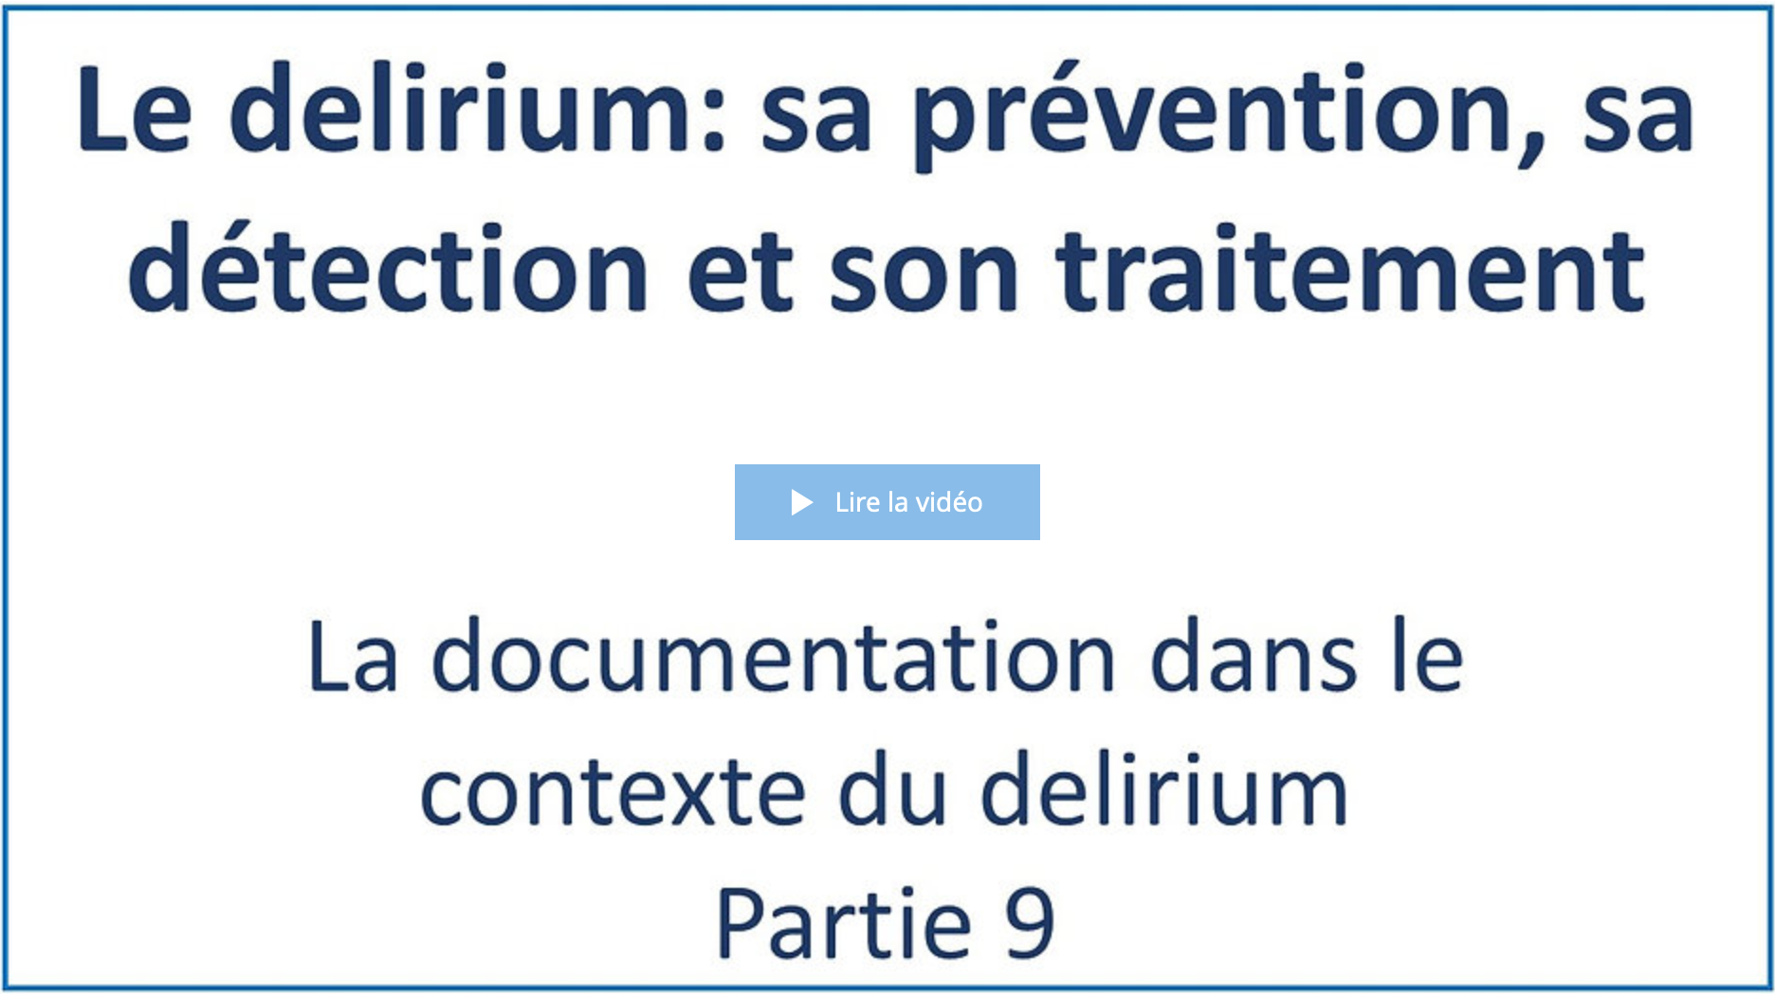
Date de visionnement de la vidéo : _________________
Notes
______________________________________________________________________________________________________________________________________________________________________________________________________________________________________________________________________________________________________________________________________________________________________________________________________________________________________________________________________________________________________________________________________________________________________________________________________________________________________________________________________________________________________________________________________________________________________________________________________________________________________________________________________________________________________________________________________________________________________________________________________________________________________________________________________________________________________________________________________________________________________________________________________________________________________

Validation des apprentissages

Vous avez terminé de visionner les vidéos de la formation.
1. (Facultatif) Selon les directives de votre organisation, veuillez faire le questionnaire de validation des apprentissages en cliquant sur la rubrique encadrée en rouge.
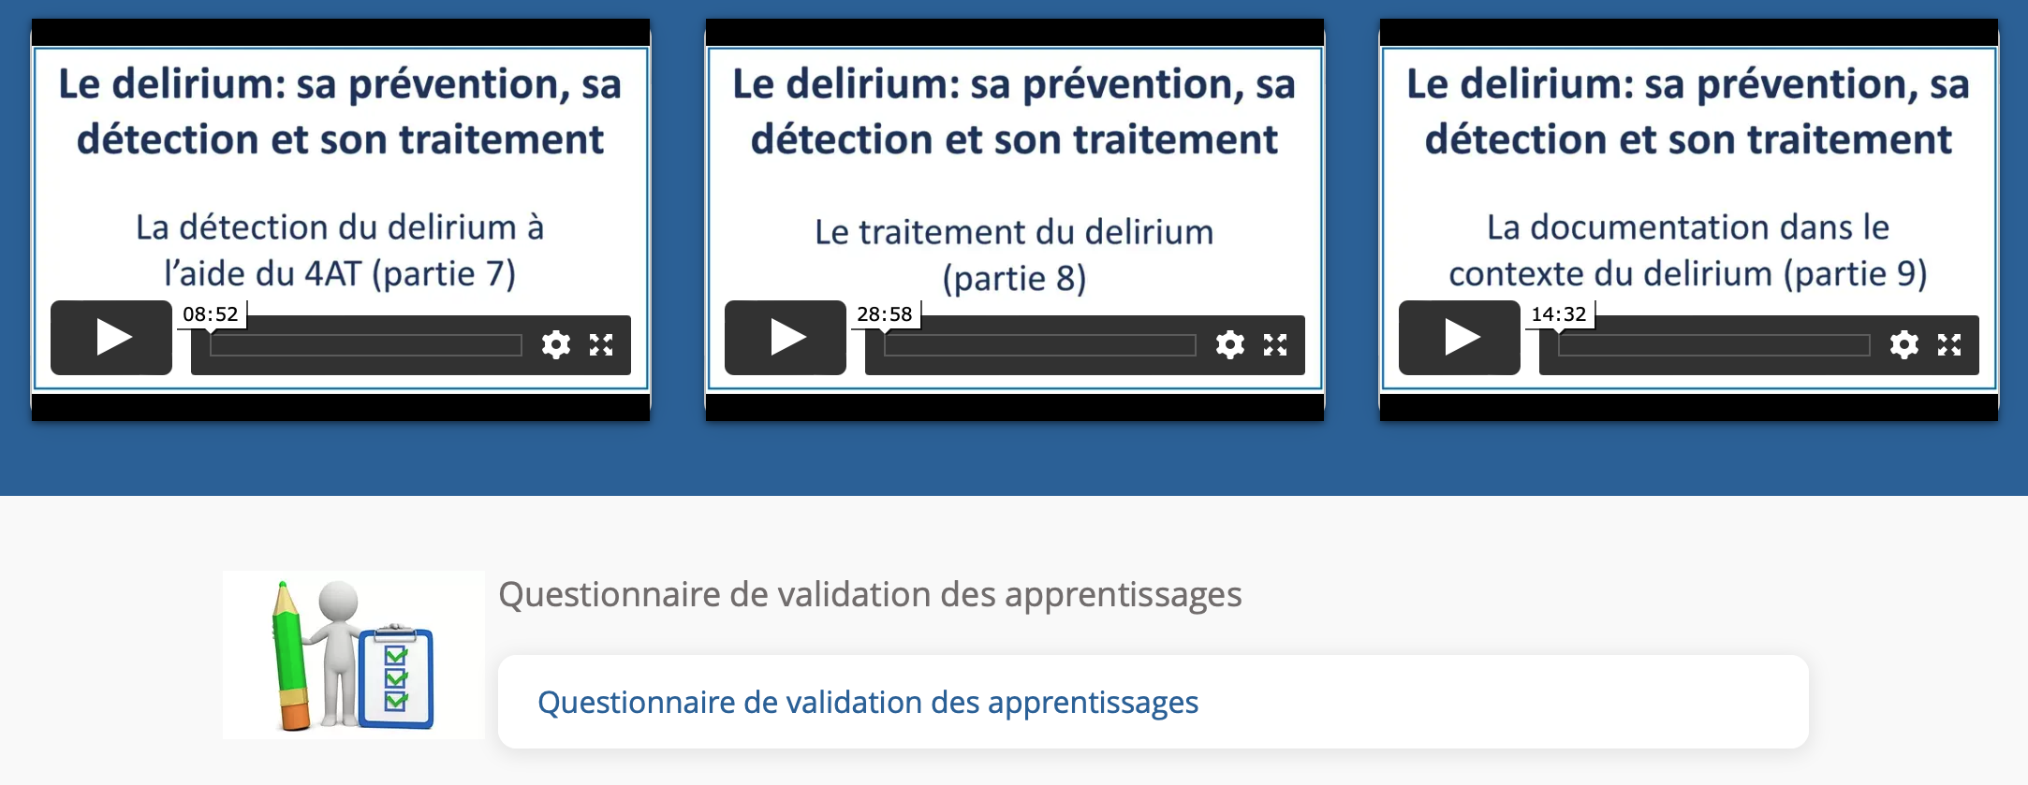
Durée approximative du questionnaire : 25 min.
Date de la réalisation du questionnaire : _________________
Résultat : _________
Signature approbative : ____________________________________________

Formation #2
La relation entre le poids, le vieillissement normal et les troubles neurocognitifs majeurs

Format : Vidéos asynchrones
Durée de la formation : 26 minutes

2.1
Vidéo 1

1. Visionnez la première vidéo.
Durée : 9 min 17 sec.
Date de visionnement de la vidéo : _________________
Notes
______________________________________________________________________________________________________________________________________________________________________________________________________________________________________________________________________________________________________________________________________________________________________________________________________________________________________________________________________________________________________________________________________________________________________________________________________________________________________________________________________________________________________________________________________________________________________________________________________________________________________________________________________________________________________________________________________________________________________________________________________________________________________________________________________________________________________________________________________________________________________________________________________________________________________
2.2
Vidéo 2

1. Visionnez la deuxième vidéo.
Durée : 5 min 16 sec.
Date de visionnement de la vidéo : _________________
Notes
______________________________________________________________________________________________________________________________________________________________________________________________________________________________________________________________________________________________________________________________________________________________________________________________________________________________________________________________________________________________________________________________________________________________________________________________________________________________________________________________________________________________________________________________________________________________________________________________________________________________________________________________________________________________________________________________________________________________________________________________________________________________________________________________________________________________________________________________________________________________________________________________________________________________________
2.3
Vidéo 3

1. Visionnez la troisième vidéo.
Durée : 11 min 33 sec.
Date de visionnement de la vidéo : _________________
Notes
______________________________________________________________________________________________________________________________________________________________________________________________________________________________________________________________________________________________________________________________________________________________________________________________________________________________________________________________________________________________________________________________________________________________________________________________________________________________________________________________________________________________________________________________________________________________________________________________________________________________________________________________________________________________________________________________________________________________________________________________________________________________________________________________________________________________________________________________________________________________________________________________________________________________________
Validation des apprentissages

Vous avez terminé de visionner les vidéos de la formation.
1. (Facultatif) Selon les directives de votre organisation, veuillez faire le questionnaire de validation des apprentissages en cliquant sur la rubrique encadrée en rouge.
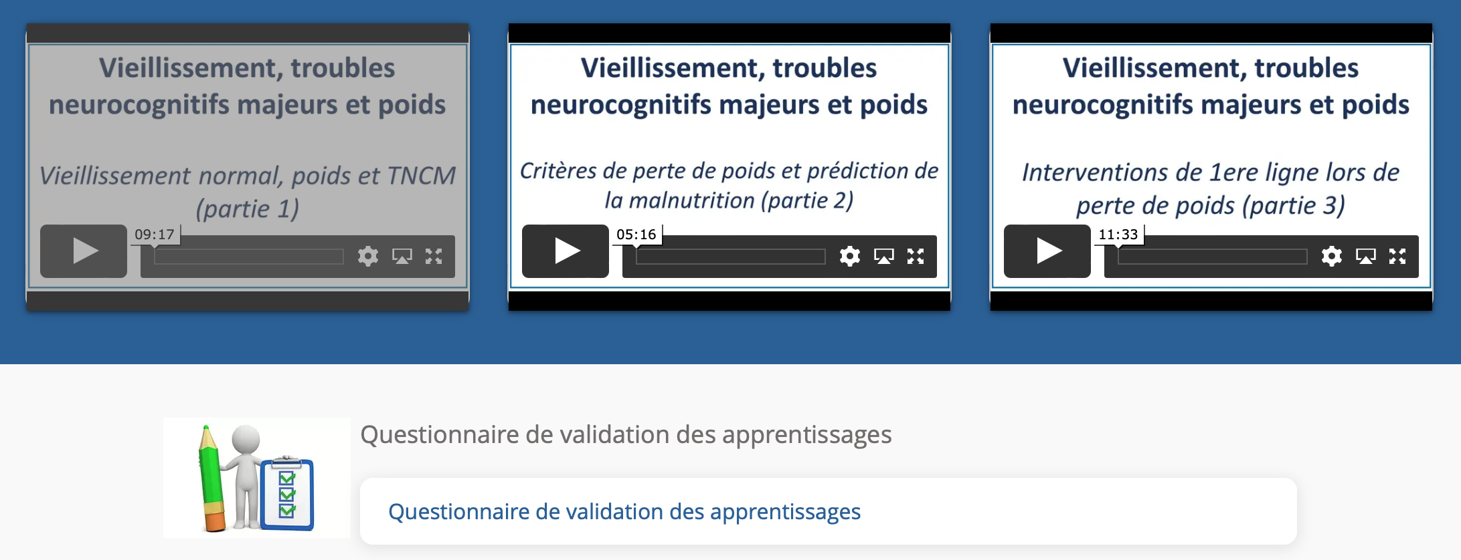
Durée approximative du questionnaire : 25 min.
Date de la réalisation du questionnaire : _________________
Résultat : _________
Signature approbative : ____________________________________________

Formation #3
L’impact d’une transition sur l’aîné atteint de problèmes cognitifs : mieux comprendre pour en atténuer les effets potentiellement négatifs

Format : Vidéos asynchrones
Durée de la formation : 25 minutes

3.1
Vidéo 1

1. Visionnez la première vidéo.
Durée : 25 min 03 sec.
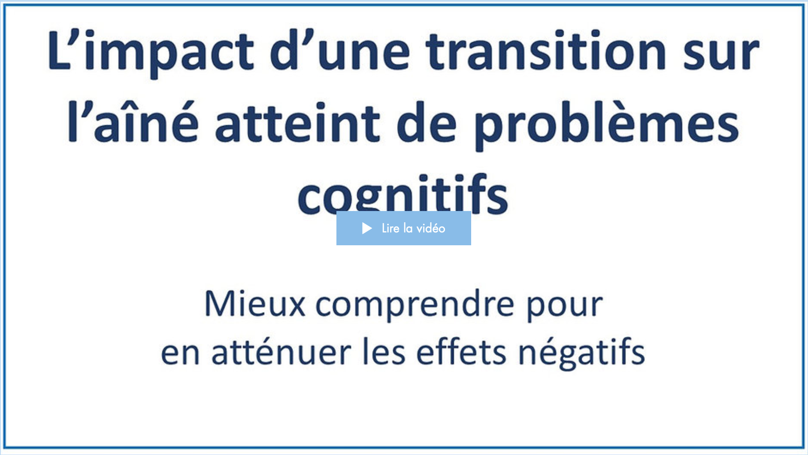
Date de visionnement de la vidéo : _________________
Notes
______________________________________________________________________________________________________________________________________________________________________________________________________________________________________________________________________________________________________________________________________________________________________________________________________________________________________________________________________________________________________________________________________________________________________________________________________________________________________________________________________________________________________________________________________________________________________________________________________________________________________________________________________________________________________________________________________________________________________________________________________________________________________________________________________________________________________________________________________________________________________________________________________________________________________
Formation #4
Détection et surveillance clinique de la douleur chez les aînés atteints de TNCM

Format : Vidéos asynchrones
Durée de la formation : 19 minutes

4.1
Vidéo 1

1. Visionnez la première vidéo.
Durée : 18 min 44 sec.
Date de visionnement de la vidéo : _________________
Notes
______________________________________________________________________________________________________________________________________________________________________________________________________________________________________________________________________________________________________________________________________________________________________________________________________________________________________________________________________________________________________________________________________________________________________________________________________________________________________________________________________________________________________________________________________________________________________________________________________________________________________________________________________________________________________________________________________________________________________________________________________________________________________________________________________________________________________________________________________________________________________________________________________________________________________
Formation #5
Maladie d’Alzheimer et les problèmes comportementaux : comprendre pour mieux prévenir

Format : Webinaires-interactifs - Virtuelles synchrones
Durée de la formation : 60 minutes

Webinaire-interactif

1. Le moment venu, participez au webinaire-interactif.
Date de participation du webinaire-interactif : _____________________

Notes
__________________________________________________________________________________________________________________________________________________________________________________________________________________________________________________________________________________________________________________________________________________________________________________________________________________________________________________________________________________________________________________________________________________________________________________________________________________________________________________________________________________________________________________________________________________________________________________________________________________________________________________________________________________________________________________________________________________________________________________________________________________________________________________________________________________________________________________________________________________________________________________________________________________________________________________________________________________________________________________________________________________________________________________________________________________________________________________________________________________________________________________________________________________________________________________________________________________________________________________________________________________________________________________________________________________________________________________________________________________________________________________________________________________________________________________________________________________________________________________________________________________________________________________________________________________________________________________________________________________________________________________________________________________________________________________________________________________________________
Formation #6
L’évaluation et la surveillance clinique de l’aîné

Format : Webinaires-interactifs - Virtuelles synchrones
Durée de la formation : 60 minutes

Webinaire-interactif

1. Le moment venu, participez au webinaire-interactif.
Date de participation au webinaire-interactif : _____________________

Notes
__________________________________________________________________________________________________________________________________________________________________________________________________________________________________________________________________________________________________________________________________________________________________________________________________________________________________________________________________________________________________________________________________________________________________________________________________________________________________________________________________________________________________________________________________________________________________________________________________________________________________________________________________________________________________________________________________________________________________________________________________________________________________________________________________________________________________________________________________________________________________________________________________________________________________________________________________________________________________________________________________________________________________________________________________________________________________________________________________________________________________________________________________________________________________________________________________________________________________________________________________________________________________________________________________________________________________________________________________________________________________________________________________________________________________________________________________________________________________________________________________________________________________________________________________________________________________________________________________________________________________________________________________________________________________________________________________________________________________
Formation #7
Le mentorat clinique à distance : Les problèmes de comportements et psychologiques liés aux troubles neurocognitifs majeurs

Format : Webinaires-interactifs - Virtuelles synchrones
Durée de la formation : 60 minutes

Mentorat clinique

1. Le moment venu, participez au mentorat clinique.
Date de participation au mentorat clinique : _____________________

Notes
__________________________________________________________________________________________________________________________________________________________________________________________________________________________________________________________________________________________________________________________________________________________________________________________________________________________________________________________________________________________________________________________________________________________________________________________________________________________________________________________________________________________________________________________________________________________________________________________________________________________________________________________________________________________________________________________________________________________________________________________________________________________________________________________________________________________________________________________________________________________________________________________________________________________________________________________________________________________________________________________________________________________________________________________________________________________________________________________________________________________________________________________________________________________________________________________________________________________________________________________________________________________________________________________________________________________________________________________________________________________________________________________________________________________________________________________________________________________________________________________________________________________________________________________________________________________________________________________________________________________________________________________________________________________________________________________________________________________________
Cheminement d’apprentissage – Personnel infirmier et milieux d’hébergement

Félicitations ! Vous avez complété le plan de développement des compétences prévu à la quatrième année d’embauche.
Maintenant, il ne vous reste plus qu’à mettre en application vos apprentissages auprès des résidents !

