Guide de l’apprenant
  - Le delirium : le prévenir, le détecter et le traiter
Tous droits réservés - www.philippevoyer.org

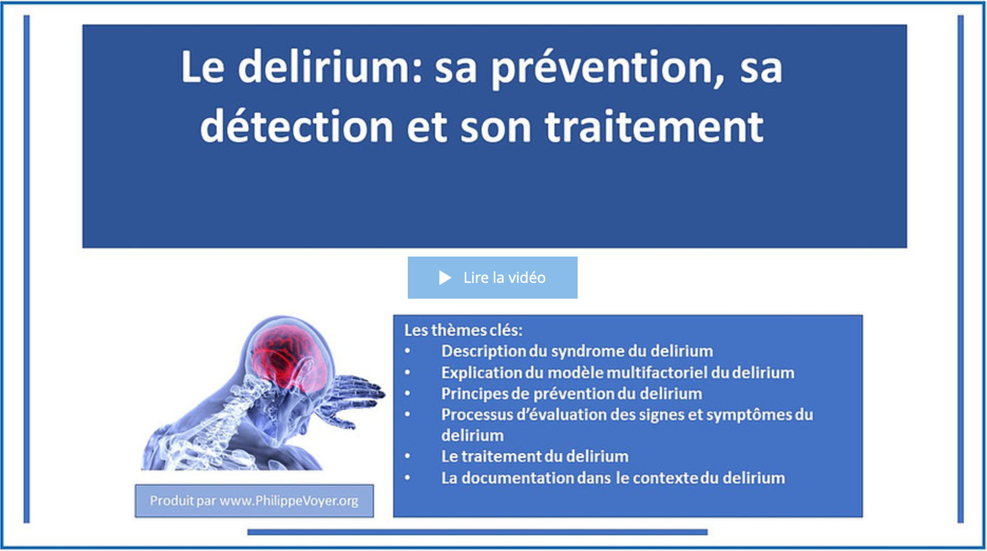

Formation destinée :

au personnel infirmier;

aux éducateurs spécialisé;

aux travailleurs sociaux;

au membre de l’équipe d’encadrement clinique;

aux autres professionnels de la santé.

Nom : _________________________________________________________
1
Préparation à la formation

Bienvenue à la formation sur le delirium !
- Avant de débuter la formation, assurez-vous que vous avez lu récemment un livre de physiopathologie du corps humain, vous permettant d’être en mesure de bien comprendre la formation qui suit.
- Nous vous invitons fortement à suivre la formation dans l’ordre suggéré par le guide de l’apprenant.

2
Vidéo 1

1. Visionnez la première vidéo.
Durée : 24 min 54 sec.
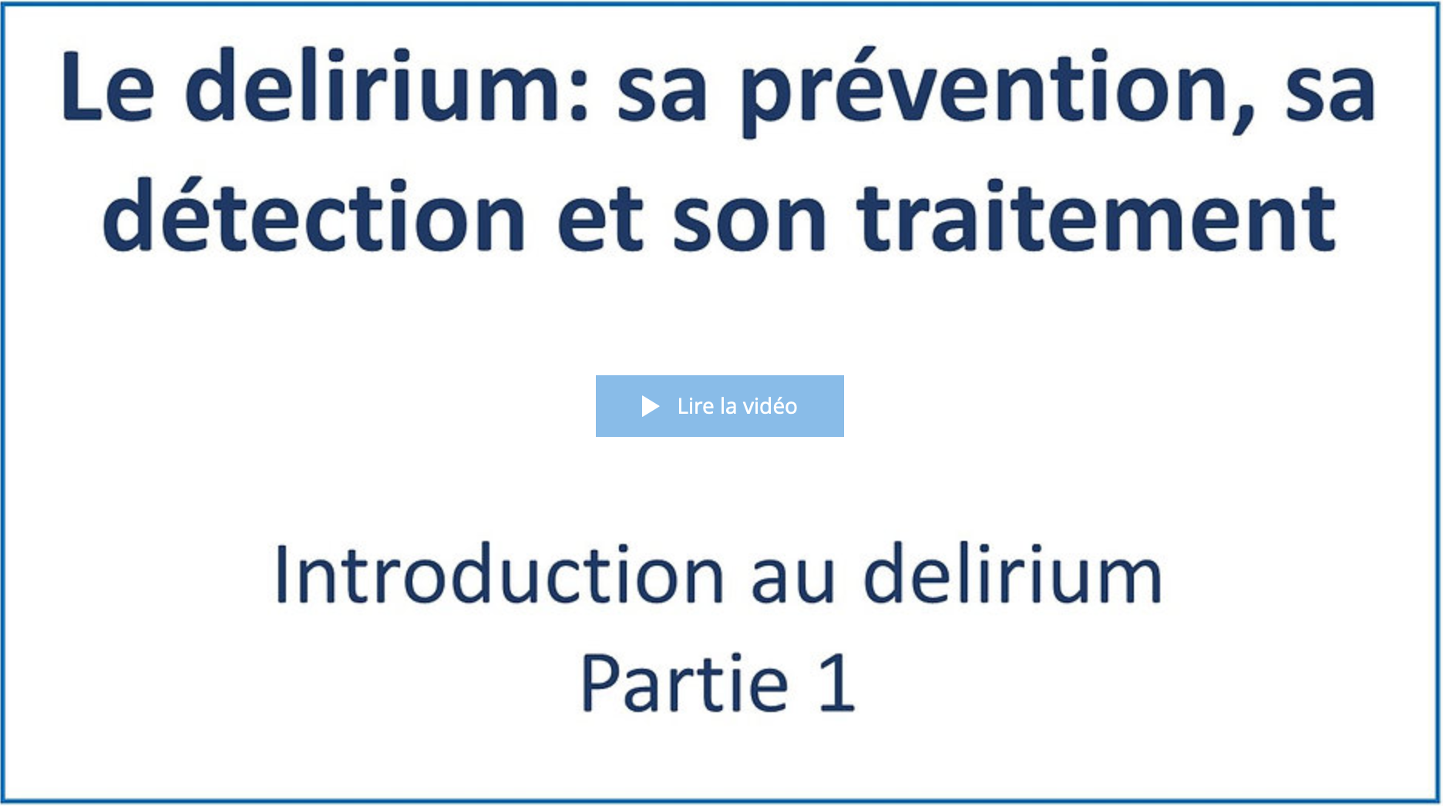
Date de visionnement de la vidéo : _________________
Notes
______________________________________________________________________________________________________________________________________________________________________________________________________________________________________________________________________________________________________________________________________________________________________________________________________________________________________________________________________________________________________________________________________________________________________________________________________________________________________________________________________________________________________________________________________________________________________________________________________________________________________________________________________________________________________________________________________________________________________________________________________________________________________________________________________________________________________________________________________________________________________________________________________________________________________

3
Vidéo 2

1. Visionnez la deuxième vidéo.
Durée : 15 min 59 sec.
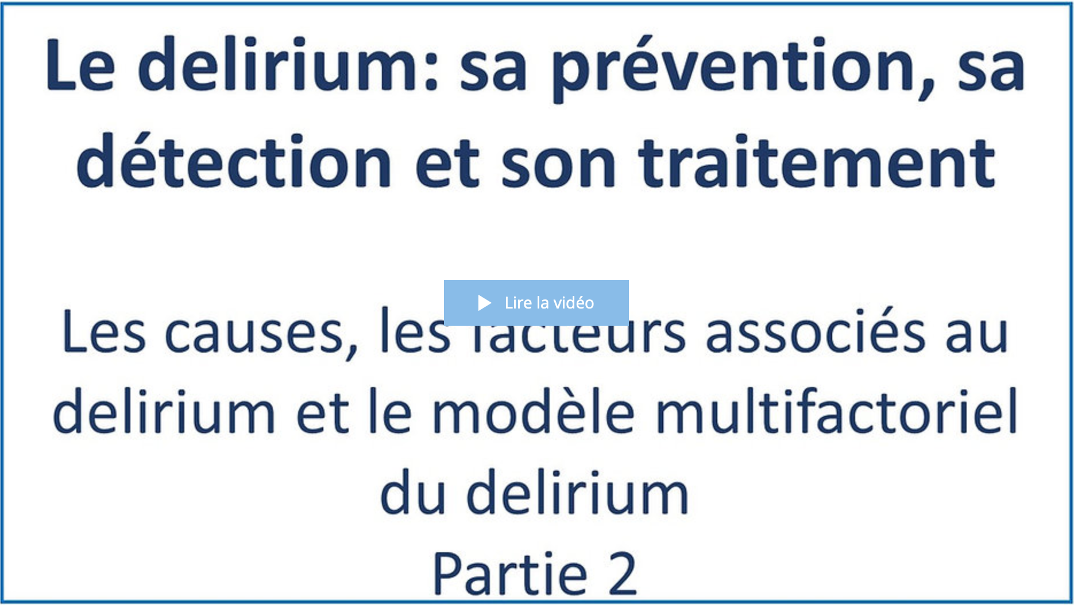
Date de visionnement de la vidéo : _________________
Notes
______________________________________________________________________________________________________________________________________________________________________________________________________________________________________________________________________________________________________________________________________________________________________________________________________________________________________________________________________________________________________________________________________________________________________________________________________________________________________________________________________________________________________________________________________________________________________________________________________________________________________________________________________________________________________________________________________________________________________________________________________________________________________________________________________________________________________________________________________________________________________________________________________________________________________
4
Vidéo 3

1. Visionnez la troisième vidéo.
Durée : 14 min 10 sec.
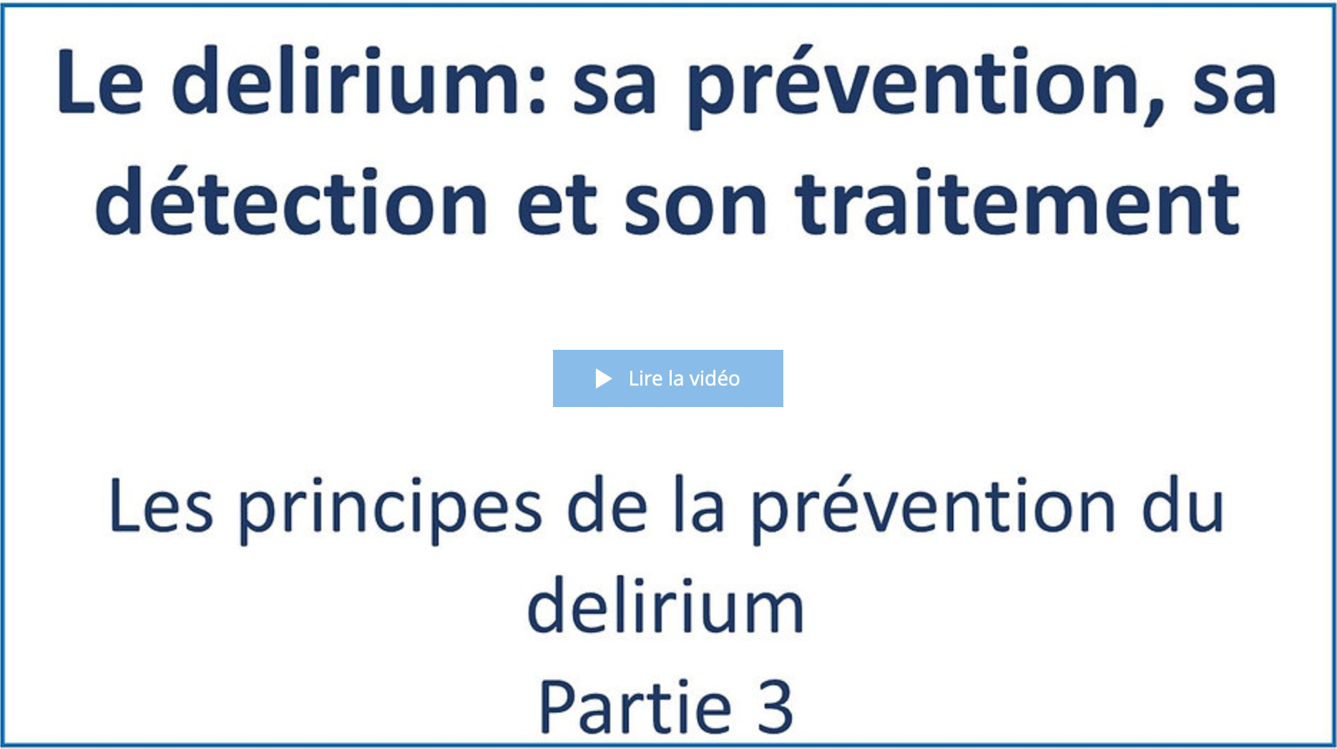
Date de visionnement de la vidéo : _________________
Notes
______________________________________________________________________________________________________________________________________________________________________________________________________________________________________________________________________________________________________________________________________________________________________________________________________________________________________________________________________________________________________________________________________________________________________________________________________________________________________________________________________________________________________________________________________________________________________________________________________________________________________________________________________________________________________________________________________________________________________________________________________________________________________________________________________________________________________________________________________________________________________________________________________________________________________

5
Vidéo 4

1. Visionnez la quatrième vidéo.
Durée : 13 min 55 sec.
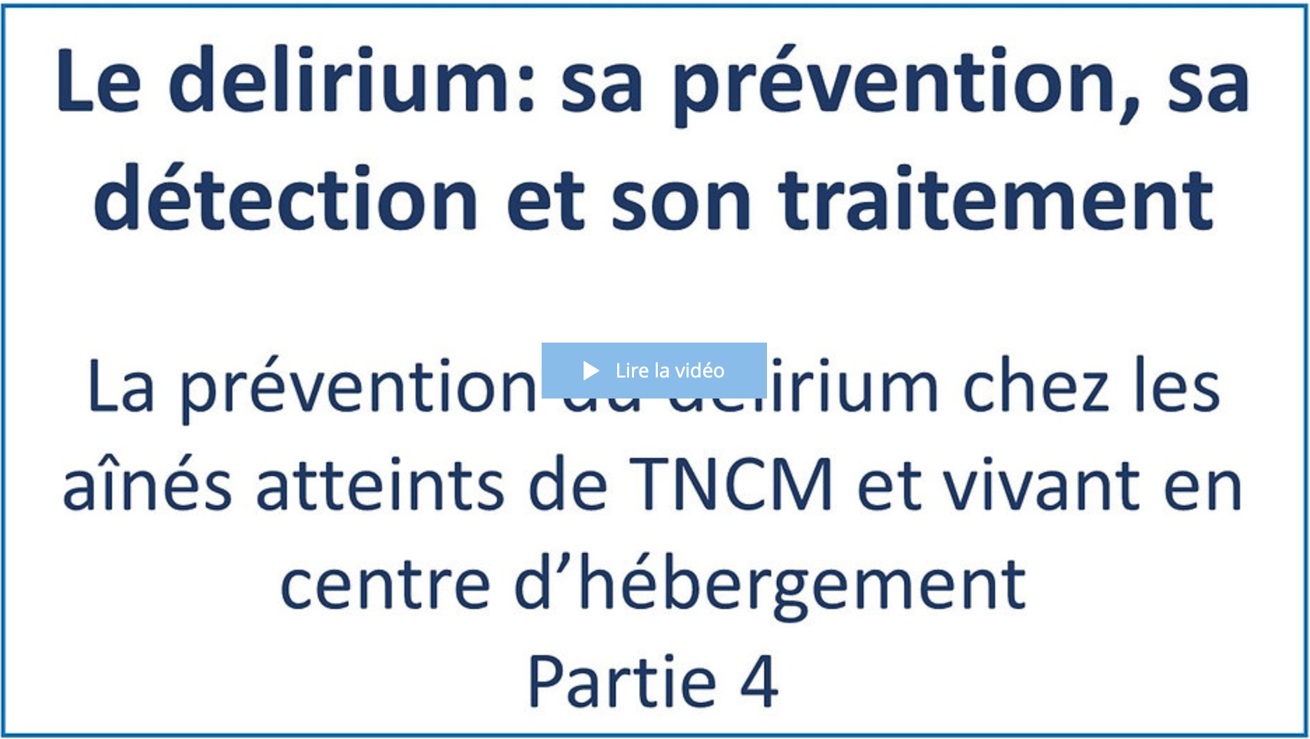
Date de visionnement de la vidéo : _________________
Notes
______________________________________________________________________________________________________________________________________________________________________________________________________________________________________________________________________________________________________________________________________________________________________________________________________________________________________________________________________________________________________________________________________________________________________________________________________________________________________________________________________________________________________________________________________________________________________________________________________________________________________________________________________________________________________________________________________________________________________________________________________________________________________________________________________________________________________________________________________________________________________________________________________________________________________
6
Vidéo 5

1. Visionnez la cinquième vidéo.
Durée : 18 min 20 sec.
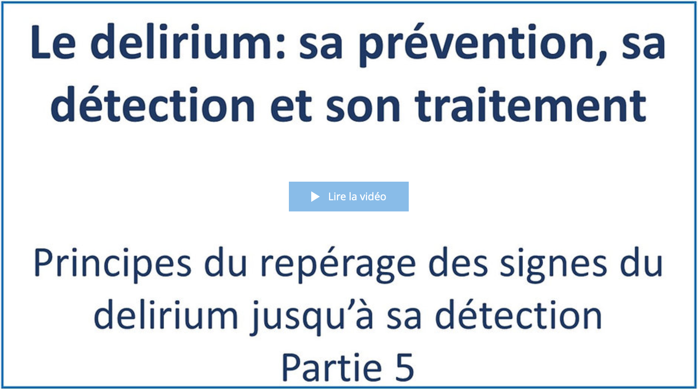
Date de visionnement de la vidéo : _________________
Notes
_________________________________________________________________________________________________________________________________________________________________________________________________________________________________________________________________________________________________________________________________________________________________________________________________________________________________________________________________________________________________________________________________________________________________________________________________________________________________________________________________________________________________________________________________________________________________________________________________________________________________________________________________________________________________________________________________________________________________________________________________________________________________________________________________________________________________________________________________________________
_____________________________________________________________________________________
7
Vidéo 6

1. Visionnez la sixième vidéo.
Durée : 27 min 07 sec.
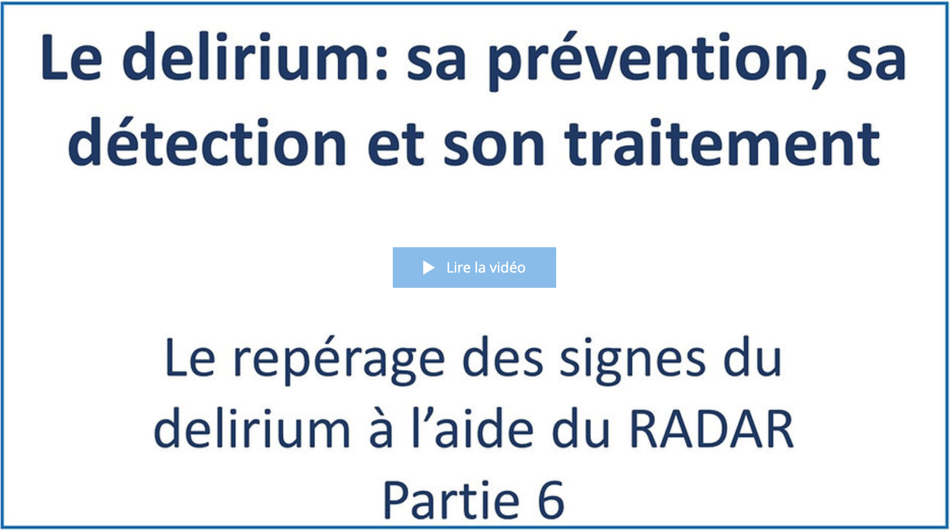
Date de visionnement de la vidéo : _________________
Notes
______________________________________________________________________________________________________________________________________________________________________________________________________________________________________________________________________________________________________________________________________________________________________________________________________________________________________________________________________________________________________________________________________________________________________________________________________________________________________________________________________________________________________________________________________________________________________________________________________________________________________________________________________________________________________________________________________________________________________________________________________________________________________________________________________________________________________________________________________________________________________________________________________________________________________

8
Vidéo 7

1. Visionnez la septième vidéo.
Durée : 8 min 52 sec.
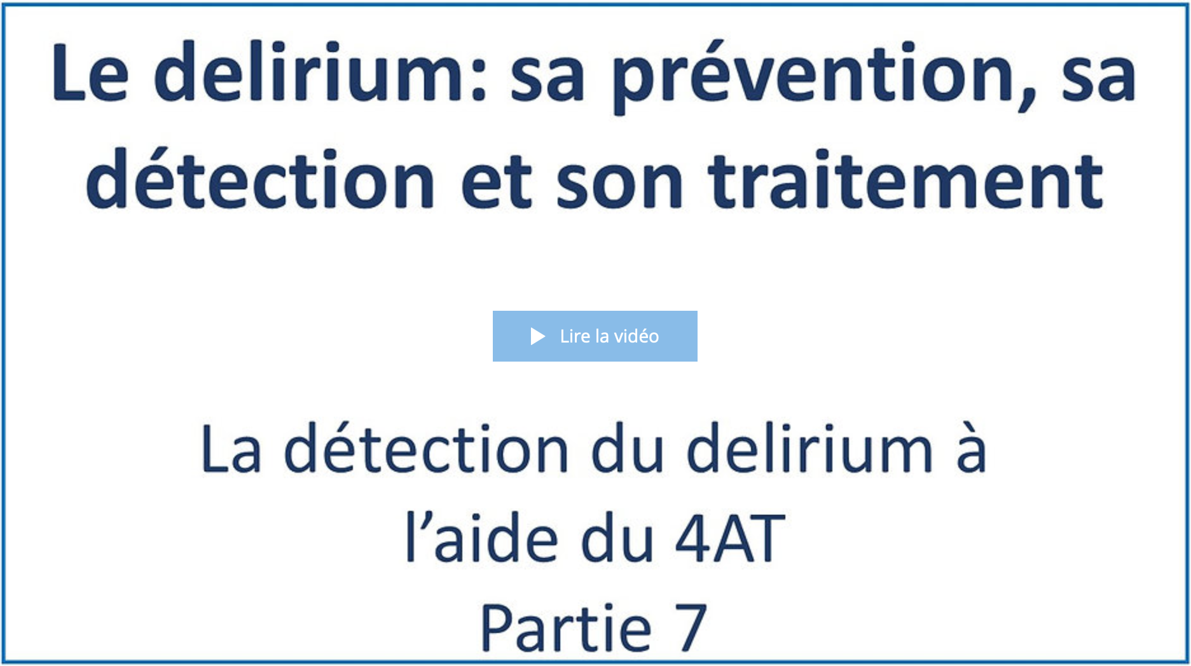
Date de visionnement de la vidéo : _________________
Notes
______________________________________________________________________________________________________________________________________________________________________________________________________________________________________________________________________________________________________________________________________________________________________________________________________________________________________________________________________________________________________________________________________________________________________________________________________________________________________________________________________________________________________________________________________________________________________________________________________________________________________________________________________________________________________________________________________________________________________________________________________________________________________________________________________________________________________________________________________________________________________________________________________________________________________

9
Vidéo 8

1. Visionnez la huitième vidéo.
Durée : 28 min 58 sec.
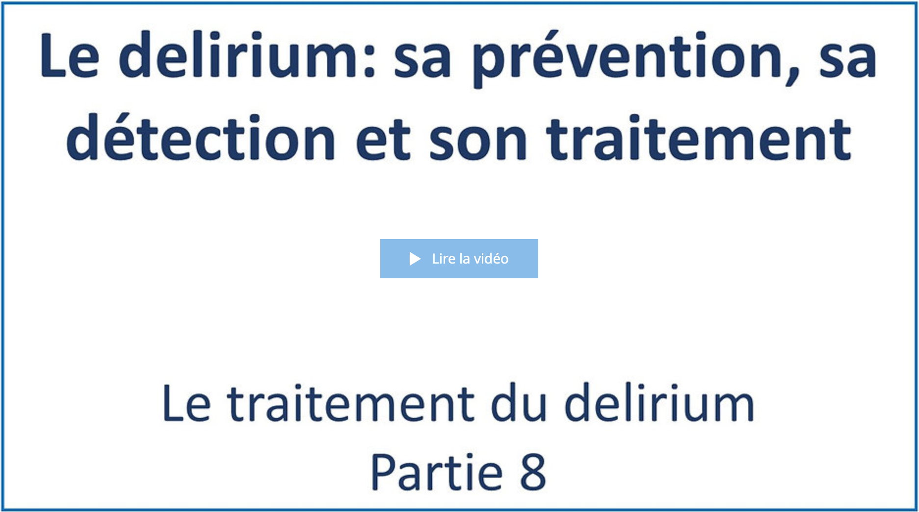
Date de visionnement de la vidéo : _________________
Notes
______________________________________________________________________________________________________________________________________________________________________________________________________________________________________________________________________________________________________________________________________________________________________________________________________________________________________________________________________________________________________________________________________________________________________________________________________________________________________________________________________________________________________________________________________________________________________________________________________________________________________________________________________________________________________________________________________________________________________________________________________________________________________________________________________________________________________________________________________________________________________________________________________________________________________
_____________________________________________________________________________________
10
Vidéo 9

1. Visionnez la neuvième vidéo.
Durée : 14 min 32 sec.
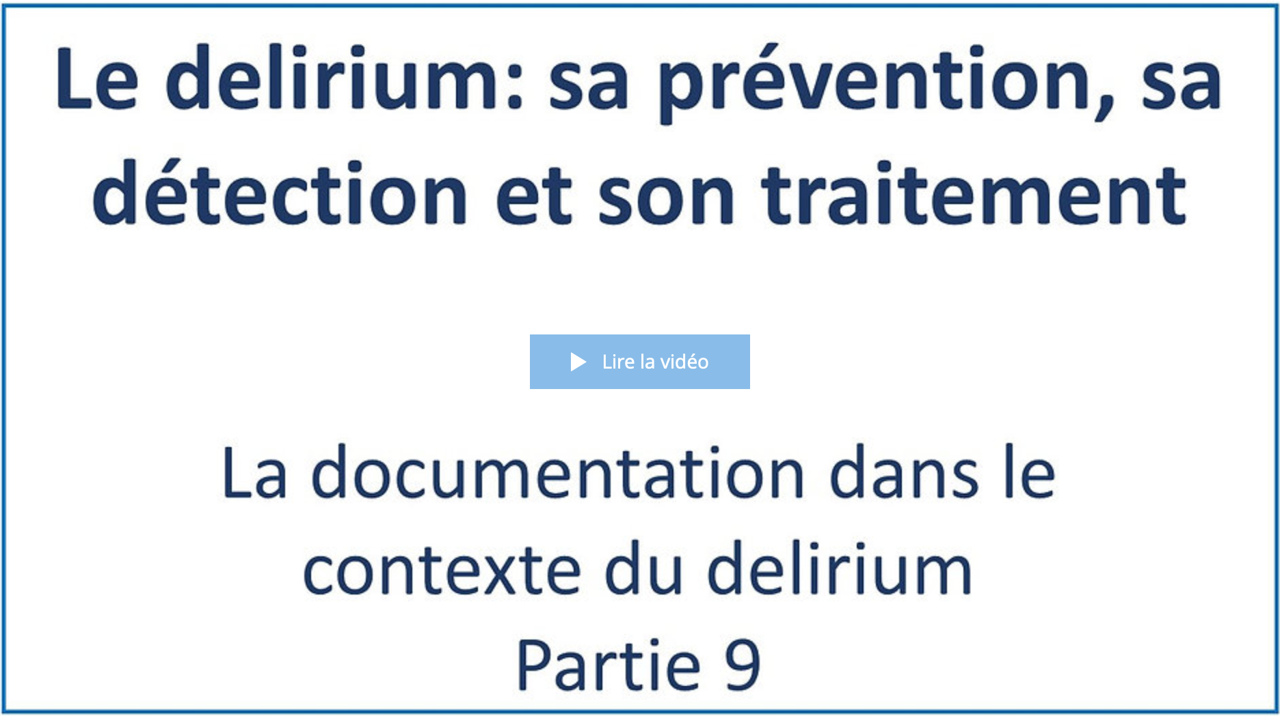
Date de visionnement de la vidéo : _________________
Notes
______________________________________________________________________________________________________________________________________________________________________________________________________________________________________________________________________________________________________________________________________________________________________________________________________________________________________________________________________________________________________________________________________________________________________________________________________________________________________________________________________________________________________________________________________________________________________________________________________________________________________________________________________________________________________________________________________________________________________________________________________________________________________________________________________________________________________________________________________________________________________________________________________________________________________

11
Après la formation

Vous avez terminé de visionner les vidéos de la formation.
1. (Facultatif) Selon les directives de votre organisation, veuillez faire le questionnaire de validation des apprentissages en cliquant sur la rubrique encadrée en rouge.
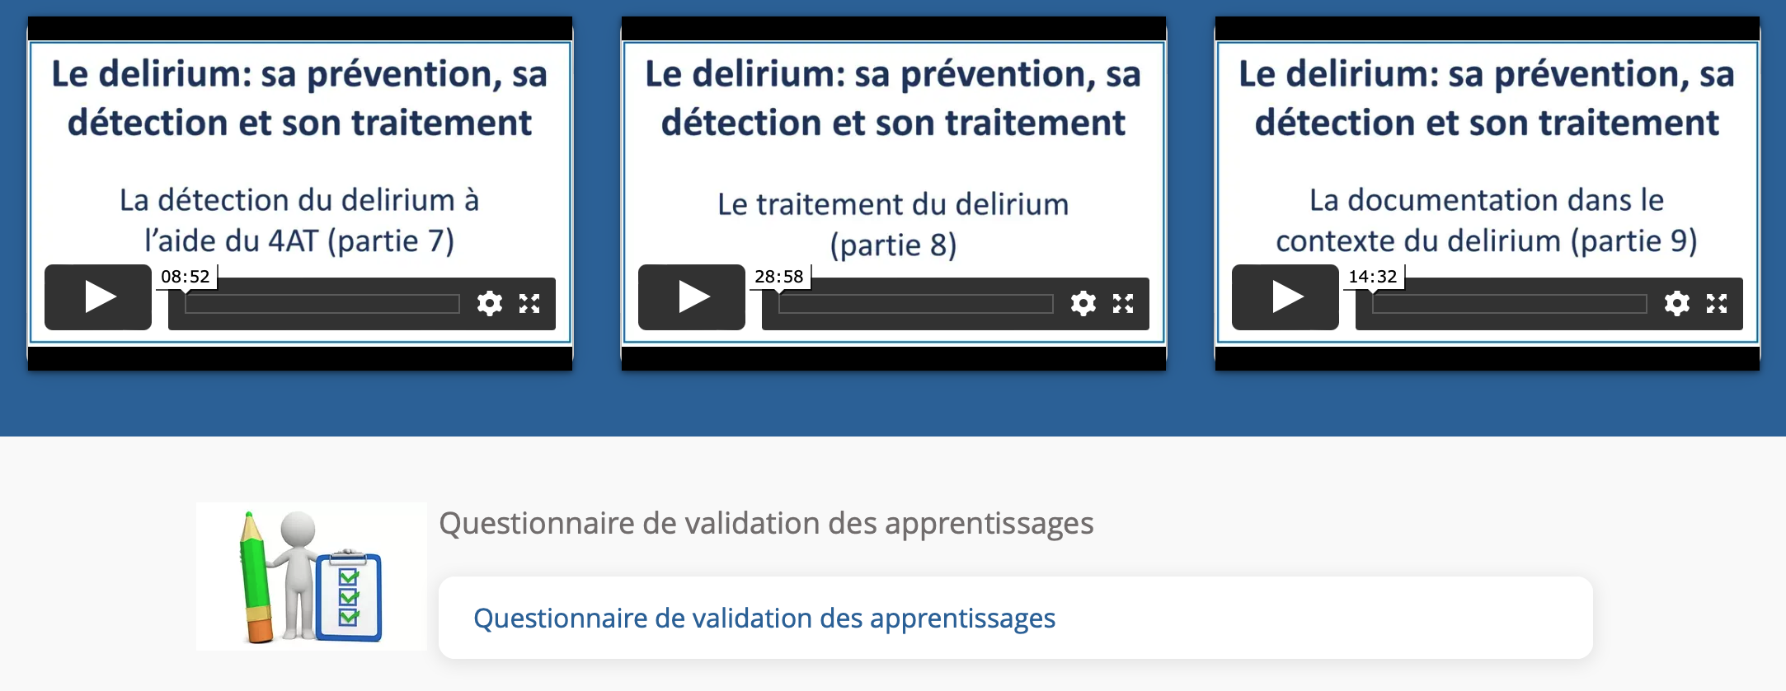
Durée approximative du questionnaire : 25 min.
Date de la réalisation du questionnaire : _________________
Résultat : _________
Signature approbative : ____________________________________________

