Guide de l’apprenant
  - La contribution des infirmières auxiliaires à l’évaluation et la surveillance clinique de l’aîné
Tous droits réservés - www.philippevoyer.org

Formation destinée :

Aux infirmières auxiliaires et infirmiers auxiliaires.

Nom : _________________________________________________________
Préparation à la formation

Bienvenue à la formation sur le delirium !
- Avant de débuter la formation, assurez-vous que vous avez lu récemment un livre de physiopathologie du corps humain, vous permettant d’être en mesure de bien comprendre la formation qui suit.
- Nous vous invitons fortement à suivre la formation dans l’ordre suggéré par le guide de l’apprenant.

Vidéo 1

Durée : 15 min 15 sec.
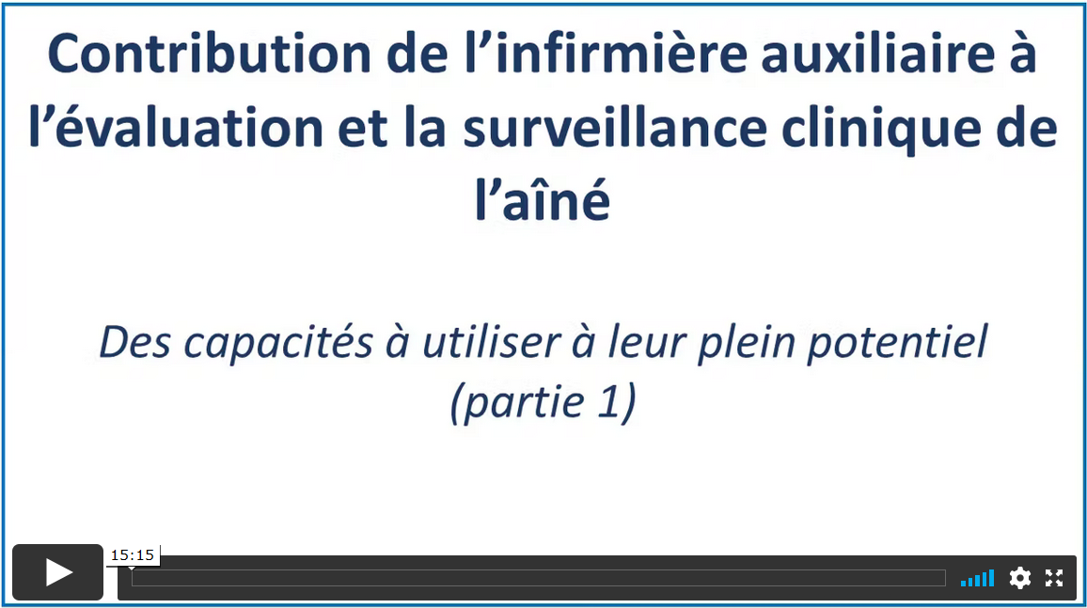

Date de visionnement de la vidéo : _________________
Notes
______________________________________________________________________________________________________________________________________________________________________________________________________________________________________________________________________________________________________________________________________________________________________________________________________________________________________________________________________________________________________________________________________________________________________________________________________________________________________________________________________________________________________________________________________________________________________________________________________________________________________________________________________________________________________________________________________________________________________________________________________________________________________________________________________________________________________________________________________________________________________________________________________________________________________
Vidéo 2

Durée : 14 min 37 sec.
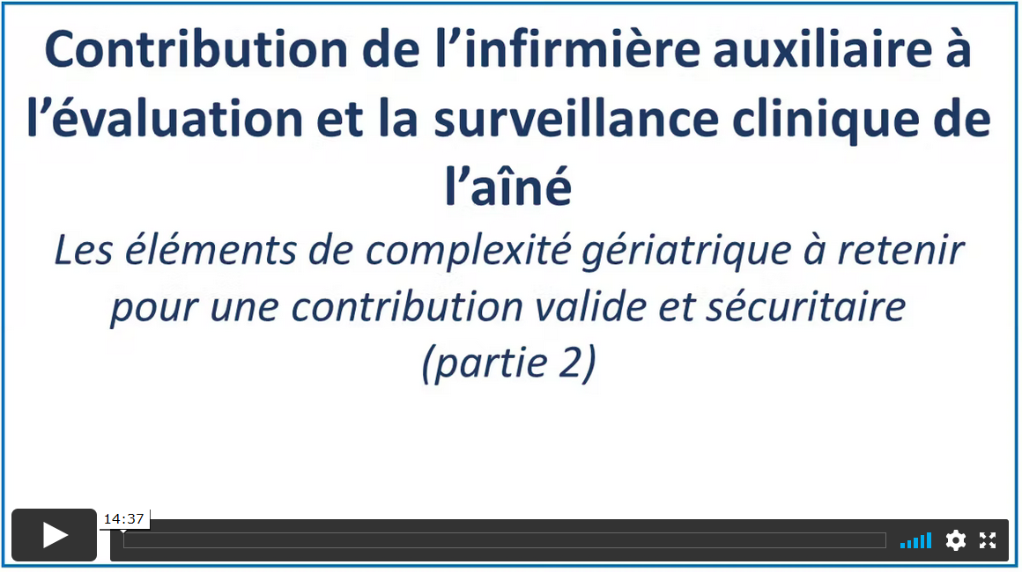
Date de visionnement de la vidéo : _________________
Notes
______________________________________________________________________________________________________________________________________________________________________________________________________________________________________________________________________________________________________________________________________________________________________________________________________________________________________________________________________________________________________________________________________________________________________________________________________________________________________________________________________________________________________________________________________________________________________________________________________________________________________________________________________________________________________________________________________________________________________________________________________________________________________________________________________________________________________________________________________________________________________________________________________________________________________
_____________________________________________________________________________________
Vidéo 3

Durée : 25 min 38 sec.
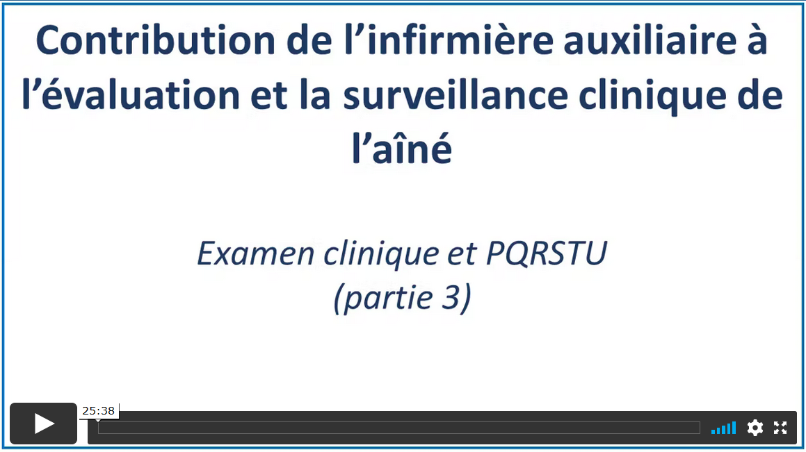
Date de visionnement de la vidéo : _________________
Notes
______________________________________________________________________________________________________________________________________________________________________________________________________________________________________________________________________________________________________________________________________________________________________________________________________________________________________________________________________________________________________________________________________________________________________________________________________________________________________________________________________________________________________________________________________________________________________________________________________________________________________________________________________________________________________________________________________________________________________________________________________________________________________________________________________________________________________________________________________________________________________________________________________________________________________
Vidéo 4

Durée : 18 min 32 sec.
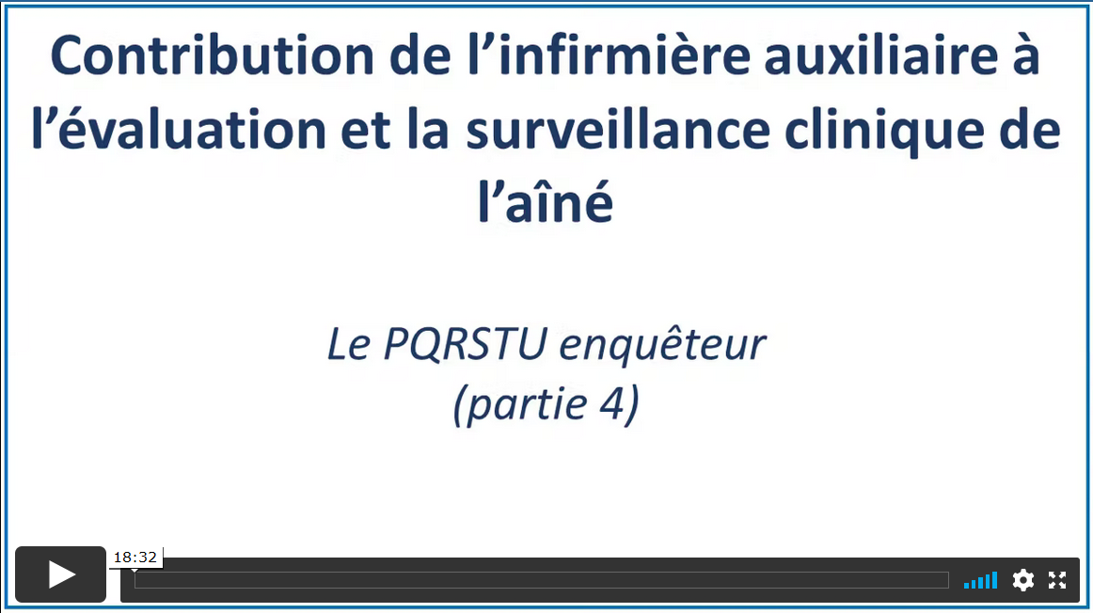
Date de visionnement de la vidéo : _________________
Notes
___________________________________________________________________________________________________________________________________________________________________________________________________________________________________________________________________________________________________________________________________________________________________________________________________________________________________________________________________________________________________________________________________________________________________________________________________________________________________________________________________________________________________________________________________________________________________________________________________________________________________________________________________________________________________________________________________________________________________________________________________________________________________________________________________________________________________________________________________________________________________________________________________________________________________________________________________________________________________________________________
Vidéo 5

Durée : 11 min 47 sec.
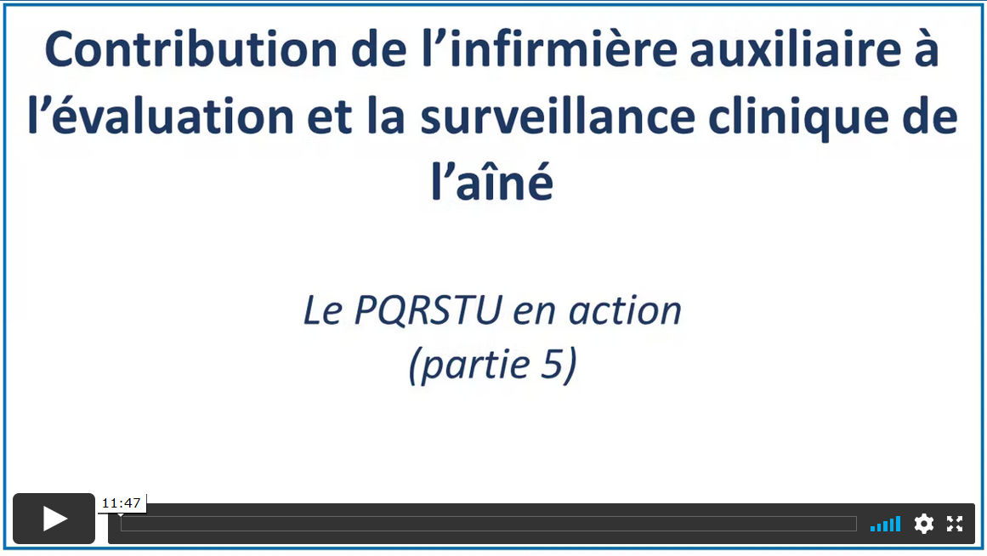
Date de visionnement de la vidéo : _________________
Notes
_________________________________________________________________________________________________________________________________________________________________________________________________________________________________________________________________________________________________________________________________________________________________________________________________________________________________________________________________________________________________________________________________________________________________________________________________________________________________________________________________________________________________________________________________________________________________________________________________________________________________________________________________________________________________________________________________________________________________________________________________________________________________________________________________________________________________________________________________________________
_____________________________________________________________________________________
Vidéo 6

Durée : 24 min 08 sec.
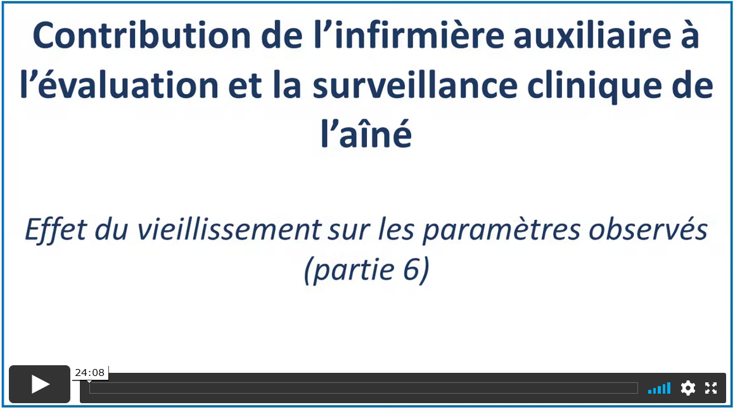
Date de visionnement de la vidéo : _________________
Notes
______________________________________________________________________________________________________________________________________________________________________________________________________________________________________________________________________________________________________________________________________________________________________________________________________________________________________________________________________________________________________________________________________________________________________________________________________________________________________________________________________________________________________________________________________________________________________________________________________________________________________________________________________________________________________________________________________________________________________________________________________________________________________________________________________________________________________________________________________________________________________________________________________________________________________

Vidéo 7

Durée : 23 min 57 sec.
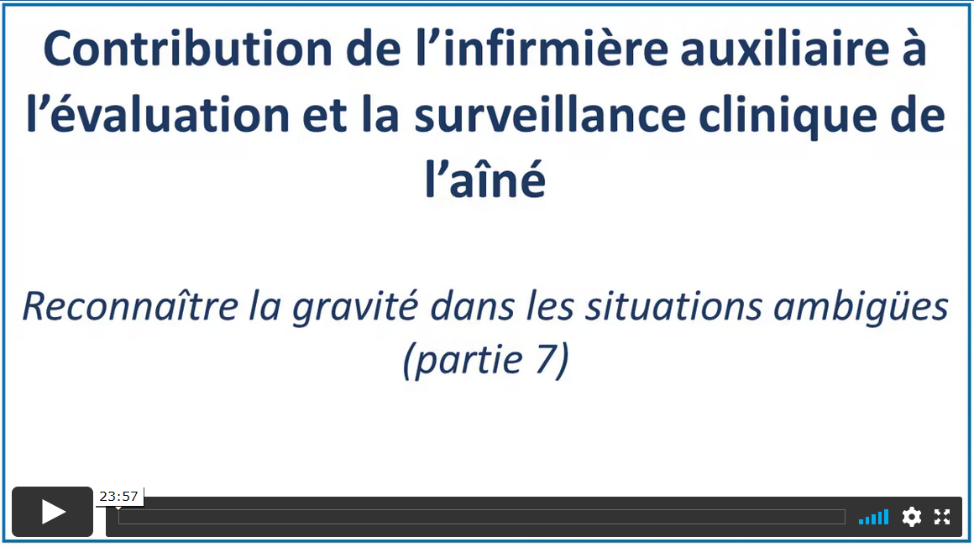
Date de visionnement de la vidéo : _________________
Notes
______________________________________________________________________________________________________________________________________________________________________________________________________________________________________________________________________________________________________________________________________________________________________________________________________________________________________________________________________________________________________________________________________________________________________________________________________________________________________________________________________________________________________________________________________________________________________________________________________________________________________________________________________________________________________________________________________________________________________________________________________________________________________________________________________________________________________________________________________________________________________________________________________________________________________

Vidéo 8

Durée : 24 min 38 sec.
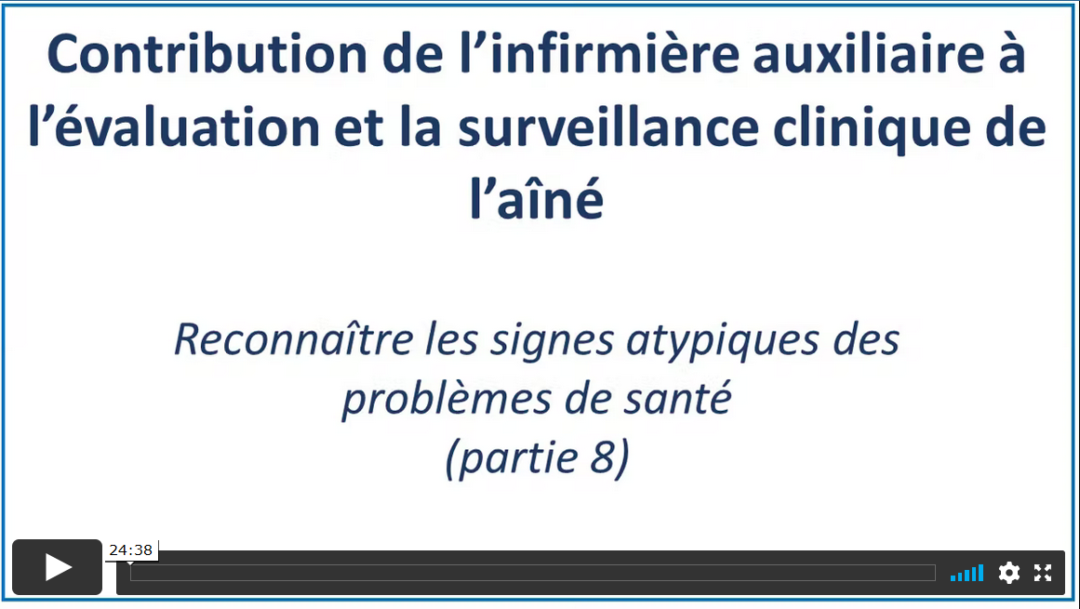
Date de visionnement de la vidéo : _________________
Notes
____________________________________________________________________________________________________________________________________________________________________________________________________________________________________________________________________________________________________________________________________________________________________________________________________________________________________________________________________________________________________________________________________________________________________________________________________________________________________________________________________________________________________________________________________________________________________________________________________________________________________________________________________________________________________________________________________________________________________________________________________________________________________________________________
_____________________________________________________________________________________
Vidéo 9

Durée : 21 min 05 sec.
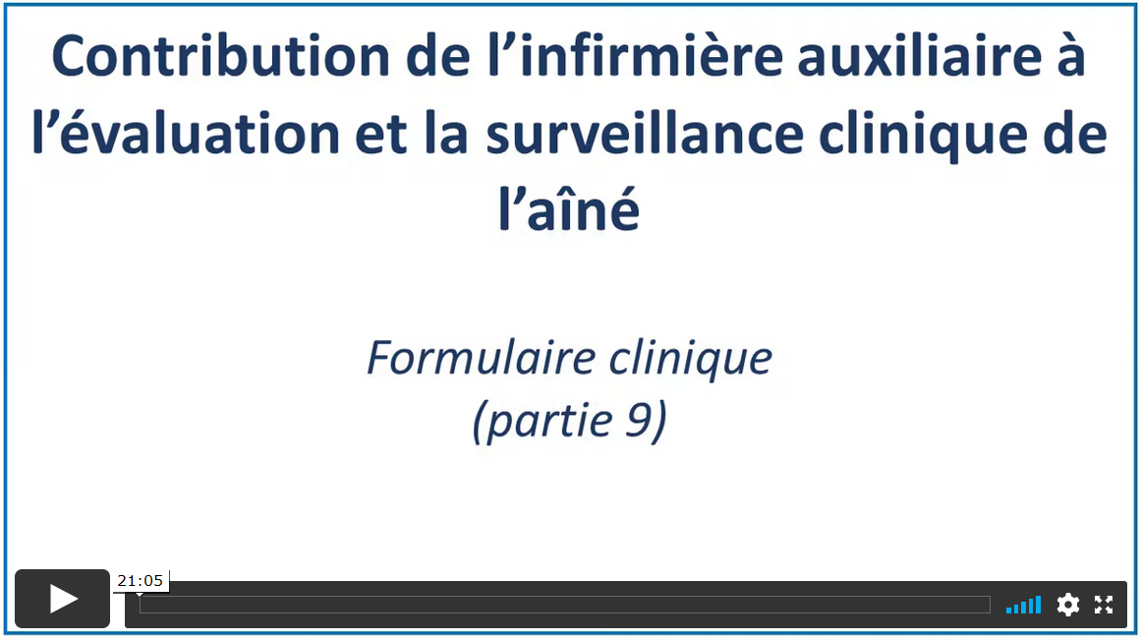
Date de visionnement de la vidéo : _________________
Notes
______________________________________________________________________________________________________________________________________________________________________________________________________________________________________________________________________________________________________________________________________________________________________________________________________________________________________________________________________________________________________________________________________________________________________________________________________________________________________________________________________________________________________________________________________________________________________________________________________________________________________________________________________________________________________________________________________________________________________________________________________________________________________________________________________________________________________________________________________________________________________________________________________________________________________

Vidéo 10

Durée : 14 min 15 sec.
Date de visionnement de la vidéo : _________________
Notes
______________________________________________________________________________________________________________________________________________________________________________________________________________________________________________________________________________________________________________________________________________________________________________________________________________________________________________________________________________________________________________________________________________________________________________________________________________________________________________________________________________________________________________________________________________________________________________________________________________________________________________________________________________________________________________________________________________________________________________________________________________________________________________________________________________________________________________________________________________________________________________________________________________________________________
Vidéo 11

Durée : 14 min 19 sec.
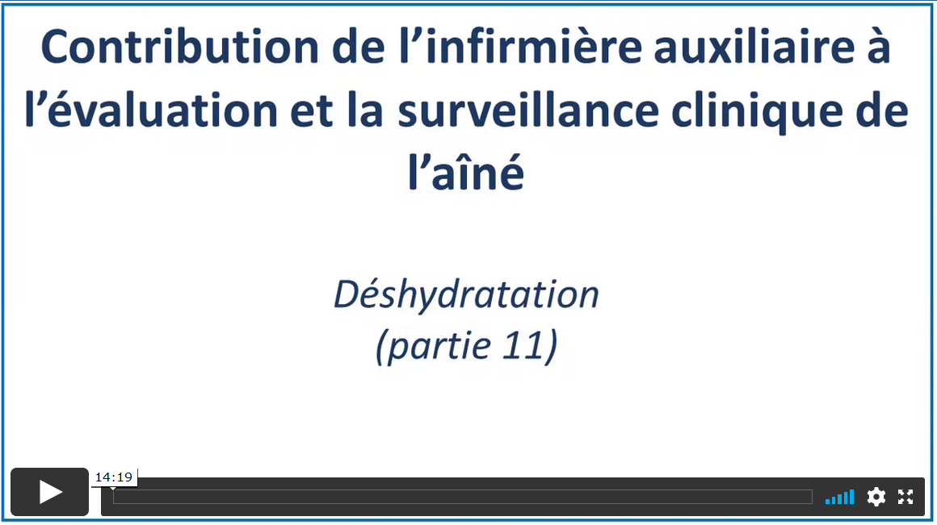
Date de visionnement de la vidéo : _________________
Notes
______________________________________________________________________________________________________________________________________________________________________________________________________________________________________________________________________________________________________________________________________________________________________________________________________________________________________________________________________________________________________________________________________________________________________________________________________________________________________________________________________________________________________________________________________________________________________________________________________________________________________________________________________________________________________________________________________________________________________________________________________________________________________________________________________________________________________________________________________________________________________________________________________________________________________
Vidéo 12

Durée : 16 min 30 sec.
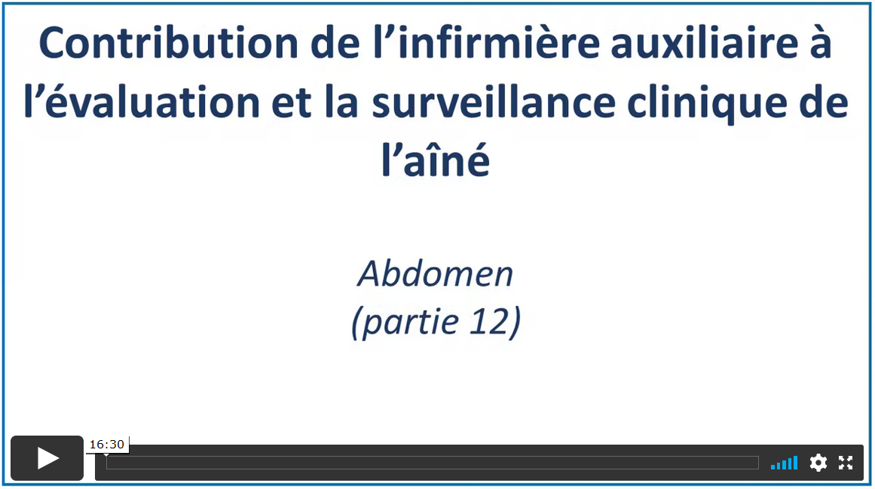
Date de visionnement de la vidéo : _________________
Notes
______________________________________________________________________________________________________________________________________________________________________________________________________________________________________________________________________________________________________________________________________________________________________________________________________________________________________________________________________________________________________________________________________________________________________________________________________________________________________________________________________________________________________________________________________________________________________________________________________________________________________________________________________________________________________________________________________________________________________________________________________________________________________________________________________________________________________________________________________________________________________________________________________________________________________
Vidéo 13

Durée : 18 min 35 sec.
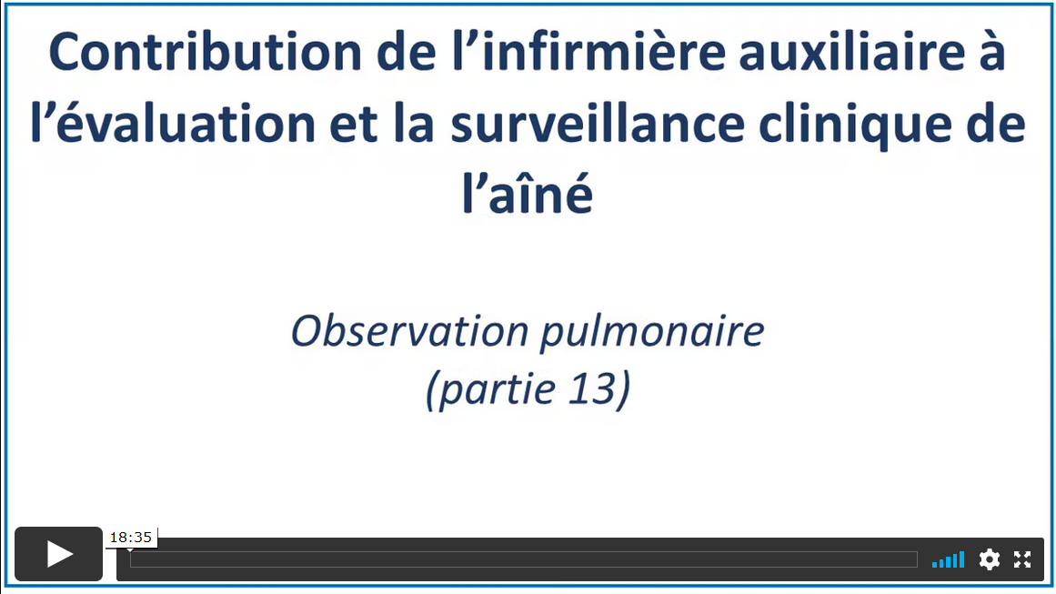
Date de visionnement de la vidéo : _________________
Notes
____________________________________________________________________________________________________________________________________________________________________________________________________________________________________________________________________________________________________________________________________________________________________________________________________________________________________________________________________________________________________________________________________________________________________________________________________________________________________________________________________________________________________________________________________________________________________________________________________________________________________________________________________________________________________________________________________________________________________________________________________________________________________________________________

Après la formation

Vous avez terminé de visionner les vidéos de la formation.
Selon les directives de votre organisation, veuillez faire le questionnaire de validation des apprentissages se trouvant sous les vidéos.
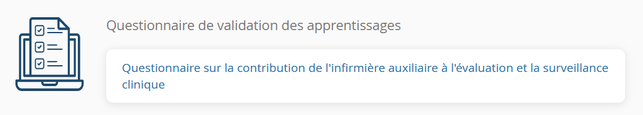

Durée approximative du questionnaire : 25 min.

Date de la réalisation du questionnaire : _________________
Résultat : _________

Signature approbative : ____________________________________________

