Guide de l’apprenant
  - Les chutes : dépistage, prévention et évaluation post-chute
Tous droits réservés - www.philippevoyer.org

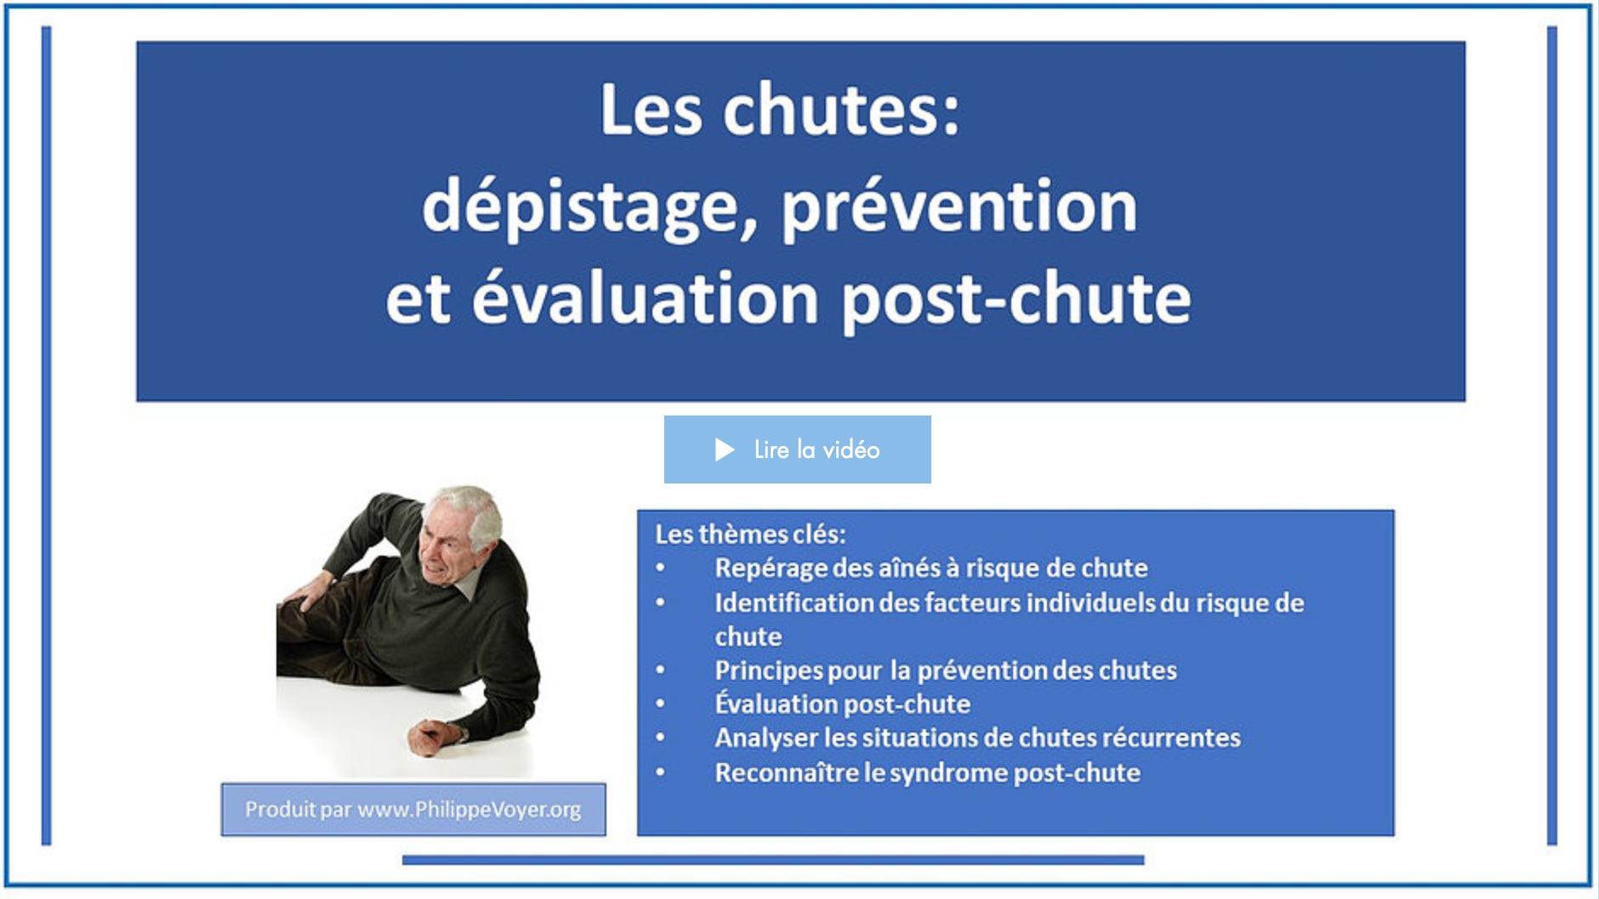

Formation destinée :

au personnel infirmier;

aux éducateurs spécialisé;

aux travailleurs sociaux;

aux préposés aux bénéficiaires/préposés aux résidents/aides de service;

au membre de l’équipe d’encadrement clinique;

aux autres professionnels de la santé.

Nom : _________________________________________________________
1
Préparation à la formation

Bienvenue à la formation sur les chutes !
- Avant de débuter la formation, assurez-vous que vous avez lu récemment un livre de physiopathologie du corps humain, vous permettant d’être en mesure de bien comprendre la formation qui suit.
- Nous vous invitons fortement à suivre la formation dans l’ordre suggéré par le guide de l’apprenant.

2
Vidéo 1

1. Visionnez la première vidéo.
Durée : 13 min 12 sec.
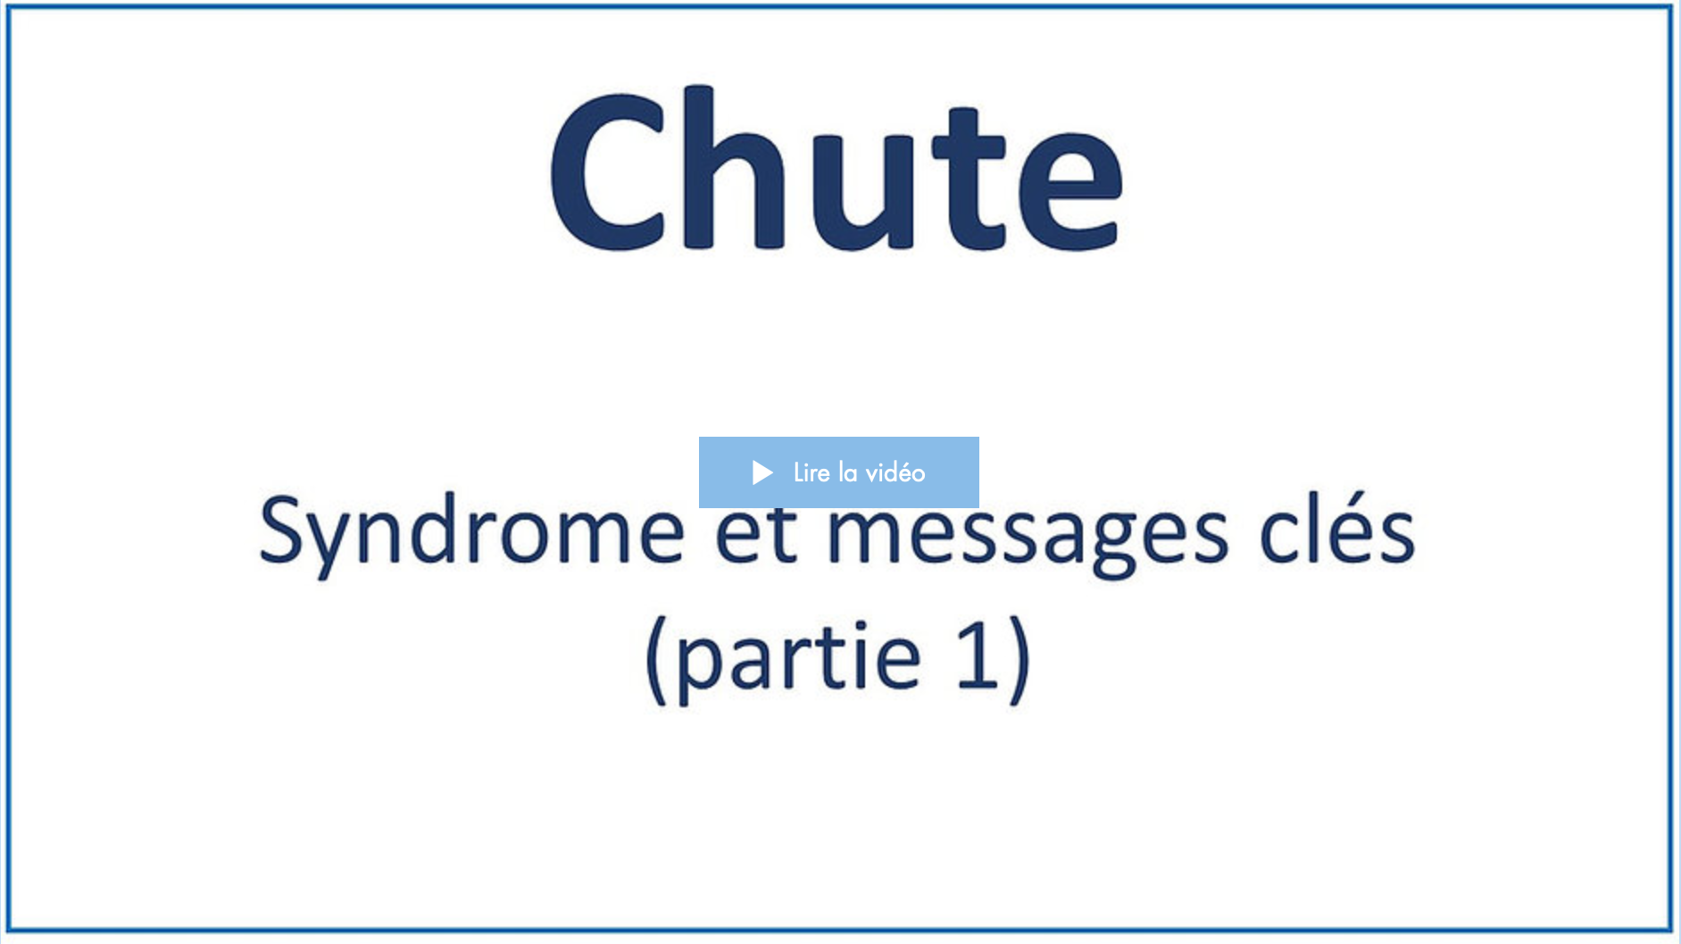
Date de visionnement de la vidéo : _________________
Notes
______________________________________________________________________________________________________________________________________________________________________________________________________________________________________________________________________________________________________________________________________________________________________________________________________________________________________________________________________________________________________________________________________________________________________________________________________________________________________________________________________________________________________________________________________________________________________________________________________________________________________________________________________________________________________________________________________________________________________________________________________________________________________________________________________________________________________________________________________________________________________________________________________________________________________

3
Vidéo 2

1. Visionnez la deuxième vidéo.
Durée : 19 min 28 sec.
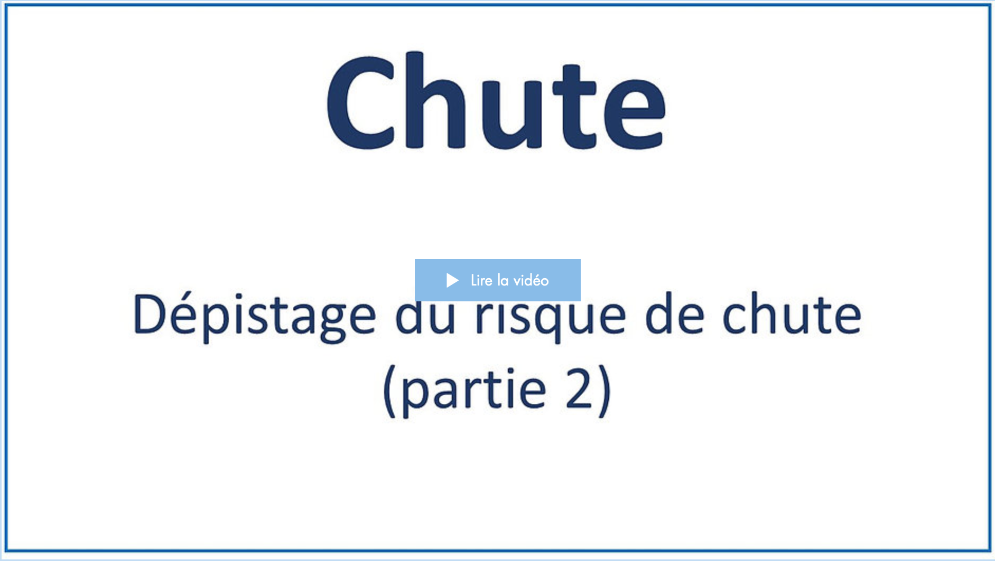
Date de visionnement de la vidéo : _________________
Notes
______________________________________________________________________________________________________________________________________________________________________________________________________________________________________________________________________________________________________________________________________________________________________________________________________________________________________________________________________________________________________________________________________________________________________________________________________________________________________________________________________________________________________________________________________________________________________________________________________________________________________________________________________________________________________________________________________________________________________________________________________________________________________________________________________________________________________________________________________________________________________________________________________________________________________
4
Vidéo 3

1. Visionnez la troisième vidéo.
Durée : 19 min 11 sec.
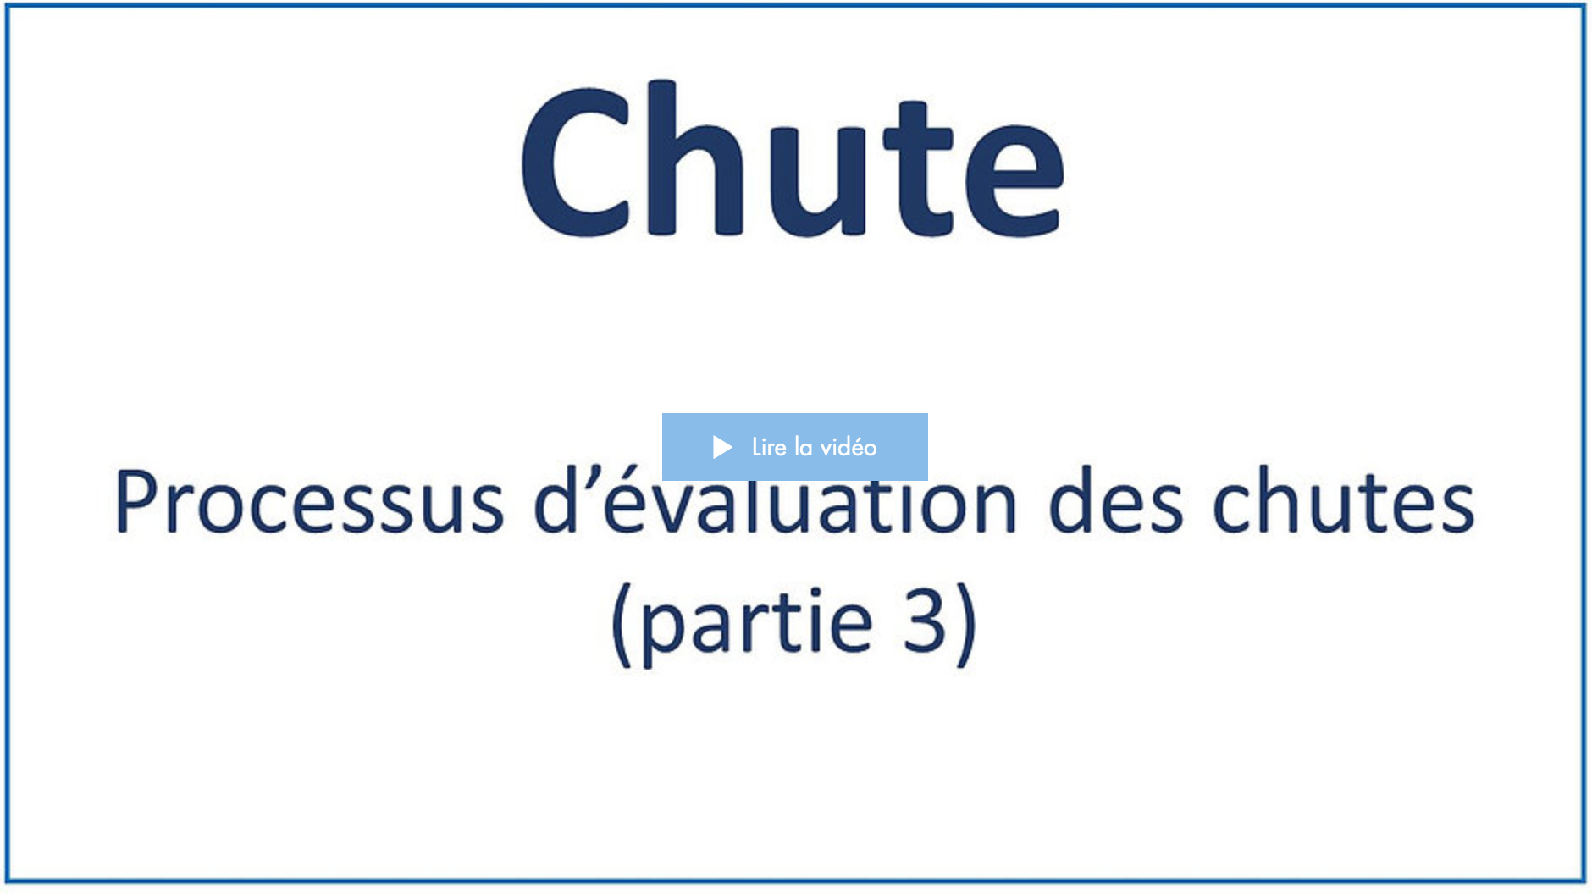
Date de visionnement de la vidéo : _________________
Notes
______________________________________________________________________________________________________________________________________________________________________________________________________________________________________________________________________________________________________________________________________________________________________________________________________________________________________________________________________________________________________________________________________________________________________________________________________________________________________________________________________________________________________________________________________________________________________________________________________________________________________________________________________________________________________________________________________________________________________________________________________________________________________________________________________________________________________________________________________________________________________________________________________________________________________
5
Vidéo 4

1. Visionnez la quatrième vidéo.
Durée : 10 min 05 sec.
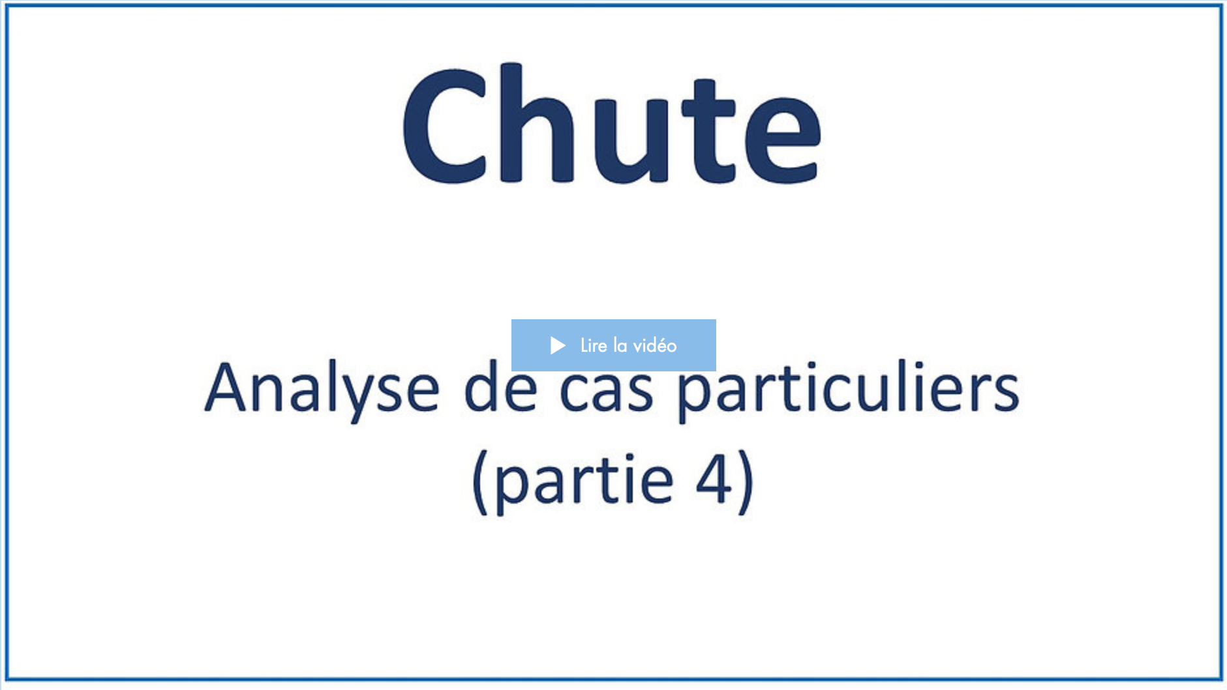
Date de visionnement de la vidéo : _________________
Notes
______________________________________________________________________________________________________________________________________________________________________________________________________________________________________________________________________________________________________________________________________________________________________________________________________________________________________________________________________________________________________________________________________________________________________________________________________________________________________________________________________________________________________________________________________________________________________________________________________________________________________________________________________________________________________________________________________________________________________________________________________________________________________________________________________________________________________________________________________________________________________________________________________________________________________
6
Vidéo 5

1. Visionnez la cinquième vidéo.
Durée : 31 min 31 sec.
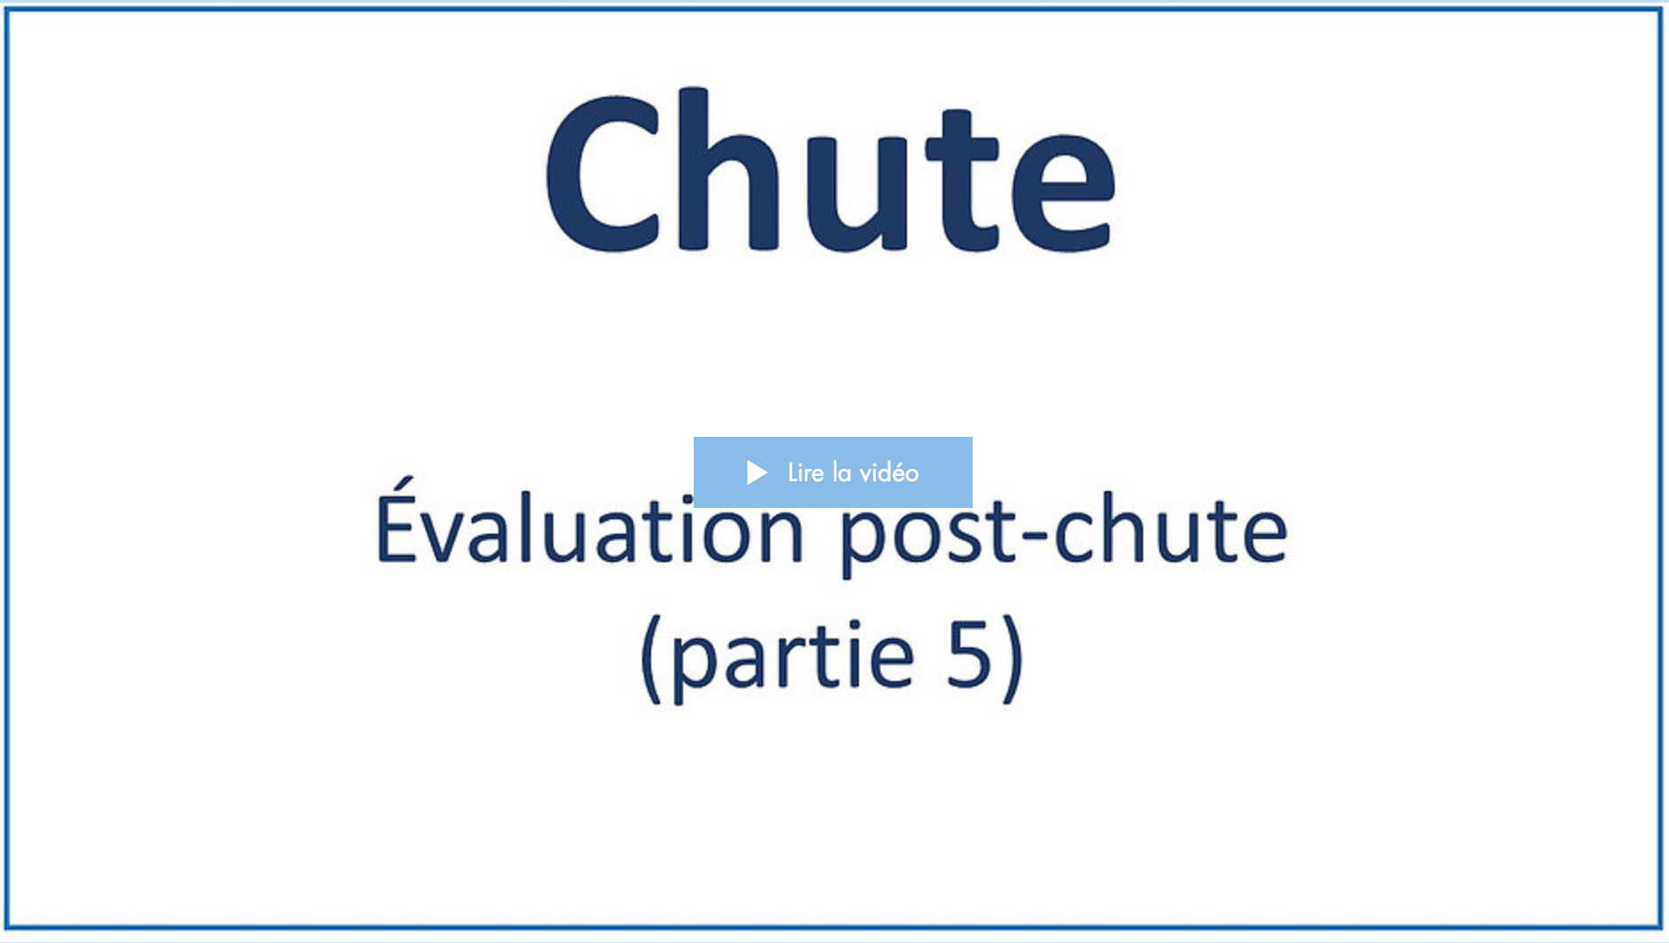
Date de visionnement de la vidéo : _________________
Notes
______________________________________________________________________________________________________________________________________________________________________________________________________________________________________________________________________________________________________________________________________________________________________________________________________________________________________________________________________________________________________________________________________________________________________________________________________________________________________________________________________________________________________________________________________________________________________________________________________________________________________________________________________________________________________________________________________________________________________________________________________________________________________________________________________________________________________________________________________________________________________________________________________________________________________
7
Vidéo 6

1. Visionnez la sixième vidéo.
Durée : 9 min 28 sec.
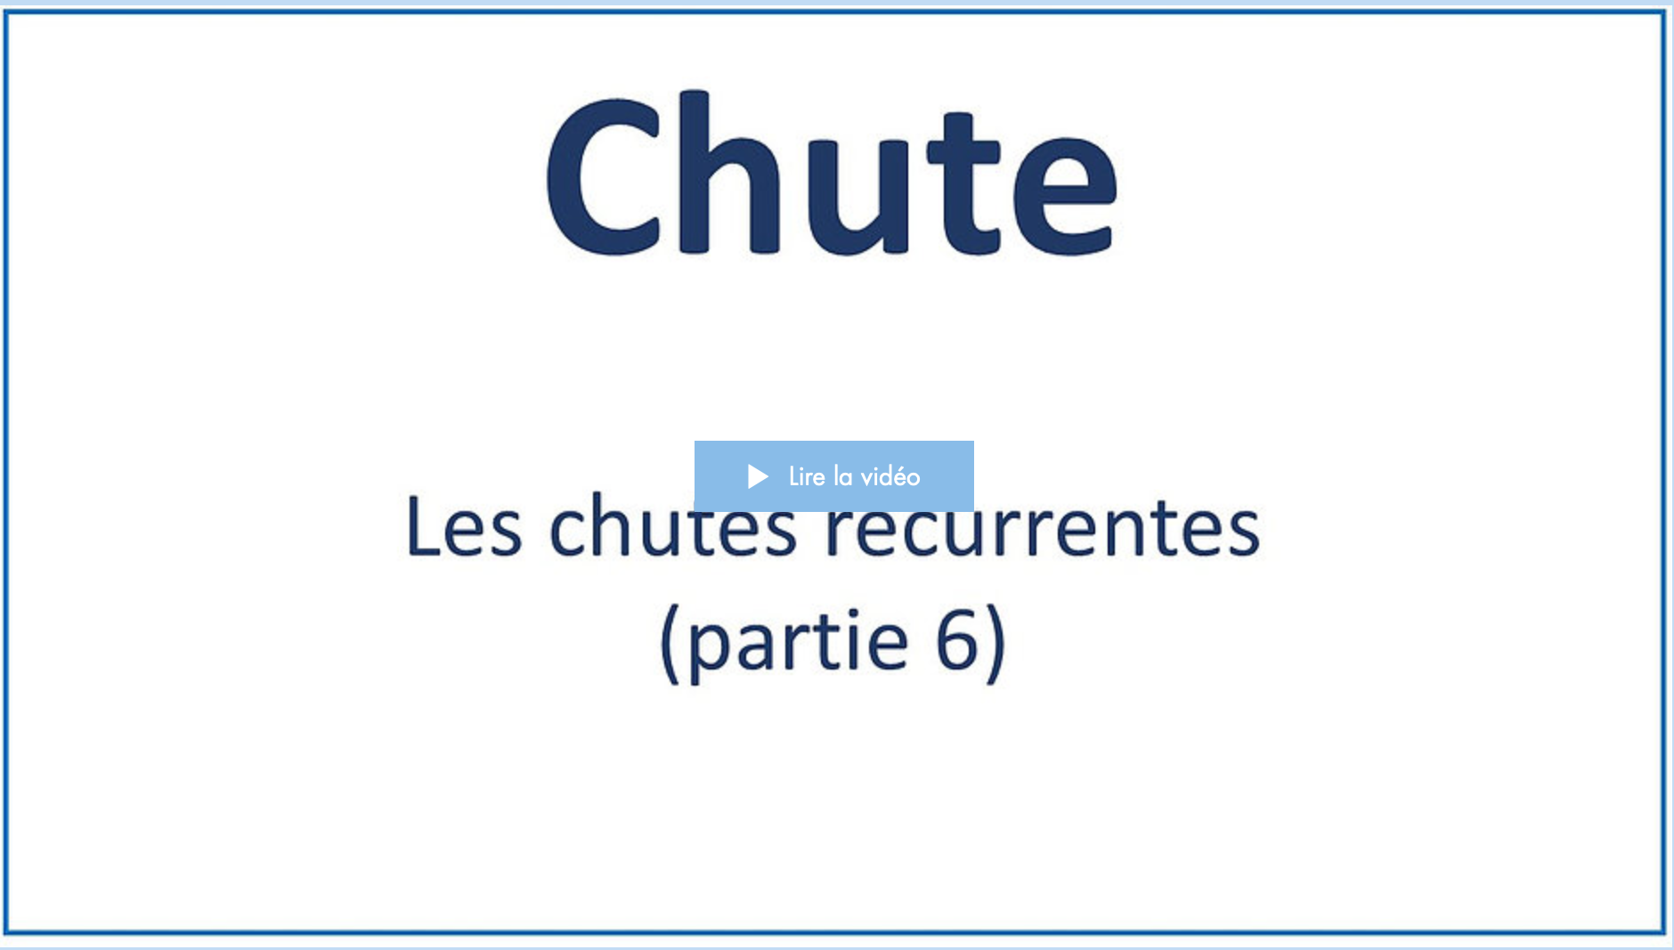
Date de visionnement de la vidéo : _________________
Notes
______________________________________________________________________________________________________________________________________________________________________________________________________________________________________________________________________________________________________________________________________________________________________________________________________________________________________________________________________________________________________________________________________________________________________________________________________________________________________________________________________________________________________________________________________________________________________________________________________________________________________________________________________________________________________________________________________________________________________________________________________________________________________________________________________________________________________________________________________________________________________________________________________________________________________
8
Vidéo 7

1. Visionnez la septième vidéo.
Durée : 6 min 22 sec.
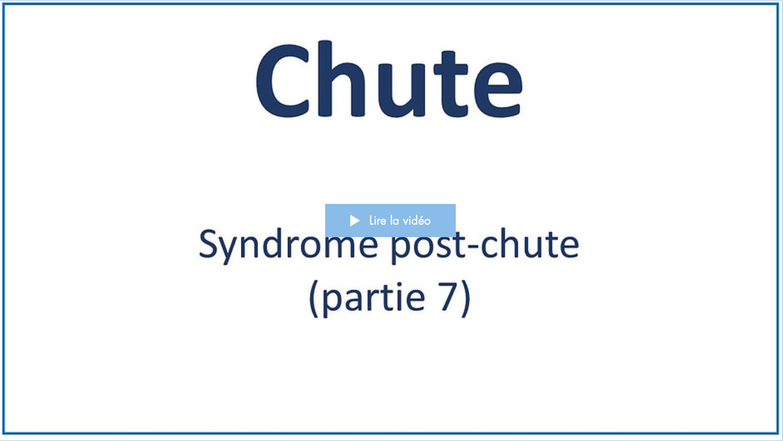
Date de visionnement de la vidéo : _________________
Notes
______________________________________________________________________________________________________________________________________________________________________________________________________________________________________________________________________________________________________________________________________________________________________________________________________________________________________________________________________________________________________________________________________________________________________________________________________________________________________________________________________________________________________________________________________________________________________________________________________________________________________________________________________________________________________________________________________________________________________________________________________________________________________________________________________________________________________________________________________________________________________________________________________________________________________
9
Après la formation

Vous avez terminé de visionner les vidéos de la formation.
1. (Facultatif) Selon les directives de votre organisation, veuillez faire le questionnaire de validation des apprentissages en cliquant sur la rubrique encadrée en rouge.
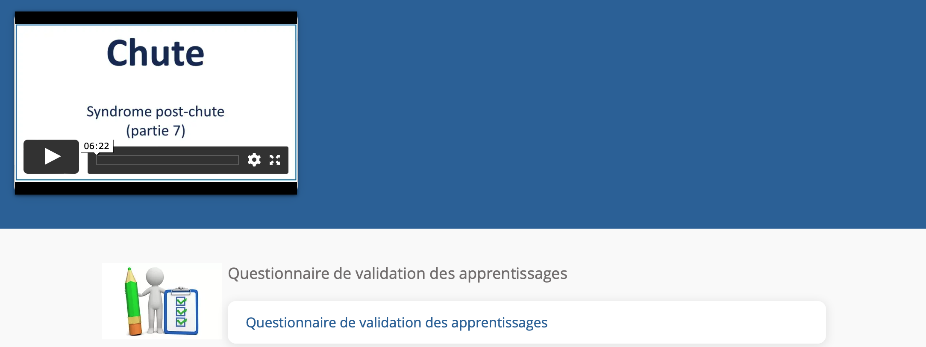
Durée approximative du questionnaire : 25 min.
Date de la réalisation du questionnaire : _________________
Résultat : _________
Signature approbative : ____________________________________________

