Guide de l’apprenant
  - L’examen clinique cardiaque de l’aîné
Tous droits réservés - www.philippevoyer.org

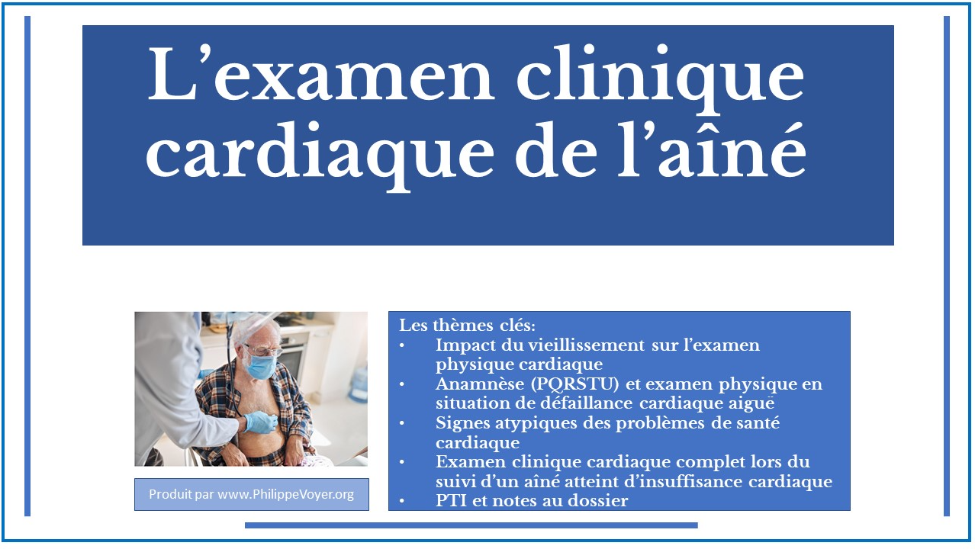

Formation destinée :

au personnel infirmier ;
- au membre de l’équipe d’encadrement clinique.

Nom : _________________________________________________________

1
Objectifs de la formation

Au terme de cette formation, vous serez en mesure de :
- Nommer les notions de base de l’examen clinique ;
- Décrire l’anatomie et la physiologie du cœur ;
- Décrire l’impact du vieillissement normal sur le système cardiovasculaire ;
- Reconnaître les signes typiques et atypiques des problèmes de santé du système cardiaque chez l’aîné ;
- Expliquer les causes des bruits cardiaques normaux et anormaux chez l’aîné ;
- Procéder à l’examen clinique physique du système cardiaque ;
- Réaliser l’examen clinique cardiaque en situation aiguë et lors d’un suivi ;
- Établir la relation entre l’examen clinique, le PTI et la note au dossier.

2
Préparation à la formation

Bienvenue à la formation sur l’examen clinique cardiaque de l’aîné !
- Avant de débuter la formation, assurez-vous que vous avez lu récemment un livre de physiopathologie du corps humain, vous permettant d’être en mesure de bien comprendre la formation qui suit.
- Nous vous invitons fortement à suivre la formation dans l’ordre suggéré par le guide de l’apprenant.

3
Vidéo 1

1. Visionnez la première vidéo.
Durée : 31 min 30 sec.
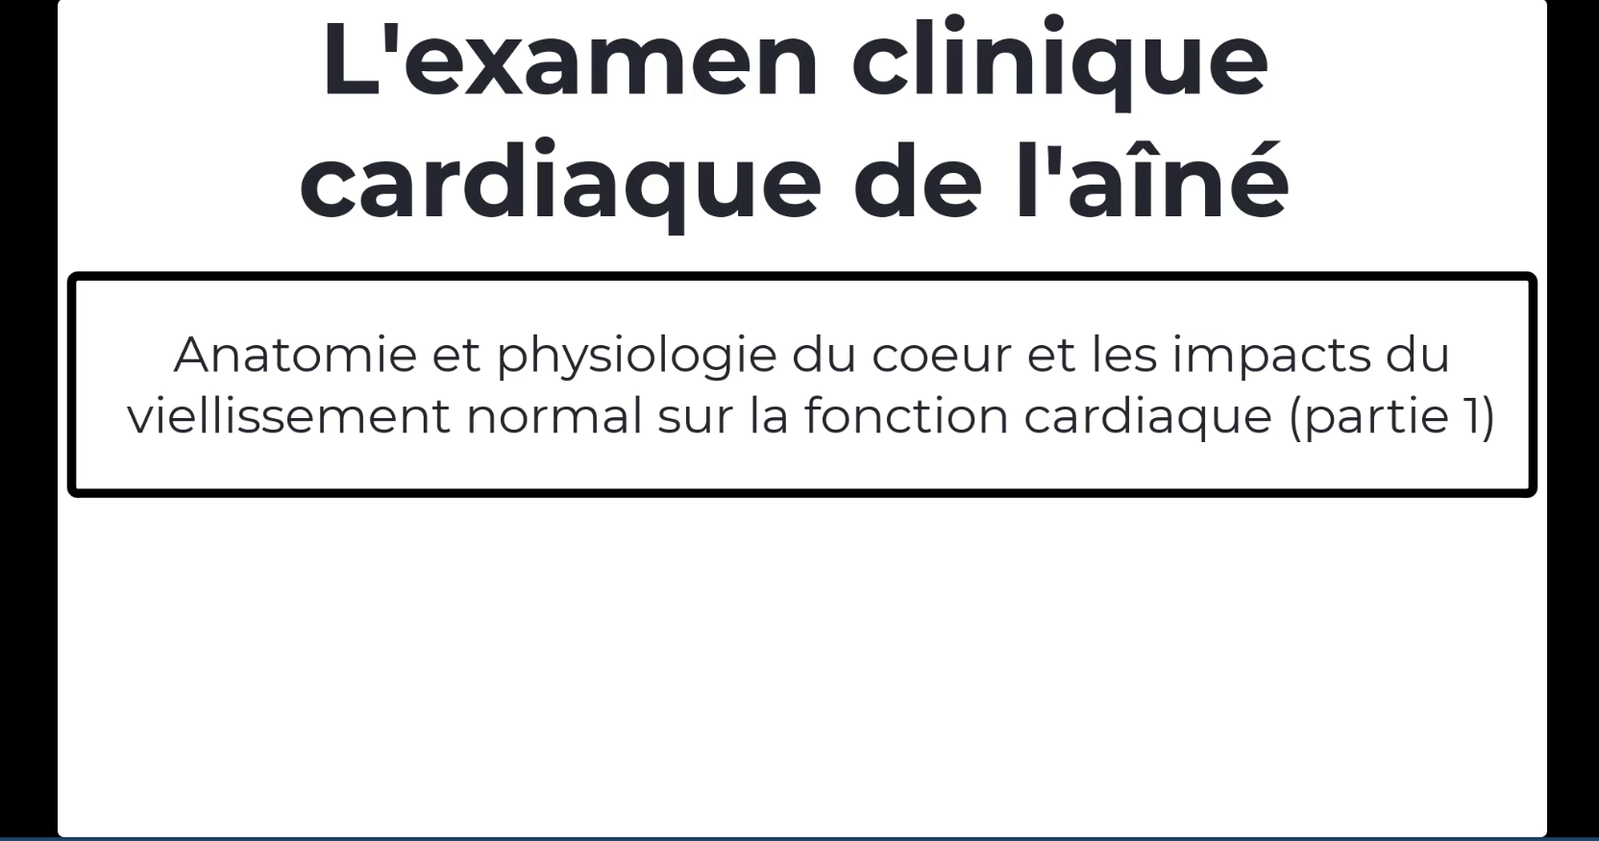
Date de visionnement de la vidéo : _________________
Notes
______________________________________________________________________________________________________________________________________________________________________________________________________________________________________________________________________________________________________________________________________________________________________________________________________________________________________________________________________________________________________________________________________________________________________________________________________________________________________________________________________________________________________________________________________________________________________________________________________________________________________________________________________________________________________________________________________________________________________________________________________________________________________________________________________________________________________________________________________________________________________________________________________________________________________

4
Vidéo 2

1. Visionnez la deuxième vidéo.
Durée : 26 min 39 sec.
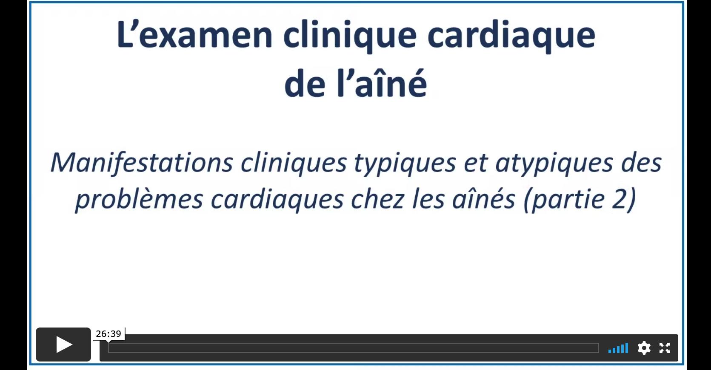
Date de visionnement de la vidéo : _________________
Notes
______________________________________________________________________________________________________________________________________________________________________________________________________________________________________________________________________________________________________________________________________________________________________________________________________________________________________________________________________________________________________________________________________________________________________________________________________________________________________________________________________________________________________________________________________________________________________________________________________________________________________________________________________________________________________________________________________________________________________________________________________________________________________________________________________________________________________________________________________________________________________________________________________________________________________

5
Vidéo 3

1. Visionnez la troisième vidéo.
Durée : 35 min 38 sec.
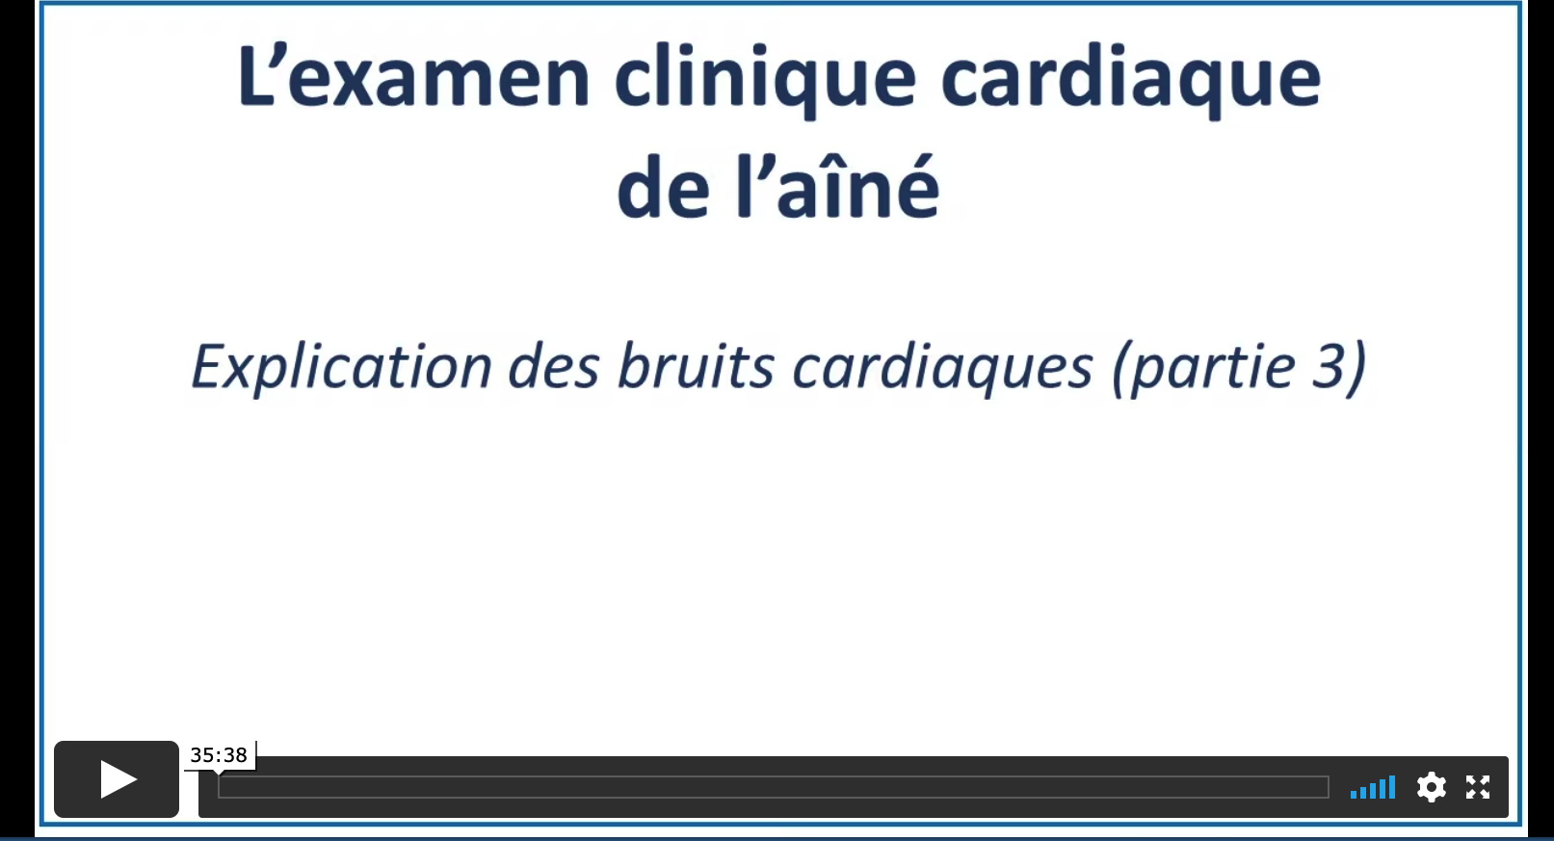
Date de visionnement de la vidéo : _________________
Notes
______________________________________________________________________________________________________________________________________________________________________________________________________________________________________________________________________________________________________________________________________________________________________________________________________________________________________________________________________________________________________________________________________________________________________________________________________________________________________________________________________________________________________________________________________________________________________________________________________________________________________________________________________________________________________________________________________________________________________________________________________________________________________________________________________________________________________________________________________________________________________________________________________________________________________
6
Vidéo 4

1. Visionnez la quatrième vidéo.
Durée : 11 min 12 sec.
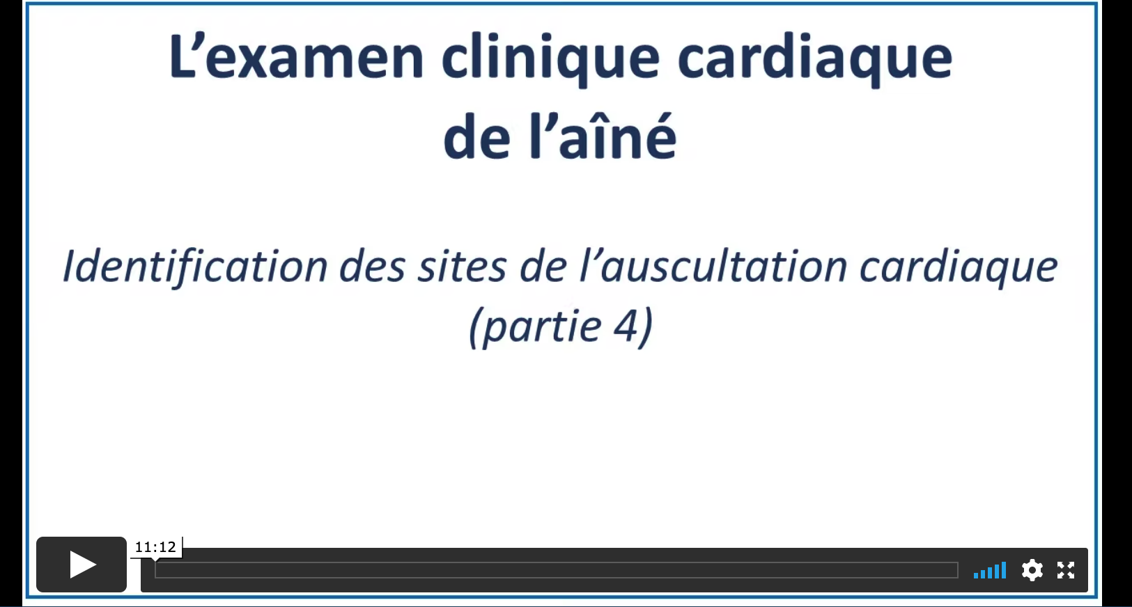
Date de visionnement de la vidéo : _________________
Notes
______________________________________________________________________________________________________________________________________________________________________________________________________________________________________________________________________________________________________________________________________________________________________________________________________________________________________________________________________________________________________________________________________________________________________________________________________________________________________________________________________________________________________________________________________________________________________________________________________________________________________________________________________________________________________________________________________________________________________________________________________________________________________________________________________________________________________________________________________________________________________________________________________________________________________

7
Vidéo 5

1. Visionnez la cinquième vidéo.
Durée : 21 min 38 sec.
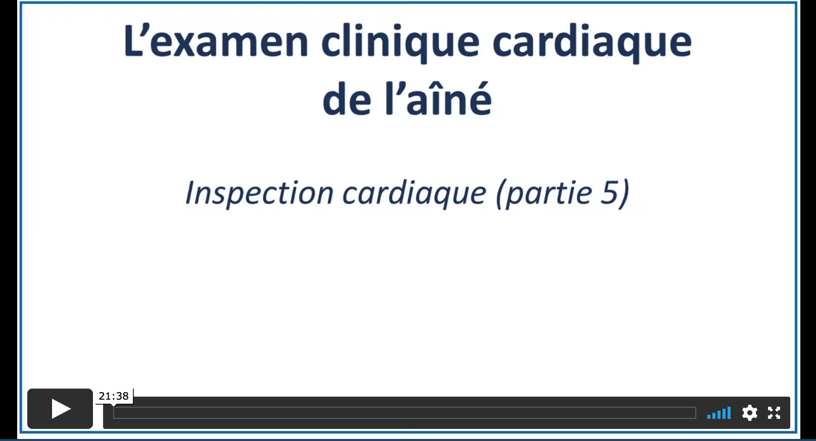
Date de visionnement de la vidéo : _________________
Notes
______________________________________________________________________________________________________________________________________________________________________________________________________________________________________________________________________________________________________________________________________________________________________________________________________________________________________________________________________________________________________________________________________________________________________________________________________________________________________________________________________________________________________________________________________________________________________________________________________________________________________________________________________________________________________________________________________________________________________________________________________________________________________________________________________________________________________________________________________________________________________________________________________________________________________

8
Vidéo 6

1. Visionnez la sixième vidéo.
Durée : 15 min 19 sec.
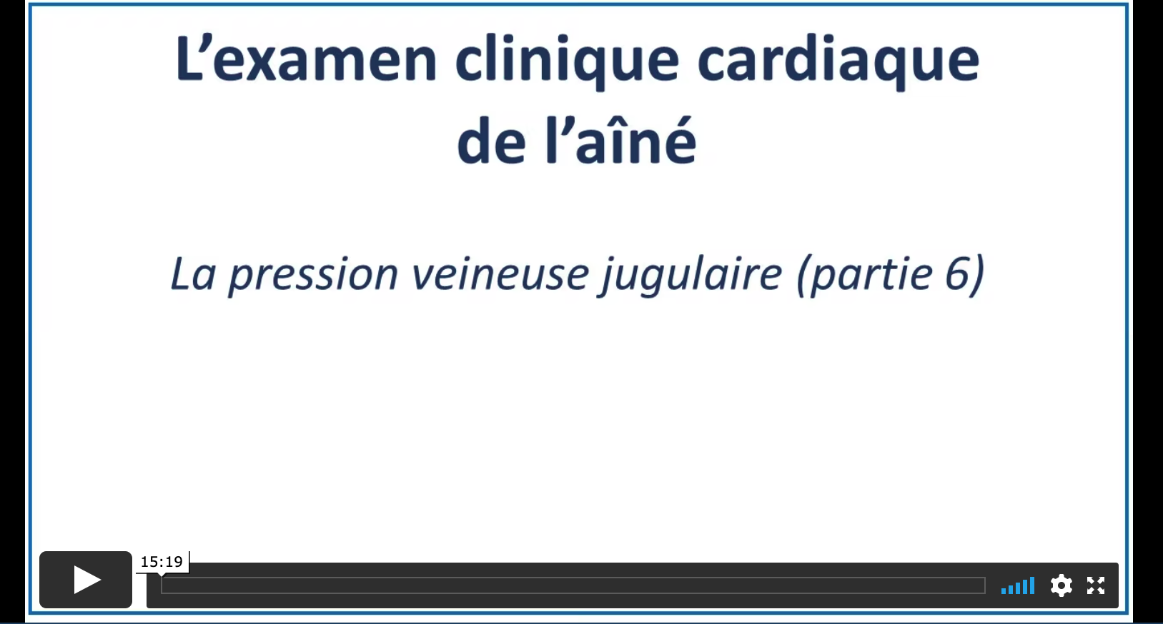
Date de visionnement de la vidéo : _________________
Notes
______________________________________________________________________________________________________________________________________________________________________________________________________________________________________________________________________________________________________________________________________________________________________________________________________________________________________________________________________________________________________________________________________________________________________________________________________________________________________________________________________________________________________________________________________________________________________________________________________________________________________________________________________________________________________________________________________________________________________________________________________________________________________________________________________________________________________________________________________________________________________________________________________________________________________

9
Vidéo 7

1. Visionnez la septième vidéo.
Durée : 20 min 51 sec.
Date de visionnement de la vidéo : _________________
Notes
______________________________________________________________________________________________________________________________________________________________________________________________________________________________________________________________________________________________________________________________________________________________________________________________________________________________________________________________________________________________________________________________________________________________________________________________________________________________________________________________________________________________________________________________________________________________________________________________________________________________________________________________________________________________________________________________________________________________________________________________________________________________________________________________________________________________________________________________________________________________________________________________________________________________________

10
Vidéo 8

1. Visionnez la huitième vidéo.
Durée : 24 min 27 sec.
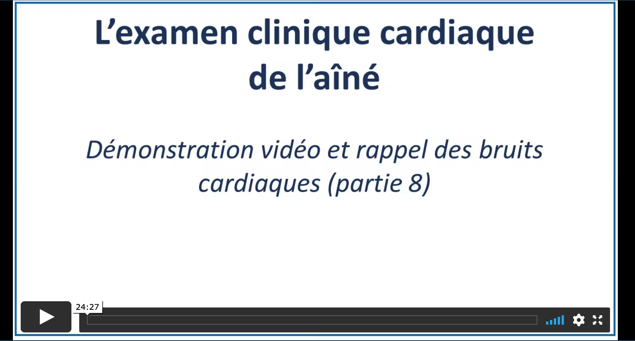
Date de visionnement de la vidéo : _________________
Notes
______________________________________________________________________________________________________________________________________________________________________________________________________________________________________________________________________________________________________________________________________________________________________________________________________________________________________________________________________________________________________________________________________________________________________________________________________________________________________________________________________________________________________________________________________________________________________________________________________________________________________________________________________________________________________________________________________________________________________________________________________________________________________________________________________________________________________________________________________________________________________________________________________________________________________

11
Vidéo 9

1. Visionnez la neuvième vidéo.
Durée : 11 min 00 sec.
Date de visionnement de la vidéo : _________________
Notes
______________________________________________________________________________________________________________________________________________________________________________________________________________________________________________________________________________________________________________________________________________________________________________________________________________________________________________________________________________________________________________________________________________________________________________________________________________________________________________________________________________________________________________________________________________________________________________________________________________________________________________________________________________________________________________________________________________________________________________________________________________________________________________________________________________________________________________________________________________________________________________________________________________________________________

12
Vidéo 10

1. Visionnez la dixième vidéo.
Durée : 12 min 55 sec.
Date de visionnement de la vidéo : _________________
Notes
______________________________________________________________________________________________________________________________________________________________________________________________________________________________________________________________________________________________________________________________________________________________________________________________________________________________________________________________________________________________________________________________________________________________________________________________________________________________________________________________________________________________________________________________________________________________________________________________________________________________________________________________________________________________________________________________________________________________________________________________________________________________________________________________________________________________________________________________________________________________________________________________________________________________________

15
Après la formation

Vous avez terminé de visionner les vidéos de la formation.
1. (Facultatif) Selon les directives de votre organisation, veuillez faire le questionnaire de validation des apprentissages en cliquant sur la rubrique encadrée en rouge.
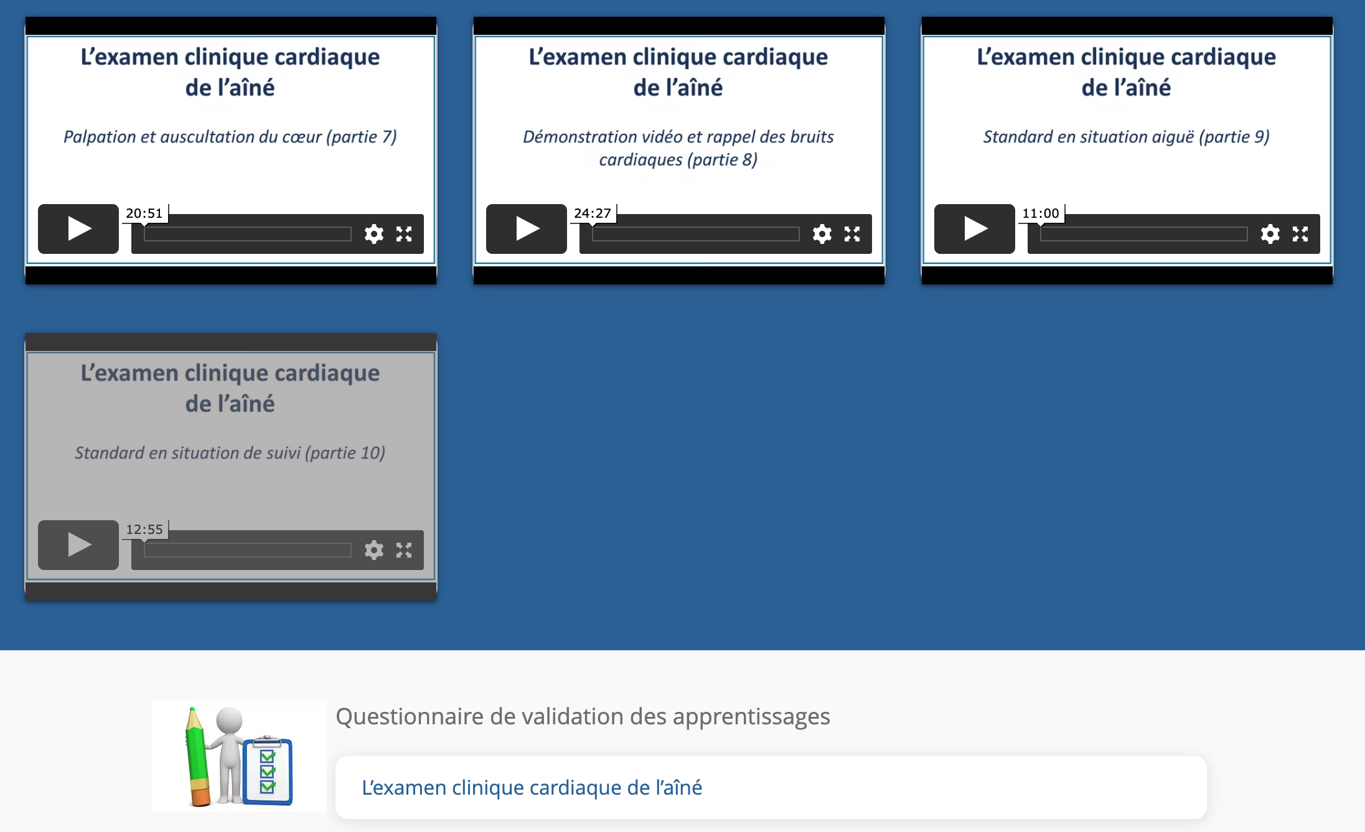
Durée approximative du questionnaire : 25 min.
Date de la réalisation du questionnaire : _________________
Résultat : _________
Signature approbative : ____________________________________________

